**Task: Watch the playlist video of Electronic Basic and note the key insights**

Episode 01: **Electronic Basics #1: The Multimeter**

* **Instrument Name**: Multimeter (Digital Multimeter or DMM)
* **Essential Accessories**:
  + **Probes**: Two insulated wires with pointed metal tips. Typically, one Red (for positive or the measurement point) and one Black (for common/ground).
* **Probe Sockets on the Multimeter**:
  + **COM (Common)**: The black probe *always* connects here.
  + **VΩHz (or similar)**: The red probe connects here for measuring Voltage, Resistance, Continuity, and often Frequency or Capacitance.
  + **mA/µA (Milliamps/Microamps)**: The red probe moves here for measuring *small* currents. This port is usually fused at a lower rating (e.g., 500mA in the video).
  + **10A (or 20A MAX)**: The red probe moves here for measuring *large* currents. This port is fused at a higher rating.

**Measuring Resistance (Ω) and Continuity**

1. Resistance Measurement:
   * **Dial Setting:** Turn the rotary dial to the **Ω (Ohm)** symbol.
2. Continuity Test:

* **Dial Setting:** Turn the dial to the **continuity symbol** (often looks like a sound wave or Wi-Fi symbol, usually sharing a position with Ω and selected via a function button).

**Measuring DC Voltage (V---)**

* + **Dial Setting:** Turn the dial to **V---** (Voltage Direct Current). (V~ is for AC Voltage).

**Measuring DC Current (A---)**

* **Dial Setting:** Turn the dial to **A---** (Amperes Direct Current).

Key Takeaways & Troubleshooting

* A multimeter is an indispensable tool for diagnosing and understanding electronic circuits.
* **Voltage is measured in parallel.**
* **Current is measured in series (requiring opening the circuit and careful probe placement in current sockets).**
* **Resistance is best measured with the component out of circuit.**
* Always double-check your dial settings and probe connections, especially when measuring current, to avoid blowing fuses or damaging the meter.

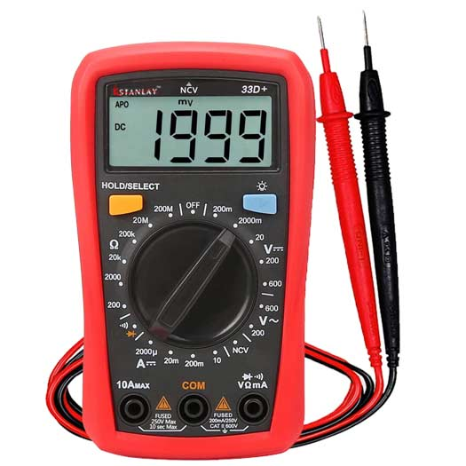

**The Multimeter**

Episode 02:Electronic Basics #2: Dimming all kinds of LEDs!?

**Electronic Basics: The Art of LED Dimming via PWM, Arduino, and the 555 IC**

**Instruments & Components Used for Demonstration:**

* **LEDs:** Various types including standard 5mm green LEDs, blue LED strips, and other high-power LED modules.
* **Coin Cell Battery:**For a simple initial demonstration.
* **Bench Power Supply:** **ELV DPS 7000** (used to show the effect of direct voltage change on LED brightness).
* **Oscilloscope: RFT EO 213** (used to visualize PWM waveforms and duty cycle changes).
* **Arduino Uno:**Microcontroller used for generating PWM signals.
* **555 Timer IC (NE555N):**Used to generate PWM signals without a microcontroller.
* **Potentiometer:**Used as an input device to control the duty cycle for both Arduino and 555 timer setups.
* **MOSFET:**Used as a switch to control high-power LEDs with a low-power PWM signal.
* **Breadboard & Jumper Wires:**For prototyping the circuits.
* **Resistors, Capacitors, Diodes:**Passive components used in the 555-timer circuit.

**Key Points & Techniques:**

1. Why Simple Voltage Reduction/Potentiometers Fall Short:
   * **Variable Power Supply:**Lowering voltage with a bench power supply (like the **ELV DPS 7000** shown) dims an LED, but this isn't a viable solution for most projects with fixed power supplies.
   * **Potentiometer in Series:**While a potentiometer can vary resistance and thus voltage/current to an LED, this method is:
     + **Inefficient for high power:**It wastes energy as heat.
     + **Impractical for high current:**Requires a large, "beefy" potentiometer that can handle the power, which is expensive. The presenter calls this approach "bullshit" for such applications.
2. Pulse Width Modulation (PWM) Explained:
   * PWM involves rapidly switching the LED ON and OFF at a fixed voltage (e.g., 5V).
   * The human eye perceives this rapid switching as an average brightness.
   * **Duty Cycle:**This is the crucial parameter – the percentage of time the signal is ON within one full cycle.
     + 100% duty cycle = LED fully ON.  
       kontinuierlich leuchtet.
     + 50% duty cycle = LED is ON for half the time, OFF for half the time (appears at half brightness).
     + 0% duty cycle = LED fully OFF.
   * **Oscilloscope Demonstration:** An **RFT EO 213 Oscilloscope** is used to visually demonstrate the PWM square wave. It shows how the 'width' of the 'pulse' (ON time) changes while the voltage level (amplitude) remains constant during the ON phase.
3. Methods to Generate PWM:
   * **Using an Arduino (Microcontroller):**
     + **Instrument:**Arduino Uno.
     + **Function:**The analog Write (pin, value) command is used.
     + **Control:**The value ranges from 0 (0% duty cycle, 0V effective) to 255 (100% duty cycle, 5V effective).
   * **Using a 555 Timer IC:**
     + **Instrument:**NE555N Timer IC.
     + **Circuit:** A specific circuit configuration (schematic shown) with resistors, capacitors, and diodes allows the 555 timer to operate in astable mode and generate a PWM signal.
     + **Control:**A potentiometer is integrated into the 555-timer circuit to adjust the duty cycle of the output PWM signal.
4. Driving Higher Power LEDs (e.g., LED Strips, High-Power LEDs):
   * Neither the Arduino pins nor the 555-timer output can directly handle the high current or voltage required by powerful LEDs.
   * **Solution:**A **MOSFET** (Metal-Oxide-Semiconductor Field-Effect Transistor) is used as a switch.



**Dimming all Kind of LEDs**

Episode 03:Electronic Basics #3: **Programming an Attiny+Homemade Arduino Shield**

* **Objective:**To control a WS2801 LED strip for animations on a large (1.5m x 1m) LED board project.
* **Reason for ATtiny:** Instead of using a full, more expensive Arduino board (like an ATmega328P, ~€4) for this relatively simple task (2 outputs for LED strip, 1 input for a push button), the much cheaper and smaller ATtiny85 microcontroller (€1) is chosen.

**Core Component: ATtiny85 Microcontroller**

* Component Name: ATtiny85 (8-pin microcontroller)
* **Key Features/Specifications:**
  + Flash Memory: 8 Kilobytes (for program storage).
  + Special Pin Functions:
    - Analog Inputs (on 3 of the I/O pins).
    - PWM (Pulse Width Modulation) output (on 2 of the I/O pins).
    - Reset pin.
  + Pinout (for Arduino programming context):
    - IC Pin 1: RESET
    - IC Pin 2: IO3 / Analog Input 3
    - IC Pin 3: IO4 / Analog Input 2
    - IC Pin 4: Ground (GND)
    - IC Pin 5: IO0 / MOSI / PWM
    - IC Pin 6: IO1 / MISO / PWM
    - IC Pin 7: IO2 / SCK / Analog Input 1
    - IC Pin 8: VCC (+5V)

**Programming Instrument: Arduino Uno as ISP (In-System Programmer)**

* **Instrument Used:**An Arduino Uno board is used as a programmer to upload code to the ATtiny85.
* **Software Configuration:**
  1. Arduino IDE: Version 1.0.5 must be used (the video states version 1.5.5 Beta did not work for this). Download from arduino.cc.
  2. ATtiny Core Files: Additional board definition files for ATtiny microcontrollers need to be downloaded (from highlowtech.org or a link provided in the video description) and installed into the Arduino IDE's hardware folder. This allows the IDE to recognize and compile code for ATtiny chips.
  3. Arduino ISP Sketch: The ArduinoISP sketch (found under File > Examples > ArduinoISP) must be uploaded to the Arduino Uno. This sketch turns the Arduino Uno into a dedicated programmer.
* **Hardware Wiring (Arduino Uno to ATtiny85 for Programming):**
  1. Arduino Pin 13 (SCK) → ATtiny85 IO2 (IC Pin 7)
  2. Arduino Pin 12 (MISO) → ATtiny85 IO1 (IC Pin 6)
  3. Arduino Pin 11 (MOSI) → ATtiny85 IO0 (IC Pin 5)
  4. Arduino Pin 10 → ATtiny85 RESET (IC Pin 1)
  5. Arduino 5V → ATtiny85 VCC (IC Pin 8)
  6. Arduino GND → ATtiny85 GND (IC Pin 4)
  7. **Crucial Component:**A 10µF capacitor is placed between the Arduino Uno's RESET pin and its GND pin. This prevents the Arduino Uno from resetting itself when the upload process begins, which is necessary when using it as an ISP.
* **Uploading Code to ATtiny85:**
  1. In Arduino IDE: Select Tools > Board > "ATtiny85 (e.g., internal 1MHz clock)".
  2. Select Tools > Programmer > "Arduino as ISP".
  3. Upload the sketch using File > "Upload Using Programmer" (or Shift + Upload button). (The video mentions some "PAGEL" errors might appear but can be ignored if programming is successful).

**Enhancement: Homemade ATtiny Programming Shield**

* **Purpose:**To create a convenient, reusable shield that plugs directly onto the Arduino Uno, making it easy to program ATtiny85 chips without rewiring each time.

**Application Demonstration: Controlling WS2801 LED Strip**

* Challenge: The ATtiny85 does not have built-in hardware support for SPI (Serial Peripheral Interface), which is typically used to communicate with WS2801 LED strips.
* Solution: "Bit-banging" the SPI protocol. This means manually controlling the I/O pins in software to emulate the SPI signals (clock, data). The video mentions that SparkFun provides a library that handles this bit-banging for the WS2801, simplifying the code.
* Result: The ATtiny85, programmed via the Arduino Uno (and the custom shield), successfully controls the WS2801 LED strip, demonstrating animations. This serves as a proof-of-concept for the larger LED board project.

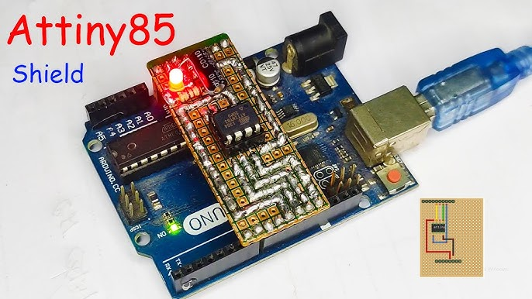

Episode 04: **Electronic Basics #4: Arduino+Bluetooth+Android=Awesome**

**Project Overview: Smartphone-Controlled LEDs via Bluetooth & Arduino**

**The video demonstrates how to control an RGB LED using an Android smartphone by sending commands over Bluetooth to an Arduino Nano, which then manipulates the LED. It highlights the ease of using a common Bluetooth module for DIY electronics projects.**

**Core Components Used:**

* **Bluetooth Module:**
  + Name:**Primarily features the JY-MCU Bluetooth module (labeled BT\_BOARD V1.05) but also mentions and uses the HC-05 module for connection with the Android app.**
  + Pins Used: **VCC (Power), GND (Ground), TXD (Transmit Data), RXD (Receive Data).**
  + Function:**Receives commands from the smartphone and transmits data to the Arduino.**
* **Microcontroller:**
  + Name: **Arduino Nano.**
  + Function:**Receives serial data from the Bluetooth module, processes commands, and controls the output pins for the RGB LED.**
* **Output Device:**
  + Name:**Common Anode RGB LED.**
  + Function: **Visually displays different colors based on commands.**
* **Control Interface:**
  + Name:**Android Smartphone.**
  + App Used: **"S2 Terminal for Bluetooth" (searched as "s2 terminal" on Play Store).**
  + Function:**Sends ASCII text commands (e.g., "red", "green", "blue") to the Bluetooth module.**
* **Circuit Building:**
  + Breadboard:**For prototyping the circuit.**
  + Jumper Wires: **For making connections.**
  + **Resistors:**
    - **Current-limiting resistors for the RGB LED (e.g., ~460Ω shown, typical values might be 220-330Ω).**
    - **Voltage divider resistors (2kΩ and 4.7kΩ) for the Arduino TX to Bluetooth RX line.**

**Key Technical Challenge: Logic Level Conversion**

* **The Issue: The Arduino Nano operates at 5V logic levels, while the Bluetooth module operates at 3.3V logic levels.**
* **Bluetooth TX to Arduino RX: The 3.3V signal from the Bluetooth module's TX pin is generally high enough to be interpreted as a 'HIGH' by the Arduino's 5V RX pin, so no conversion is needed here.**
* **Arduino TX to Bluetooth RX: Sending a 5V signal from the Arduino's TX pin directly to the Bluetooth module's 3.3V RX pin can damage the module.**
* **The Solution: A voltage divider is implemented using two resistors (2kΩ and 4.7kΩ) to step down the Arduino's 5V TX signal to approximately 3.4V before it reaches the Bluetooth module's RX pin.**

**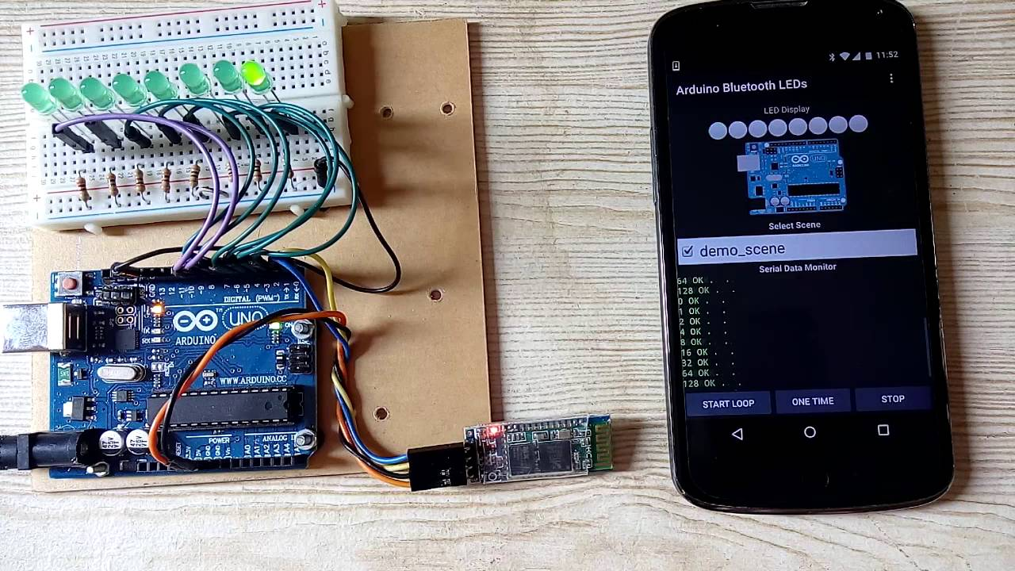**

**Arduino+Bluetooth+Android**

Episode 05: **Electronic Basics #5: How to Multiplex.**

**Key Components Used in the 10x5 LED Matrix Demonstration:**

* **Microcontroller:**Arduino Nano
* **LED Driver IC:**TLC5940NT (16-channel, 12-bit PWM LED driver)
  + Used to control the 10 cathode columns of the LED matrix. Provides constant current and PWM for brightness control.
* **Switching Transistors:** 5 x F9540N P-Channel MOSFETs
  + Used to switch power (anodes) to each of the 5 rows of the LED matrix. Necessary because a row can draw more current (up to 200mA in the example) than an Arduino pin or the TLC5940 can directly handle.
* **Resistors:**
  + 1 x 2kΩ resistor: Connected to the IREF pin of the TLC5940 to set the maximum current for the LEDs (sets it to ~20mA per LED in this case).
  + 5 x 1kΩ resistors: Used as pull-up resistors for the gates of the P-Channel MOSFETs.
* **LEDs:** 50 standard LEDs (blue in the demo) arranged in a 10x5 matrix on a perfboard.
* **Other:**Breadboard, jumper wires.

**Circuit Configuration & Multiplexing Explained (10x5 Matrix Example):**

* **LED Matrix Wiring:**
  + Cathodes (-): All LED cathodes in a single *column* are connected together.
  + Anodes (+): All LED anodes in a single *row* are connected together.
* **MOSFET (Row) Control:**
  + The Arduino Nano's digital output pins control the Gates of the P-Channel MOSFETs.
* **TLC5940 (Column & Brightness) Control:**
  + The Arduino Nano communicates with the TLC5940 via serial interface pins (SCLK, SIN, XLAT, BLANK, GSCLK).
* **Multiplexing Sequence**

**Software & Control:**

* Arduino IDE: Used for programming the Arduino Nano.
* TLC5940 Arduino Library: A specific library for the TLC5940 is used (downloadable from Arduino Playground) to simplify communication and control.

**Key Takeaways:**

* Multiplexing, combined with LED driver ICs (like TLC5940) and switching transistors (like MOSFETs), is a powerful and efficient way to control a large number of LEDs.
* The TLC5940 simplifies brightness control (PWM) and reduces the number of microcontroller pins needed for column driving.
* MOSFETs are essential for switching the higher currents required by entire rows of LEDs.
* The speed of cycling through rows is critical for a flicker-free display.

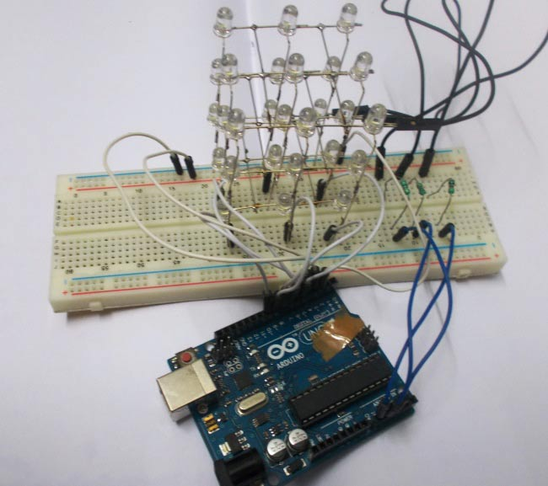

[DIY 3x3x3 LED Cube using Arduino](https://www.google.com/url?sa=i&url=https%3A%2F%2Fcircuitdigest.com%2Fmicrocontroller-projects%2Fmaking-3X3X3-led-cube-with-arduino&psig=AOvVaw3PtylADE7q1XZXaif-tS1Z&ust=1748166352253000&source=images&cd=vfe&opi=89978449&ved=0CBcQjhxqFwoTCOjGkqzqu40DFQAAAAAdAAAAABAM" \t "_blank)

Episode 06: **Electronic Basics #6: Standalone Arduino Circuit**

**Key Project & Goal:**

* **Instrument:** The core of the demonstration is the **ATmega328P microcontroller**.
* **Goal:** To create a minimal circuit around the ATmega328P so it can run Arduino code independently of the full Arduino Uno board, allowing for smaller, custom-built projects.

**Minimal Components Required for ATmega328P Operation:**  
The ATmega328P uses these external components for basic functionality:

1. ATmega328P Microcontroller: The central processing unit.
2. 16 MHz Crystal Oscillator: Provides the clock signal for the microcontroller to execute instructions at the correct speed.
3. Two 22 picofarad (pF) Capacitors: Used in conjunction with the crystal to stabilize the clock signal. They connect from each leg of the crystal to ground.
4. One 10 kilohm (kΩ) Resistor: Used as a pull-up resistor on the Reset pin. This connects the Reset pin to 5V, preventing the microcontroller from randomly resetting.
5. 5V Power Supply: To power the microcontroller (VCC and AVCC pins).
6. Ground Connection: For the GND pins.

**Wiring Essentials for the Standalone ATmega328P:**

* **Power:** Pins 7 (VCC), 20 (AVCC), and 21 (AREF, if using analog reference as 5V) connect to 5V. Pins 8 and 22 connect to Ground.
* **Clock Circuit:**The 16 MHz crystal connects to pins 9 (XTAL1) and 10 (XTAL2). Each of these pins also connects to ground through a 22pF capacitor.
* **Reset Circuit:**Pin 1 (RESET) connects to 5V through the 10kΩ pull-up resistor.

**Programming the Standalone ATmega328P:  
1. Temporary Transfer (Least Convenient)**

* 1. **Using an Arduino Uno as a Serial Passthrough/Programmer**
  2. **Using an FTDI (or similar USB-to-Serial) Adapter.**

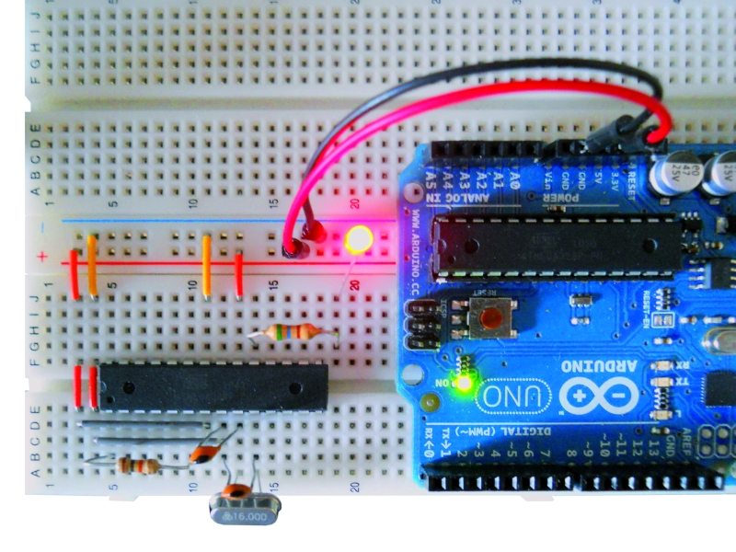

**Standalone Arduino Circuit**

Episode 07: **Electronic Basics #7: 7 Segment Display**

Introduction to 7-Segment Displays

* **What they are: "Old school" but useful displays consisting of 7 individual LED segments (labeled A-G) arranged in a figure-8 pattern, plus an 8th LED for a decimal point (DP).**
* **Purpose: Ideal for displaying numbers and some letters in simple projects.**
* **Examples of Use: Clocks, temperature sensors, power supply readouts.**
* **Types Mentioned:**
  + Single-digit displays: **e.g., LTS-546AG (Common Anode used in the video).**
  + **Dual-digit displays: e.g., LD-0036HR-C.**
* Using 7-Segment Displays *Without* a Microcontroller (Discrete Logic Counter)
* **Core Idea:**Combine a BCD (Binary Coded Decimal) to 7-Segment Driver IC with a 4-Bit Binary Counter IC.
* **Component 1: BCD to 7-Segment Driver**
* Instrument Name: **SN74LS247N**
* **Component 2:** 4-Bit Binary (Decade/BCD) Counter
* Instrument Name: SN74LS290N

**Overall Function:** Each button press increments the SN74LS290N counter, which outputs a new BCD code to the SN74LS247N, which then displays the new digit on the 7-segment display.

Using Multiple 7-Segment Displays with an Arduino (via I²C Driver)

* **Challenge:** Directly driving many segments of multiple displays consumes too many Arduino pins. Multiplexing directly from Arduino is possible but still pin-intensive (e.g., 12 pins for 4 digits).
* **Solution:** Dedicated I²C Display Driver IC
  + Instrument Name: SAA1064 (NXP)
    - **Multiplexing:** Internally multiplexes two pairs of digits.
    - **Arduino Pins:**A4 (SDA), A5 (SCL).
    - **External Components for SAA1064:**
      * **ADR pin (address select):**Tied to GND to set a specific I²C address (e.g., 0x70).
      * **CEXT pin (external capacitor):**A capacitor (e.g., 2.2nF) to set the multiplexing oscillator frequency.
      * **Pull-up Resistors:**Two 4.7kΩ resistors are needed on the SDA and SCL lines, connected to 5V.
      * **Transistors (for multiplexing common anodes):**Two NPN transistors (e.g., BC337) are used to switch power to the common anodes of the display pairs, controlled by the SAA1064's MX1 and MX2 pins.
    - **Software:** Requires an Arduino library for I²C communication and control of the SAA1064. The video uses the "cool-SAA1064-lib" by cscheiblich (found on GitHub).
* **Overall Function:**The Arduino sends commands and data (what to display) to the SAA1064 over I²C. The SAA1064 then handles the multiplexing and segment driving for the connected 7-segment displays. This allows complex displays (like a clock) with minimal Arduino pin usage.

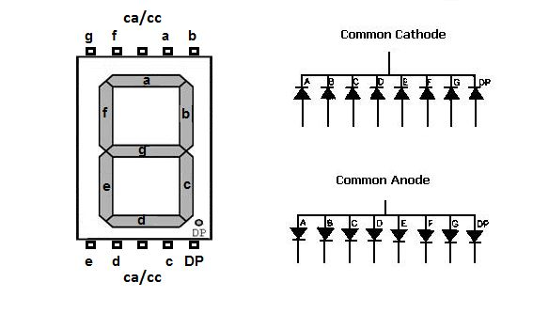

**7 Segment Display**

**Episode 08:** **Electronic Basics #8: Everything about LEDs and current limiting resistors**

I. Beginner's Guide to Lighting LEDs (0:36 - 3:15)

**Key Points:**

1. **Essential LED Parameters:**
   * **Forward Voltage (Vf):**The voltage drop across the LED when it's lit (e.g., 3.2V for the green LED shown).
   * **Ideal Current (If):**The current at which the LED operates optimally (e.g., 20mA). These are usually provided by the seller.
2. **The Need for a Current-Limiting Resistor:**Directly connecting an LED to a power source with a higher voltage than Vf will destroy it. A resistor is crucial.
3. **Calculating the Resistor Value:**
4. **Resistor Power Rating:**
   * Power (P) = Vr \* If (or P = I²R or P = V²/R).
5. **Multiple LEDs in Series:**

Instruments & Components Used (Beginner):

* **LEDs:** (Green, 5mm shown) - The light source.
* **Resistors:** (Axial, color-coded, e.g., 150 Ohm used in combination) - To limit current.
* **Power Source:**
  + **9V Battery (Varta):** Used as a simple voltage source.
* **Breadboard:** For solderless prototyping.
* **Calculator (Texas Instruments TI-83 Plus):**For performing calculations.
* **Pen & Paper:**For drawing circuit diagrams.

II. Advanced LED Considerations & Driving Techniques (3:16 - 6:16)

**Key Points:**

1. **Manufacturer Specification Inaccuracies**
2. **Exponential I-V Characteristic of LEDs**
3. **Risk of No Resistor (Even if Vs ≈ Vf)**
4. **Problem with LEDs in Parallel (with a Single Resistor)**
5. **Forward Voltage Variation Between LEDs:**
   * Even LEDs from the same batch can have slightly different forward voltages (e.g., varying between 2.9V and 3.1V).
6. **Constant Current Driving:**
   * The *best* way to drive LEDs is with a constant current source, not a constant voltage source with a resistor.
   * **LM317 Voltage Regulator:**Can be configured as a simple constant current source with one resistor.
   * **TLC5940 LED Driver IC:**A popular constant current driver for more complex applications (like LED cubes).

Instruments & Components Used (Advanced):

* **LEDs:** (Green, Blue shown)
* **Bench Power Supply (JPS 7000 shown, also a converted ATX PSU):**For precise voltage/current control and testing.
  + **Used to:** Set specific voltages, limit current, observe current draw.
* **Multimeter (UNI-T UT61D shown):**
  + **Used to:** Measure actual Vf of LEDs at a specific current, measure current flowing in the circuit, measure voltage drops.
* **Breadboard:** For prototyping.
* **Resistors:**(Including small values like 10 Ohm for linearization).
* **Graph Paper & Pen:**For plotting the I-V characteristic curve of an LED.
* **LM317 Voltage Regulator IC:**Used to build a constant current source.
* **TLC5940 LED Driver IC:**Mentioned as a constant current driver (seen in the LED cube project).

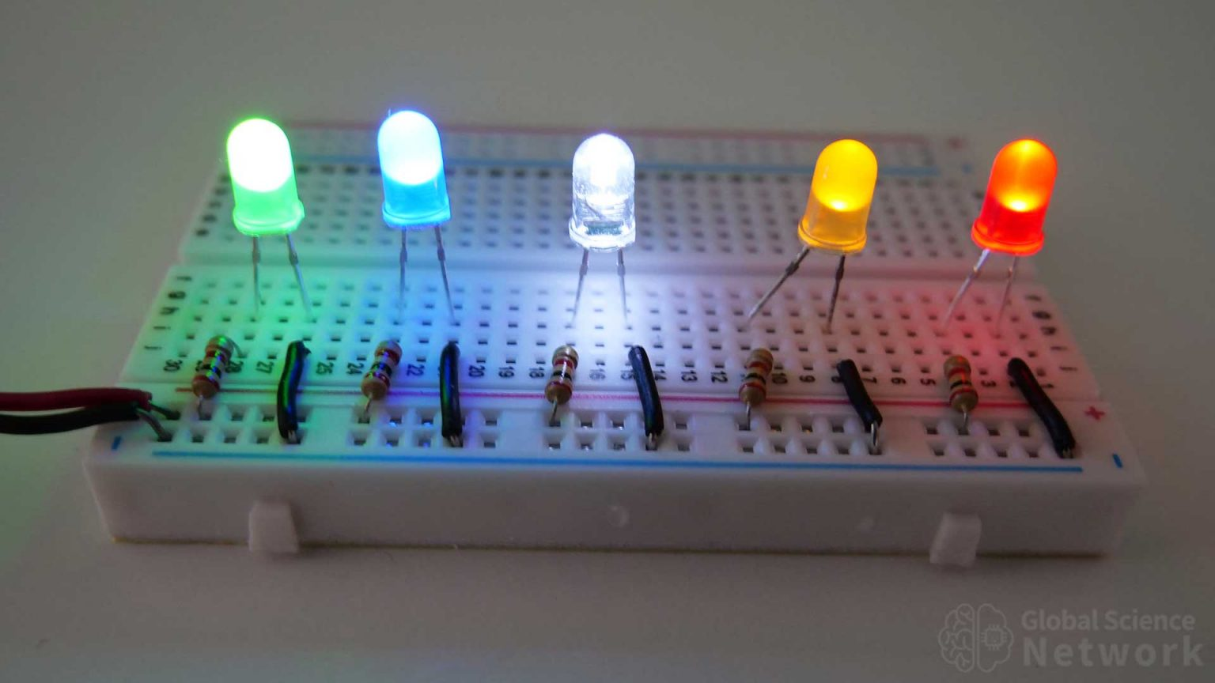

Episode 09: **Electronic Basics #9: Diodes & Bridge Rectifiers**

Video Summary: **The Role and Application of Diodes**

This video provides a foundational understanding of diodes, explaining their importance in electronics, how they function, and demonstrating their key applications in both DC and AC circuits. It covers reverse polarity protection and the conversion of AC to DC (rectification).

Key Instruments & Components Used:

* **Instruments:**
  + **Bench Power Supply:**ELV 7000 (used to power DC circuits)
  + **Digital Multimeter (DMM):**UNI-T UT61D (used to measure voltage and implied current)
  + **Oscilloscope:**Rigol (used to visualize AC and rectified DC waveforms)
  + **Soldering Iron:**(Used to attach a diode for protection)
  + **Calculator:** Texas Instruments TI-83 Plus (used for power and RMS calculations)
* Components:
  + **Diodes:** Various types including standard rectifier (e.g., 1N4007), larger power diodes, SMD diodes.
  + **LEDs (Light Emitting Diodes):**Used in the blinker circuit and as a general example.
  + **555 Timer IC:**Heart of the LED blinker circuit.
  + **Resistors:**Current limiting and timing in circuits.
  + **Capacitors (Electrolytic):**Timing in the blinker circuit and smoothing in rectifier circuits.
  + **Potentiometers:** Variable resistors for adjusting the blinker circuit.
  + **Transformer:**ZERMIN, Köln (220V AC to 15V AC) – used for AC source.
  + **Breadboard:** For prototyping circuits.
  + **Banana Pi:**Shown as an example of consumer electronics containing SMD diodes.
  + **AC/DC Adapters:**Disassembled to show internal diodes.

Part 1: Diodes in DC Circuits – Reverse Polarity Protection

* **Concept:** Diodes act as one-way valves for electrical current, protecting circuits from damage if power is connected with incorrect polarity.

**Key Takeaway:** Diodes are essential for safeguarding DC circuits against accidental reverse power connection. The forward voltage drop and power dissipation in the diode must be considered, especially with higher currents (requiring larger, more robust diodes).

Part 2: Diodes in AC Circuits – Rectification (AC to DC Conversion)

* **Concept:**Diodes are fundamental to converting Alternating Current (AC), where current direction periodically reverses, into Direct Current (DC), where current flows in one direction.
* **Key Takeaway:**Bridge rectifiers are more efficient for AC to DC conversion as they utilize the full AC waveform. Capacitors are crucial for smoothing the rectified output.

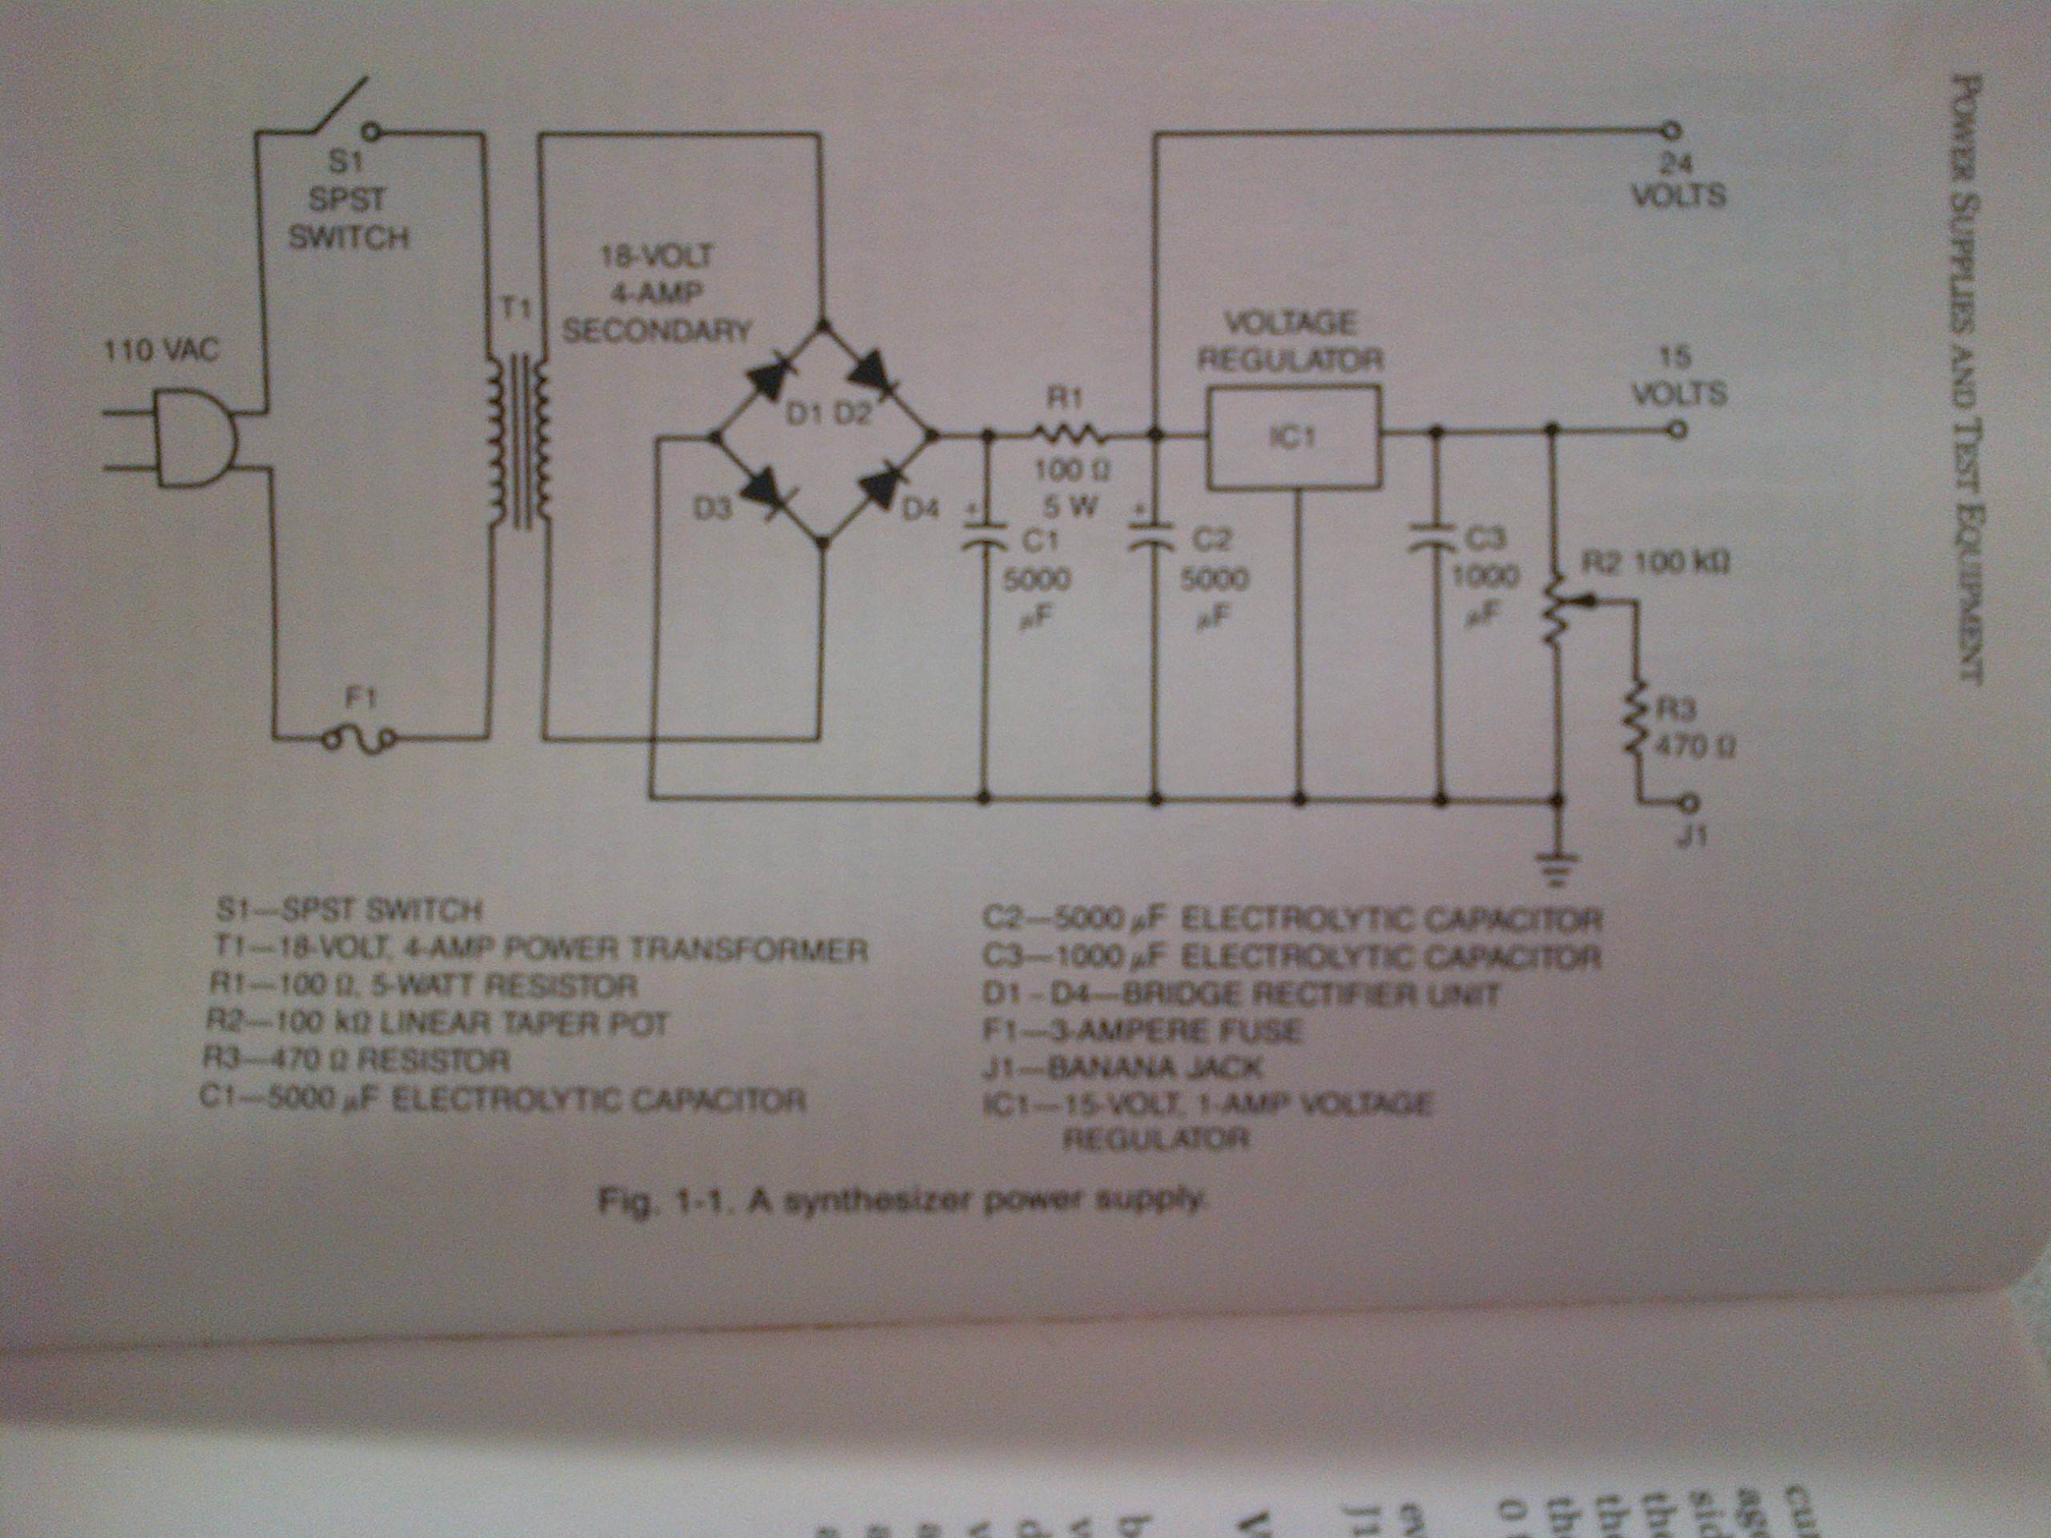

[This Photo](http://electronics.stackexchange.com/questions/37401/how-are-bridge-rectifiers-rated) by Unknown Author is licensed under [CC BY-SA](https://creativecommons.org/licenses/by-sa/3.0/)

**Diodes & Bridge Rectifier**

Episode 10: Electronic Basics #10: Digital to Analog Converter (DAC)

Headline: Method 1: DIY DAC with an R-2R Resistor Ladder

This is a fundamental way to build a DAC using basic components.

Key Points:

* **Concept:**Uses a network of resistors with two values: R and 2R (e.g., 10kΩ and 20kΩ). This forms a voltage divider.
* **Implementation:**
  + **Microcontroller (Arduino Nano):** Provides the digital input signals. An 8-bit DAC is demonstrated using 8 digital output pins (D0-D7).
  + **Resistors:** 10kΩ (R) and 20kΩ (2R) resistors are used to build the ladder on a breadboard.

**Software:** Arduino code is used to send digital values (0-255) to the PORTD register (controlling digital pins D0-D7) to generate different waveforms (ramp, triangle, sine).

Headline: Method 2: PWM & LC Filtering for Pseudo-Analog Output

**Key Points:**

* **Concept:** analogWrite () generates a Pulse Width Modulation (PWM) signal, not a true analog voltage.
* **PWM:** A digital square wave where the "duty cycle" (ratio of on-time to total period) is varied. The *average* voltage of a PWM signal corresponds to an analog level.

Instrument Used:

**Oscilloscope:** Shows the initial PWM signal and the smoothed analog output after the LC filter.

**Arduino Nano:** Generates the PWM signal.

**Inductor (Coil) & Capacitor:** Form the LC low-pass filter.

Headline: Method 3: Dedicated DAC Integrated Circuits (ICs)

**Key Points:**

* **R-2R based IC:**
  + **DAC0800:** An example of an 8-bit DAC IC that internally uses an R-2R ladder.

**I²C (Inter-Integrated Circuit) based DACs:**

* + - **Uses:** Arduino pins A4 (SDA) and A5 (SCL) for I²C communication.
  + **MCP4725:**A 12-bit DAC module (from Adafruit).
    - **Uses:**Arduino pins A4 (SDA) and A5 (SCL) for I²C communication. Offers higher resolution (2¹² = 4096 steps).
* **Advantages:**More accurate, smaller, often includes buffering.

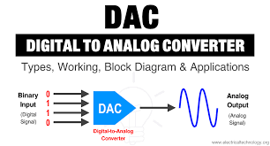

**Digital to Analog Converter (DAC)**

Episode 11: Electronic Basics #11: Sending SMS with Arduino || TC 35 GSM Module

Overview: Siemens TC35 GSM Module for SMS Projects

The video demonstrates how to set up and use a Siemens TC35 GSM module breakout board to send SMS messages, primarily using an Arduino Uno. It covers initial setup, power considerations, communication methods, and provides a practical example.

**1. The TC35 GSM Module & Breakout Board**

* Main Component: Siemens TC35 GSM Module.
  + Chosen for reliability from a known brand (Siemens).
* Breakout Board:
  + Includes necessary support circuitry like a SIM card holder, antenna connector, power input, status LEDs, and an RS232 interface (MAX232 IC).
  + Features a DC power jack and pin headers for VCC/GND.
  + Has an onboard AMS1117 voltage regulator to provide 3.3V to the TC35 module itself.

**2. Essential Setup & Peripherals Used**

* SIM Card:
  + A standard-sized SIM card is required.
  + Crucial Step: The SIM card's PIN lock *must be disabled* first by inserting it into a mobile phone and turning off the PIN request in the phone's security settings.
  + A prepaid SIM is recommended.
* Power Supply:
  + The board can be powered via its DC jack or dedicated VCC/GND pins.

Antenna: An external GSM antenna is connected to the board's antenna port.

**3. Communication & Control**

* Communication Protocol: AT Commands.
* Logic Levels: The TC35 module uses 3.3V logic levels but is generally 5V tolerant for it’s I/O pins, making it compatible with 5V microcontrollers like the Arduino Uno.
* **A) With a PC (via FTDI Breakout):**
  + **Instrument Used:**FTDI (USB to Serial TTL) breakout board.
  + **Software:** Arduino IDE's Serial Monitor.
  + **Serial Settings:**9600 baud, "Carriage Return" line ending.

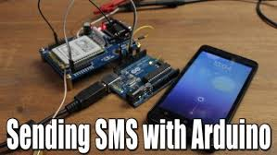

Episode 12: Electronic Basics #12: Coils / Inductors (Part 1)

This video provides a foundational understanding of inductors (coils), one of the most important basic passive components in electronics, alongside resistors and capacitors. It demonstrates their properties and common applications through various experiments and explanations.

Key Instruments & Their Usage

**Oscilloscope (Rigol DS1052E):**

**Used to observe/visualize:**

Voltage waveforms (e.g., mains AC sine wave, square waves from function generator).

The current waveform in an inductor (showing lag behind voltage in DC switching).

Voltage induced by a human body acting as an antenna.

**Function Generator (ASCEL Electronic AE20125):**

**Used to generate:**

Square wave signals for testing inductor behavior in DC switching circuits.

AC signals for demonstrating transformer operation.

**Bench Power Supply (Custom-built unit with digital Volts/Amps display):**

**Used to provide:**

Controlled DC current and voltage to inductors, wires, and electromagnets.

Power for breadboard circuits

**Current Clamp Meter (UNI-T UT210E):**

**Used to measure:**

The current flowing through a wire by sensing its magnetic field, non-intrusively.

**RLC Meter (ELV Digital - RLC Meter, RLC 9000):**

**Used to measure:**

The inductance value (in Henrys) of various coils.

**Multimeter (Red, UNI-T model):**

**Used to measure:**

Voltage output of a boost converter circuit.

Input voltage from a battery to the boost converter.

Core Concepts of Inductors Explained

**Electromagnetism:**

Current flowing through a wire creates a magnetic field around it.

The strength of the magnetic field is proportional to the current.

Coiling a wire concentrates and strengthens this magnetic field.

Adding a ferromagnetic core (like iron) dramatically enhances the magnetic field, creating an electromagnet.

**Inductance (L):**

The property of a coil that determines how much magnetic field it generates for a given current.

Measured in Henrys (H).

Depends on the coil's dimensions, number of windings, and core material.

Current through an inductor lags behind the voltage.

**Energy Storage:**

Inductors store energy in their magnetic field.

Energy (W) = (L \* I²) / 2.

This stored energy can be released back into the circuit.

This "inductive kickback" can damage switching components like transistors.

**Protection:** A flyback diode (or freewheeling diode) is placed in parallel with the inductive load to provide a path for the current to flow when the switch opens, dissipating the energy safely and clamping the voltage spike.

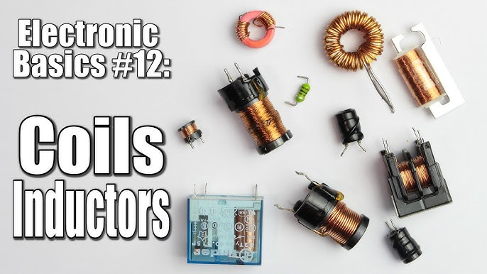

Episode 13: Electronic Basics #13: Coils / Inductors (Part 2) || Reactance

Key Concepts: Inductive Reactance & Applications

* **Inductors Limit AC Current:**An inductor in an AC circuit limit current not just by its DC resistance, but primarily by its **inductive reactance**
* **Inductive Reactance:**
* It's a form of AC resistance offered by an inductor.
* It's directly proportional to both frequency and inductance.
* Higher frequency or higher inductance leads to higher reactance and thus less current flow.
* Lower frequency or lower inductance leads to lower reactance and more current flow.
* Unlike resistance, reactance doesn't primarily dissipate power as heat; instead, energy is stored in the magnetic field and returned to the circuit.
* **Reactive Power (Q):**Due to energy storage and release, power oscillates between the source and the inductive load. This is called reactive power.
* **Phase Shift:**In an AC circuit with an inductor, the current waveform lags behind the voltage waveform. This difference is the phase shift, which can be up to 90° for a purely inductive load.
* Applications of Inductors (due to reactance):
  + **Filters:**Used to create high-pass filters (blocking low frequencies, passing high) or low-pass filters (blocking high frequencies, passing low) by exploiting the frequency-dependent nature of reactance.
  + **Current Limiting:**Used to safely limit AC current, as demonstrated with the LED.

Instruments & Their Demonstrations

1. **Oscilloscope (Rigol DS1052E - Digital Oscilloscope)**
   * **What it's used with/for:**
     + Visualizing the sine wave output of a transformer (Voltage vs. Time).
     + Showing how changing the inductor's core (and thus its inductance) affects the phase shift.
     + Visualizing the output of the function generator and the effect of changing frequencies on the circuit with the inductor and LED.
2. **Multimeter (UNI-T UT61D - Digital Multimeter)**
   * **What it's used with/for:**
     + Measuring the **RMS AC current** flowing through the LED when powered by the transformer, both with and without the series inductor.
     + Measuring the low **DC resistance** of the 1 Henry inductor coil
3. **ELV Digital RLC Meter (RLC 9000)**
   * **What it's used with/for:**
     + Precisely measuring the **inductance (L)** of the large, self-made 1 Henry coil.
     + Measuring capacitance (shown briefly measuring a capacitor).
4. **Function Generator (ASCEL AE20125 - 10 MHz Function Generator)**
   * **What it's used with/for:**
     + Providing a variable frequency AC sine wave signal.
     + Demonstrating how the inductor's reactance
5. **"Transistor Tester" / LCR Component Tester (e.g., SainSmart Mega328 based)**
   * **What it's used with/for:**
     + An inexpensive alternative to a dedicated RLC meter.
     + Measuring the **inductance** of the large 1 Henry coil (showed 1.10H).
     + Measuring the inductance of a smaller toroidal coil (showed 0.08mH for an 80.6µH coil).
     + Measuring **capacitance** (e.g., 4710µF capacitor).
     + Testing and identifying **transistors** (e.g., PNP, showing pinout ECB and gain B=257).
     + Testing **diodes** (showing forward voltage and capacitance).
6. **Other Components Used in Demonstrations:**
   * **Transformer (230V to 15V RMS):**Power source for initial LED experiments.
   * **1 Henry Inductor (self-made with iron core):** Main component for demonstrating inductive reactance and phase shift.
   * **LEDs (Red, Yellow, Blue/Clear):**Visual indicators of current flow.
   * **Resistors:**Used in series with the LED (for comparison to inductor) and in the LTSpice filter simulations.
   * **Breadboard & Jumper Wires:**For constructing test circuits.
   * **MP3 Player:**As an audio source for the N-channel MOSFET high-frequency detection circuit.
   * **N-Channel MOSFET:**Used in a simple circuit to demonstrate filtering/detecting high-frequency audio signals.
   * **Microwave Synchronous Motor:**Used as an example of an inductive load exhibiting phase shift.

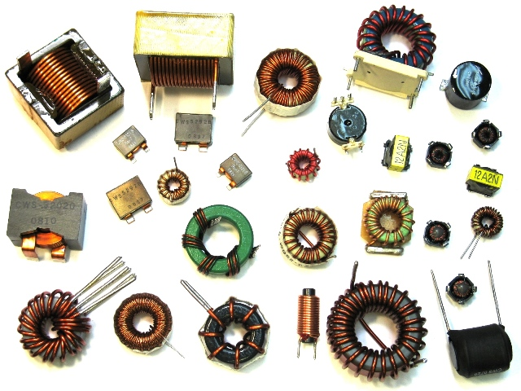

Inductor

Episode 14: Electronic Basics #14: Capacitors

Tools & Equipment Used in Demonstrations

* **Oscilloscope:**Rigol DS1052E (used to visualize voltage and current waveforms, phase shifts, charging/discharging curves).
* **Function Generator:**Ascel AE20125 (used to generate various AC and DC signals like square waves and sine waves at different frequencies).
* **Bench Power Supply:**DPS 7000 Double Power Supply (used to provide DC voltage for charging capacitors and powering circuits).
* **RLC Meter:**ELV Digital RLC-Meter RLC 9000 (used to measure capacitance values directly).
* **Digital Multimeter (DMM):**UNI-T UT61D (used to measure voltage and AC current).
* **Soldering Iron:**Used for repairing the monitor and connecting components.
* **Breadboard:** For quickly assembling and testing circuits.
* **Other Components:**Resistors, LEDs, various types of capacitors, transformer, microwave oven motor.
* **Hand Tools:**Screwdrivers, pliers, clamps, ruler, marker.

Capacitor Ratings, Properties & Safety

* **Capacitance:** Measured in Farads (F). Common units are microFarads (µF), nanoFarads (nF), and picoFarads (pF). This indicates how much charge the capacitor can store per unit of voltage.
* **Voltage Rating:**The maximum voltage the capacitor can safely withstand. Exceeding this can cause the dielectric to break down, leading to a short circuit, sparking, or even the capacitor exploding.
* **Polarity (Electrolytic Capacitors):**Many capacitors (especially electrolytic ones) are polarized and must be connected with the correct polarity (+ to +, - to -). Reversing polarity can destroy them (demonstrated with a capacitor smoking).
* **Energy Storage Comparison:** Capacitors store significantly less energy than batteries of similar size.

Capacitor Behavior & Applications in Circuits

* **DC Circuits (Direct Current):**
  + **Charging/Discharging:**The voltage across a capacitor cannot change instantaneously. It charges and discharges exponentially over time, especially when a resistor is in series (RC circuit). The current is initially high and decreases as the capacitor charges.
  + **Blocking DC:** Once fully charged, a capacitor acts like an open circuit to DC, blocking further steady current flow.
  + **Smoothing/Decoupling:**Used to stabilize voltage levels, smooth out ripples in power supplies, and decouple ICs from power supply noise.
* **AC Circuits (Alternating Current):**
  + **Passing AC:**Capacitors allow AC signals to pass through, but they offer opposition called "capacitive reactance" (Xc).
  + **Capacitive Reactance (Xc):** Inversely proportional to both frequency (f) and capacitance (C). Formula: Xc = 1 / (2πfC).
    - Higher frequency or higher capacitance = lower reactance (easier for AC to pass).
    - Lower frequency or lower capacitance = higher reactance (harder for AC to pass).
  + **Phase Shift:**In an AC circuit, the current through a capacitor leads the voltage across it.
  + **Power Factor Correction:**An inductive load (like a motor) causes current to lag voltage. A capacitor can be added in parallel to create a leading current, compensating for the lag and improving the power factor, which reduces strain on the power grid. (Demonstrated with a microwave motor).

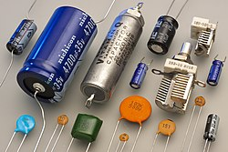

**Capacitors**

**Episode 15:** **Electronic Basics #15: Temperature Measurement (Part 1) || NTC, PT100, Wheatstone Bridge**

* Context:**The video starts by highlighting the importance of accurate temperature measurement, especially in 3D printing (nozzle, heated bed), but also in many industrial and consumer applications.**
* Goal:**To explain different methods of temperature measurement and demonstrate building a relatively accurate DIY thermometer.**

Temperature Sensors Explained

1. **NTC Thermistors (Negative Temperature Coefficient)**
   * **Component Name:**NTC Thermistor.
   * **Principle:**Resistance *decreases* as temperature *increases*.
   * **Used with:** Multimeter (for resistance reading), microcontrollers (with voltage dividers and lookup tables/formulas).
2. **RTD (Resistance Temperature Detector) - PT100**

* **Component Name:** RTD, specifically PT100 (Platinum, 100Ω at 0°C).
* **Principle:** Resistance increases as temperature increases.
* **Used with:**Specialized measurement circuits due to small resistance changes.

DIY PT100 Measurement Challenges & Solutions

1. **Basic Principle:**
   * Pass a small, stable constant current through the PT100.

* **Instrument/Component:**LM317 voltage regulator used as a constant current source.
  + Measure the voltage drop across the PT100.
  + **Calculate resistance (Ohm's Law:** R = V/I), then use the PT100 formula to find temperature.

1. **Challenges:**

**Voltage Offset:** The PT100 has a base resistance (100Ω at 0°C), creating a significant voltage offset.

**Low Sensitivity:** Small change in voltage per degree Celsius, making it difficult for standard ADCs to resolve small temperature differences accurately without amplification.

1. **Solutions (Offset Removal & Amplification):**

**Differential Op-Amp Circuit:**

**Instrument/Component:** Operational Amplifiers (Op-Amps, e.g., LM358 or similar).

**Uses:** One input measures PT100 voltage, the other measures a reference voltage (equal to PT100's 0°C voltage). The Op-Amp subtracts the offset and can then amplify the difference. Requires precision resistors.

**Wheatstone Bridge:**

**Instrument/Component:** Resistors (precision matched) and the PT100.

**Uses:** Balances out the 0°C offset. The output voltage difference is then amplified (e.g., by another Op-Amp circuit). Also requires precision components.

**Precision Potentiometers:** Often needed for fine-tuning these circuits.

**Component Name:** 10-turn precision potentiometer.

Simplified PT100 Measurement: Transmitter Modules

* **Component Name:**PT100 Temperature Transmitter (example shown is a blue, puck-shaped industrial module).
* **Principle:** An integrated circuit that conditions the PT100 signal and outputs a standardized signal, often a 4-20mA current loop.
* Alternative Integrated Temperature Sensor ICs
* **LM35**
* **Component Name:** LM35 Precision Centigrade Temperature Sensor.
* **Principle:** Outputs a voltage linearly proportional to Celsius temperature (10mV/°C).
* **Characteristics:** Calibrated directly in Celsius, good accuracy (±0.5°C), limited range (e.g., 2°C to 150°C).
* **Used with:** Direct connection to a microcontroller's ADC.
* **DS18B20**
* **Component Name:** DS18B20 Digital Thermometer.
* **Principle:** Provides temperature readings via a 1-Wire digital interface.
* **Characteristics:** Good accuracy (±0.5°C), user-selectable resolution (9-12 bits), moderate range (e.g., -55°C to +125°C).
* **Used with:** Microcontroller (using a 1-Wire library).

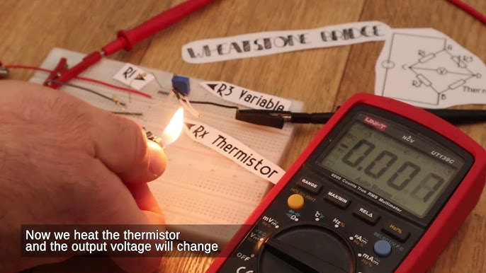

**Temperature Measurement**

Episode 16: Electronic Basics #16: Resistors

Key Component: Resistor

* **Variations Discussed:**
  + Fixed Resistors (various power ratings: 1/4W, power resistors)
  + Potentiometers (variable resistors)
  + Photoresistors (LDR - Light Dependent Resistor)
  + Thermistors (e.g., PT100)
  + Strain Gauges
  + Current Shunt Resistors

**Instruments & Tools Used:**

* Soldering Iron
* Breadboard & Perfboard
* Digital Multimeter (DMM) - for measuring voltage, current, resistance
* Bench Power Supply
* Oscilloscope (Rigol DS1052E)
* Function Generator (ASCEL AE20125)
* Component Tester (LCR Meter / Transistor Tester)
* Variac / Isolation Transformer (for AC tests)

Applications of Resistors:

**1. Basic Current Limiting (e.g., for LEDs)**

* **Purpose:** To limit the flow of current to prevent damage to components like LEDs that have specific voltage and current requirements.

**2. Resistor Power Rating**

* **Purpose:**Resistors have a maximum power they can safely dissipate (e.g., 1/4 Watt). Exceeding this causes them to overheat and burn out.

**3. Voltage Dividers**

* **Purpose:**To create a specific, lower output voltage from a higher input voltage.

**Application:** Logic level shifting (e.g., converting 5V Arduino signals to 3.3V for an ESP8266 Wi-Fi module).

**4. Potentiometers (Variable Resistors)**

* + **Purpose:** To provide an adjustable resistance, often used as an adjustable voltage divider.

**Applications:**

* Analog input for microcontrollers (e.g., Arduino ADC).
* Adjusting voltage at an op-amp input.
* Volume control, brightness control, etc.

**5. Pull-up and Pull-down Resistors**

* **Purpose:** To ensure a digital input pin is at a defined logic level (HIGH or LOW) when it's not actively being driven by a switch or sensor. Prevents a "floating" input.

**6. Current Sensing (Shunt Resistors)**

* **Purpose:** To measure the current flowing through a circuit.
* **Application:** Building constant current sources/loads, ammeters, power monitoring.

**7. Sensor Applications (Resistive Sensors)**

* **Photoresistors (LDR):**Resistance changes with light intensity.
* **Thermistors (e.g., PT100):**Resistance changes with temperature.
* **Strain Gauges:**Resistance changes with physical strain or deformation (used in load cells for weighing).
* **Fuses:** Essentially resistors designed to burn out (go open circuit) when current exceeds a certain limit, protecting the circuit.

**8. Resistors in AC Circuits & Parasitic Effects**

* **Ideal Behavior:**In an ideal AC circuit, resistors do not cause a phase shift between voltage and current, unlike capacitors and inductors.
* **Real-World (High Frequency):**Real resistors exhibit "parasitic" capacitance and inductance due to their physical construction.
  + At very high frequencies, this parasitic capacitance can dominate, causing the resistor's impedance to decrease as frequency increases, leading to higher current flow than expected.

**9. Parasitic Resistance in Other Components**

* **Concept:**No electronic component is perfectly ideal.

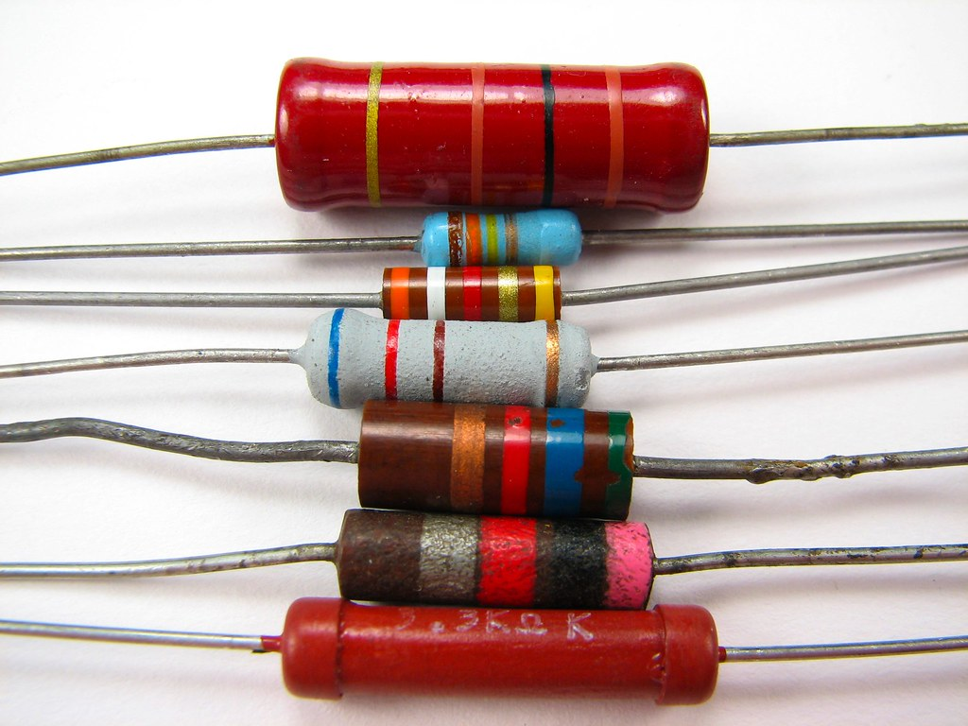

[This Photo](https://www.flickr.com/photos/oskay/437342078) by Unknown Author is licensed under [CC BY](https://creativecommons.org/licenses/by/3.0/)

Resistors

Episode 17: Electronic Basics #17: Oscillators || RC, LC, Crystal

Video Summary: Understanding Oscillators

**Overall Goal:**The video explains what oscillators are, why they are important in electronics, and demonstrates how to build and understand different types of common oscillator circuits.

What are Oscillators and Why Do We Need Them?

* **Definition:** Oscillators are electronic circuits that produce a periodic, oscillating electronic signal, often a sine wave, square wave, or triangle wave.
* **Purpose/Use Cases:**
  + **Timing/Clock Signals:**Determine the speed of microcontrollers (e.g., Arduino), refresh rate of multimeters, and the ticking of quartz watches.
  + **Waveform Generation:**Create specific waveforms for testing or signal processing (e.g., by a Function Generator).
  + **Radio Communication:**Generate carrier waves for transmitting data wirelessly (e.g., RF modules, Wi-Fi modules).
* Instruments Used to Observe/Create Oscillations:
  + **Oscilloscope (e.g., Rigol DS1052E):**Visualizes voltage signals over time, showing their waveform, frequency, and amplitude. Used to see the output of all demonstrated oscillators.
  + **Function Generator (e.g., ASCEL AE20125):**An instrument that can produce various standard waveforms (sine, square, triangle) at different frequencies and amplitudes. Used to demonstrate these basic waveforms.
  + **Multimeter:** Its display refresh rate is controlled by an internal oscillator.

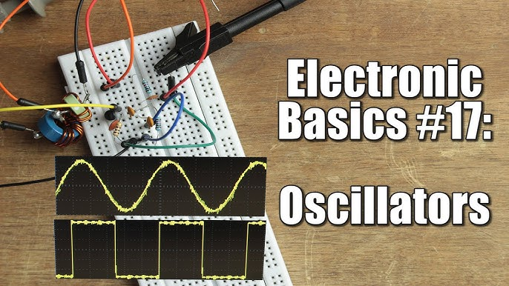

**Oscillators || RC, LC, Crystal**

Episode 18: Electronic Basics #18: DC & Brushless DC Motor + ESC

I. Introduction & Purpose

* The video aims to explain how Brushless DC (BLDC) motors and Electronic Speed Controllers (ESCs) work, building on previous projects like an electric longboard.
* These systems are common in electric vehicles, quadcopters, DVD drives, and hard disks.

II. Brushed DC Motors (For Comparison)

* **Principle:**Use direct current (DC) to create rotary motion.
* **Key Components (identified via teardown):**
  + **Stator:** Stationary part; consists of permanent magnets with opposing polarities.
  + **Rotor (Armature):**Rotating part; consists of multiple copper wire coils.
  + **Commutator:**A segmented copper cylinder on the rotor shaft; connects coils to brushes.
  + **Carbon Brushes:**Conductive blocks that press against the commutator, delivering power from the DC source to the rotor coils and mechanically switching polarity as the rotor turns.

**III. Brushless DC (BLDC) Motors**

* **Principle:** Similar magnetic interaction principle, but commutation is done electronically by an ESC, eliminating brushes and mechanical commutator.
* **Key Components (identified via teardown of "BEAST X528 3Y KV520" motor):**
  + **Stator:** Stationary part; consists of multiple (e.g., 12 in the large motor, 6 in a simplified diagram) copper wire coils, often arranged in a "Star" (Y) or "Delta" configuration. The "3Y" in the motor name indicates a 3-phase Y-connection. The metal motor casing often acts as a **heatsink**.
  + **Rotor:** Rotating part; consists of permanent magnets with alternating opposing polarities (e.g., 4 in the large motor).

IV. Electronic Speed Controller (ESC)

* **Function:** The "electronic commutator" for BLDC motors. It controls the speed and direction of the motor by precisely timing the energizing of the motor's stator coils.

**Key Internal Components:**

**MOSFETs (P-channel and N-channel):**Power transistors used in an H-bridge like configuration (3 half-bridges for 3-phase motors) to switch current to the motor coils. The number of parallel MOSFETs per phase determines the ESC's current handling capacity.

**Microcontroller:** Processes the input signal and controls the MOSFETs.

**Capacitors:** Smooth out the power supply.

**Heatsink & Fan:**For cooling, especially on higher power ESCs.

* **Inputs:**

**Power Input:**From a battery (e.g., LiPo).

**Control Input:**Typically, a PWM (Pulse Width Modulation) signal (e.g., from an RC receiver, Arduino, or joystick). The duration of the pulse determines the desired motor speed.

* **Outputs:**
  + **3-Phase Output (A, B, C):** Connect to the three wires of the BLDC motor. The ESC creates a sequence of High, Low, and Floating states on these outputs.

**Control Mechanism:**

* + The ESC varies the *frequency* at which it cycles through the coil energizing sequence. Higher frequency = higher RPM.
  + Pulse Width Modulation (PWM) is also used on the output phases to regulate the *effective voltage* and thus current/torque.

**Instruments/Tools Used:**

**Oscilloscope (RIGOL DS1052E):**

* + - To visualize the PWM input signal from a joystick.
    - To observe the complex 3-phase output waveforms (modified sine/trapezoidal) being sent to the motor coils.
    - To measure the frequency of the output waveform.

**Joystick Module / Arduino Nano (implied):**To generate the PWM control signal for the ESC.

**USB Linker (SKYLink):**To connect the ESC to a PC for programming various parameters (running mode, brake, timing, throttle curve, overheat protection, etc.) using dedicated software.

**Clamp Meter (UNI-T UT210E):**To measure the current drawn by the motor/ESC system.

**Digital Tachometer (HoldPeak HP-7236C):**To measure the RPM (Revolutions Per Minute) of the motor.

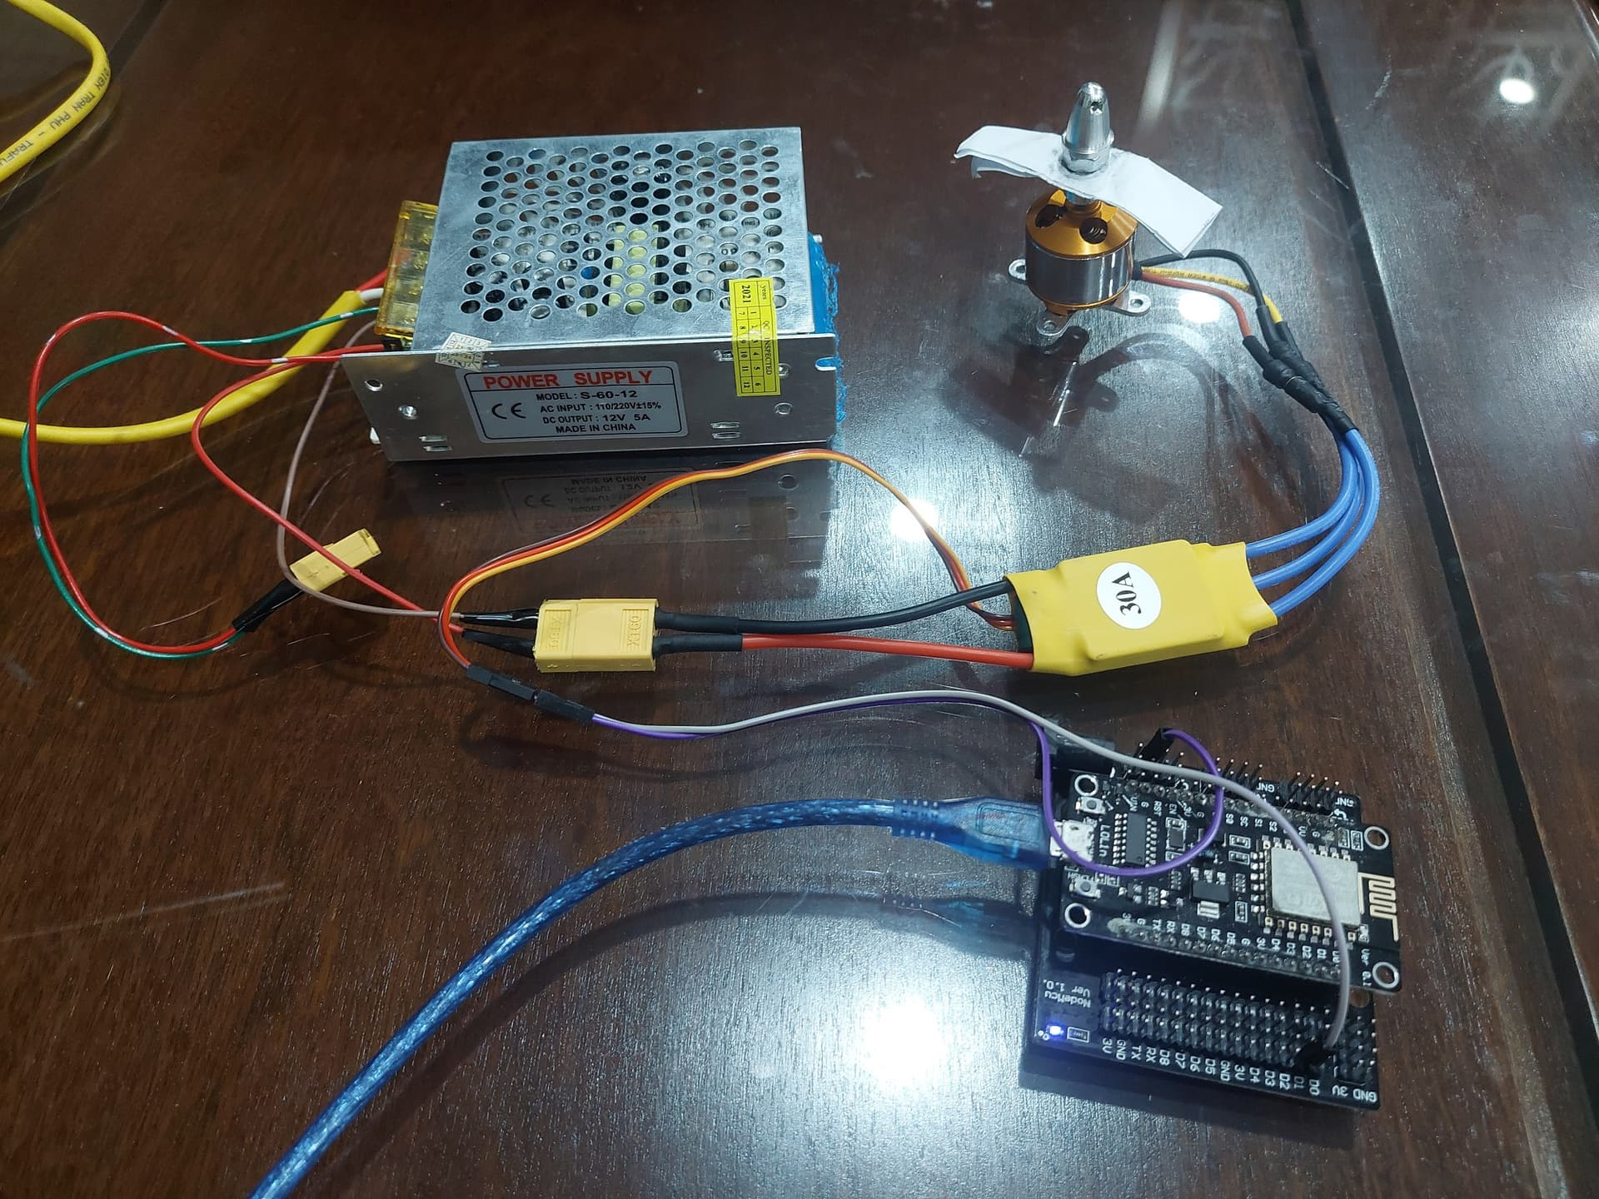

**DC & Brushless DC Motor + ESC**

Episode 19: Electronic Basics #19: I2C and how to use it

I²C Communication Explained: Building an Arduino FM Radio (TEA5767)

**1. Introduction to I²C (Inter-Integrated Circuit)**

* **What it is:**A popular, synchronous, serial communication protocol, also known as TWI (Two-Wire Interface).
* **Purpose:** Allows one or more master devices (e.g., Arduino) to communicate with up to 112 slave devices (ICs like sensors, expanders, etc.) using just two wires.
* **Wires:**
  + **SDA (Serial Data):**Carries the actual data.
  + **SCL (Serial Clock):** Synchronizes data transfer.

**2. Project Goal: Arduino FM Radio using I²C**

* To demonstrate I²C communication by building a functional FM radio.
* The Arduino Nano acts as the **master** device.
* The **TEA5767HN FM Radio IC** acts as the **slave** device.
* The project involves sending commands to the TEA5767 to tune to a specific radio frequency and receiving status data back.

**3. Key Components & Instruments Used**

* **Master Device:**Arduino Nano (ATmega328P based).
* **Slave Device:**TEA5767HN FM Radio IC module (or bare IC).
* **Testing Instrument:**
  + **Oscilloscope:**Rigol DS1052E (used to visualize I²C signals).
  + **Multimeter:** Metra hit Pro (used to check voltage levels).
* **Prototyping Tools:**
  + Breadboard.
  + Jumper wires.
  + Stripboard/Perfboard (for creating a breakout board for the TEA5767).
  + Soldering iron, solder, hot glue gun, craft knife, drill bit.
* **Essential Passive Components:**
  + **Pull-up Resistors:**Two 10 kΩ resistors (one for SDA, one for SCL).
  + **Capacitors:**(Implicitly used on modules, 100nF shown in hand-drawn schematic for audio output filtering).
* **Audio Output:**
  + Headphones.
  + Audio Amplifier Module (a small blue board, likely a PAM8403 or similar, is shown).
  + Speaker.
* **Software:**
  + Arduino IDE.
  + Datasheets for ICs.
  + Online Decimal to Binary/Hexadecimal converters.

**4. Hardware Assembly & Wiring**

* **Breakout Board for TEA5767:**
* The TEA5767 IC is often a small surface-mount device. A breakout board was created using a small piece of stripboard.
* Male pin headers were soldered for breadboard compatibility.
* Copper traces were cut to isolate pins.
* The IC was hot-glued and then hand-wired to the headers using silvered copper wire.
* **I²C Wiring to Arduino Nano:**
  + **SDA (Serial Data):**TEA5767 SDA to Arduino Nano A4.
  + **SCL (Serial Clock):** TEA5767 SCL to Arduino Nano A5.
  + **Power:**TEA5767 VCC to Arduino 5V, TEA5767 GND to Arduino GND.
* **Pull-up Resistors:**
  + A 10 kΩ resistor connects the SDA line to 5V.
  + A 10 kΩ resistor connects the SCL line to 5V.
  + ***Reason:***I²C devices typically have open-collector/open-drain outputs, meaning they can only pull the line LOW (to GND). The pull-up resistors keep the lines HIGH when no device is pulling them low, enabling proper signaling.

**Audio Output & Antenna:**

* + The L/R audio outputs from the TEA5767 were connected to headphones (and later to an amplifier and speaker).
  + A simple wire was used as an antenna.

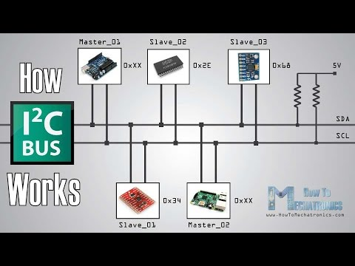

**I2C and how to use it**

**Episode 20:** **Electronic Basics #20: Thyristor, Triac || Phase Angle Control**

Instruments and Key Components Used in Demonstration

* **Main Semiconductor Devices:**
  + **Thyristor (e.g., TYN604)**
  + **Triac (e.g., TIC216M)**
  + **MOSFET (for DC turn-off demo)**
  + **Diodes (in rectifiers)**
* **Control & Isolation:**
  + **Arduino Nano (microcontroller)**
  + **Optocouplers (e.g., 4N25 for zero-crossing, MOC3020 for Triac drive)**
  + **Potentiometer (for user input)**
* **Loads:**
  + **LEDs**
  + **Incandescent Light Bulb**
* **Power & Measurement Equipment:**
  + **DC Power Supply**
  + **Autotransformer (Variac) for safe, variable AC voltage**
  + **Oscilloscope (for visualizing waveforms, voltage, current, power factor)**
  + **Multimeter (for voltage, current measurements)**
  + **Function Generator (for generating test signals)**
  + **Thermal Camera/IR Thermometer (to show heat generation)**
* **Passive Components:**
  + **Resistors**
  + **Breadboard & Jumper Wires**
  + **Heatsink**

Introducing the Thyristor: The Controllable Diode

* **Core Component: Thyristor (Silicon Controlled Rectifier - SCR)**
* **Purpose: Acts like a diode (allows current in one direction) but with an added "Gate" terminal that controls *when* it starts conducting.**
* **Structure vs. Diode:**
  + **Diode: 2 semiconductor layers (P-N), Anode (+), Cathode (-).**
  + **Thyristor: 4 semiconductor layers (P-N-P-N), Anode (+), Cathode (-), and a Gate (G) for control.**

AC Application: The Triac and Phase Angle Control

* **Problem with Single Thyristor in AC: Acts as a half-wave rectifier and turns OFF at every zero-crossing of the AC waveform.**
* **Solution for Full AC Control:**
  + **Two thyristors in an inverse-parallel configuration.**
  + **Core Component for AC: Triac (essentially two thyristors integrated into one package for bidirectional AC control), with Main Terminal 1 (MT1), Main Terminal 2 (MT2), and a Gate (G).**
* **Phase Angle Control Circuit Concept:**
  + **Zero-Crossing Detection: A circuit (e.g., full-bridge rectifier + optocoupler like 4N25) detects when the AC waveform crosses zero volts. This signal is fed to a microcontroller.**
  + **Microcontroller (Arduino Nano): Receives the zero-crossing signal as an interrupt.**
  + **Delay Timing: Based on an input (e.g., potentiometer), the Arduino calculates a delay after the zero-crossing.**
  + **Triac Triggering: After the delay, the Arduino sends a pulse (via another optocoupler like MOC3020 for isolation and Triac driving) to the Gate of the Triac.**
  + **Power Regulation: The Triac turns ON for the remainder of that AC half-cycle. By varying the delay, the amount of power delivered to the load (e.g., a light bulb) is controlled, effectively dimming it. This repeats for both positive and negative half-cycles.**

**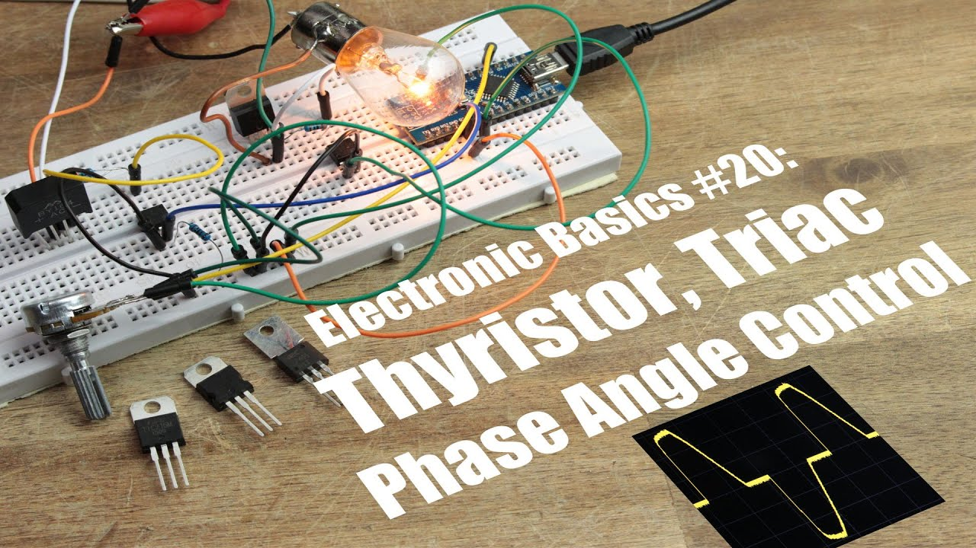**

**Thyristor, Triac || Phase Angle Control**

Episode 21: Electronic Basics #21: OpAmp (Operational Amplifier)

Introduction: What is an Op-Amp?

* **Component Name:**Operational Amplifier (Op-Amp)
* **Symbol:**A triangle in schematic diagrams.
* **Purpose:** A versatile analog integrated circuit (IC) used for a wide range of signal conditioning tasks like amplification, filtering, comparing, and mathematical operations.

**Common ICs shown/mentioned:**

NE5532 (inside an IC socket on a perfboard)

PCF8591 (on a breakout module)

DAC0800LCN (bare IC)

LM358 (primary example used for demonstrations)

TL084CN, TL082CN, UA741CN (examples of Op-Amp ICs)

LM6142, MCP602 (examples of Rail-to-Rail Op-Amps)

LM393 (Comparator IC)

* **Packaging:** Often found in Dual In-line Packages (DIP) with 8 pins (single or dual Op-Amps) or 14 pins (quad Op-Amps).

Core Concepts & Demonstrations (using LM358 Op-Amp)

* **Instruments & Tools Used:**
  + **LM358 Dual Op-Amp IC:**The main component for demonstrations.
  + **Breadboard:**For prototyping circuits.
  + **DC Power Supply:**
    - **Single Supply:** 0V (GND) and +12V.
    - **Dual Supply:** +12V and -12V (shown for AC amplification).
  + **Multimeter:** For measuring DC voltages.
  + **Oscilloscope:**For observing AC waveforms (input and output signals).
  + **Function Generator:**To provide test signals (triangle waves, sine waves).
  + **Resistors & Capacitors:**For setting gain, biasing, and AC coupling.
  + **Electret Microphone & Speaker:**For audio amplification example.
* Three Golden Rules of Op-Amps (for ideal Op-Amps with negative feedback):
  + **Voltage Difference at Inputs is Zero:**The output will do whatever it can to make the voltage difference between the inverting (-) and non-inverting (+) inputs zero (V+ = V-).
  + **Inputs Draw No Current:**The inputs have infinite impedance, so no current flows into them.
  + **Comparator Behavior (No Feedback):**
    - If V\_plus > V\_minus, Output → Positive Supply Rail.  
      других If V\_minus > V\_plus, Output → Negative Supply Rail.

Key Op-Amp Configurations & Applications Demonstrated:

1. **Non-Inverting Amplifier:**
   * **Formula:**Gain (G) = 1 + (R2 / R1)
   * **Application:** Amplifying sensor signals (e.g., PT100 temperature sensor, microphone).
2. **Inverting Amplifier:**
   * **Formula:** Gain (G) = - (R2 / R1) (The negative sign indicates phase inversion).
   * **Application:**Used for the microphone amplifier example with AC coupling (capacitors on input and output) and DC biasing on the non-inverting input for single-supply operation.
3. **Comparator:**

**Behavior:** Output swings to either the positive or negative supply rail based on which input voltage is higher (Golden Rule #3).

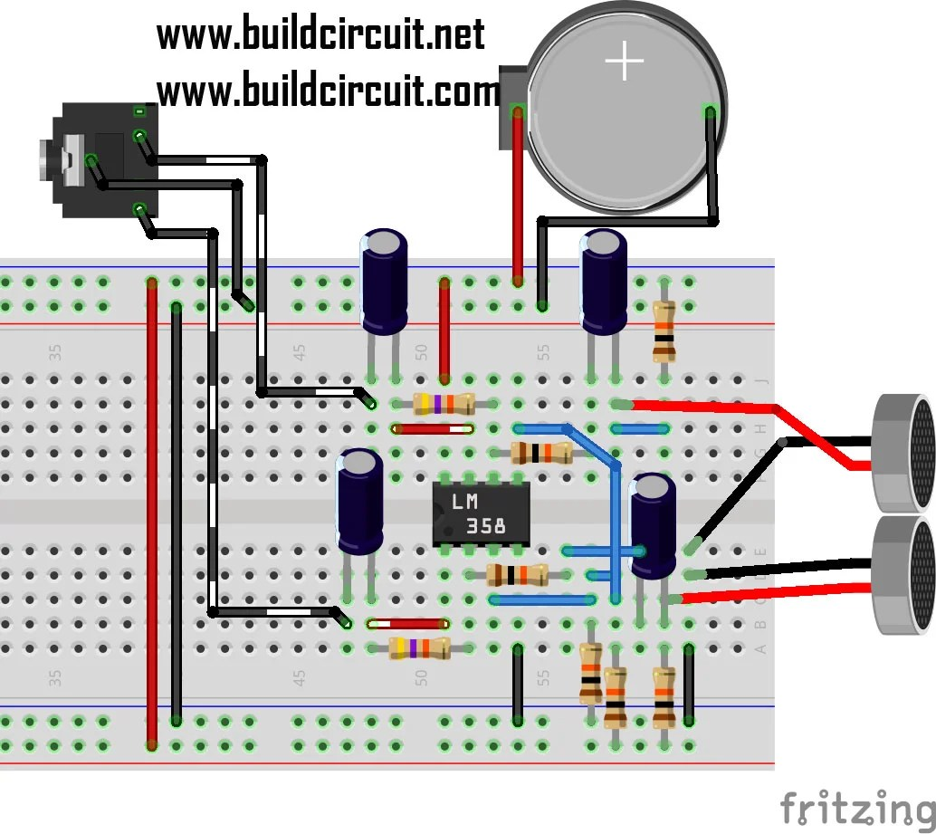

[This Photo](https://www.buildcircuit.com/preamplifier-for-electret-microphone-with-lm358-opamp/) by Unknown Author is licensed under [CC BY-SA](https://creativecommons.org/licenses/by-sa/3.0/)

**OpAmp (Operational Amplifier)**

**Episode 22:** **Electronic Basics #22: Transistor (BJT) as a Switch**

**The video explains the fundamentals of using Bipolar Junction Transistors (BJTs) as electronic switches, focusing on how to select and implement them correctly to avoid damage.**

1. Core Component: **Bipolar Junction Transistor (BJT)  
\* Full Name: Bipolar Junction Transistor.  
\* Terminals: Emitter (E), Collector (C), Base (B). Pinout varies by package, so always check the datasheet.  
\* Function: A small current at the base controls a much larger current between the collector and emitter.**

2. Types & Basic Operation:  
**\* NPN Type (e.g., BC637, BD535):  
\* Activation: A positive voltage (and resulting current flow) applied to the base (relative to the emitter) turns the transistor ON.  
\* Common Use (Low-Side Switch): Emitter connected to Ground (GND). The load is connected between the positive supply (Vcc) and the Collector. When the base is high, current flows from Vcc, through the load, through the Collector-Emitter path, to GND.  
\* PNP Type (e.g., BC640):  
\* Activation: Pulling the base low (towards GND, relative to the emitter) turns the transistor ON.**

3. Key Instruments & Components Used WITH BJTs in Switching Circuits: **\* Load: The device being switched (e.g., LED, light bulb).  
\* Power Supply: Provides voltage/current for the load and BJT (e.g., bench power supply, battery).  
\* Base Resistor (Rb): *Crucial* for limiting current into the base. Without it, excessive base current can destroy the BJT.  
\* Control Signal Source: What turns the BJT on/off (e.g., manual connection to Vcc/GND, Arduino digital pin).  
\* Multimeter: For measuring voltages (Vbe, Vce), currents (Ib, Ic), and verifying resistor values.  
\* Breadboard & Wires: For prototyping the circuits.  
\* Heatsink (for power transistors): To dissipate heat, especially when switching larger currents.  
\* Thermal Camera/Thermometer: To observe temperature rise in components.**

4. Advanced BJT Configuration: Darlington Transistor **\* Component Name: Darlington Transistor (e.g., TIP142 NPN).  
\* Structure: Essentially two BJTs connected internally in a way that multiplies their current gains.  
\* Benefit: Achieves very high current gain (β often 500-1000+), meaning a very small base current can control a very large collector current. This makes it suitable for driving high-power loads directly from low-current sources like Arduino pins.**

**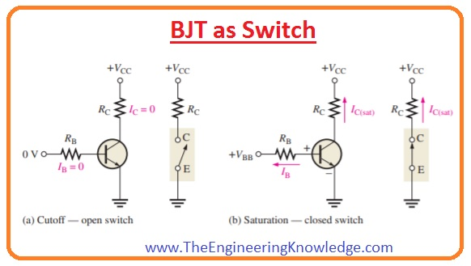**

**Transistor (BJT) as a Switch**

**Episode 23:** **Electronic Basics #23: Transistor (MOSFET) as a Switch**

**The video explores MOSFETs as a more efficient alternative to Bipolar Junction Transistors (BJTs) for switching loads, especially larger ones. It demonstrates basic control with an Arduino, highlights potential challenges like static sensitivity, high-side switching complexities, and oscillation issues at higher frequencies or with inductive loads, and suggests solutions like pull-down/pull-up resistors and gate resistors.**

MOSFET Fundamentals & Basic Control

* Types:
  + **N-Channel MOSFET: More commonly used (e.g., IRLZ44N demonstrated).**
  + **P-Channel MOSFET: Used for specific applications like simpler high-side switching (e.g., IRF9540 demonstrated).**
* **Terminals:**
  + **Gate (G): Control terminal (analogous to BJT Base).**
  + **Drain (D): Output terminal (analogous to BJT Collector).**
  + **Source (S): Common/reference terminal (analogous to BJT Emitter).**
* **Control Mechanism:**
  + **Voltage-Controlled: Activated by applying a sufficient voltage between Gate and Source (Vgs), unlike BJTs which are current-controlled.**
  + **Requires Gate-Source voltage (Vgs) to be higher than the Threshold Voltage (Vgs(th)) found in the datasheet.**
  + **Should not exceed the maximum rated Vgs.**
* **Low-Side Switching (N-Channel):**
  + **Circuit: Source to Ground, Load (e.g., LED) between VCC and Drain. Gate connected to Arduino PWM pin.**
  + **Static Sensitivity: MOSFET gates are very sensitive. Touching the gate can turn the MOSFET on due to static charge.**
  + **Pull-Down Resistor: A 10kΩ resistor between Gate and Source is crucial to keep the MOSFET off when no signal is applied.**
* **High-Side Switching (P-Channel):**
  + **If the load needs to be connected between the Drain and Ground (common in some applications), an N-Channel MOSFET becomes difficult to drive directly with a 5V Arduino (requires gate voltage significantly above VCC).**
  + **A P-Channel MOSFET (e.g., IRF9540) is a simpler solution for high-side switching.**

**Instruments & Key Components Used**

* **Main Active Components:**
  + **MOSFET N-Channel: IRLZ44N**
  + **MOSFET P-Channel: IRF9540**
  + **(Implied BJT): TIP142 (from previous video context for comparison)**
* **Controller:**
  + **Arduino Uno: For PWM signal generation and control.**
* **Prototyping:**
  + **Breadboard: For assembling circuits.**
  + **Jumper Wires, Alligator Clips.**
* **Loads:**
  + **LED (Light Emitting Diode): White.**
  + **Incandescent Light Bulb.**
* **Passive Components:**
  + **Resistors: Various values (10kΩ for pull-down/up, 1.15Ω and 470Ω for gate).**
  + **Potentiometer: B50K (for controlling PWM duty cycle via Arduino analog input).**

**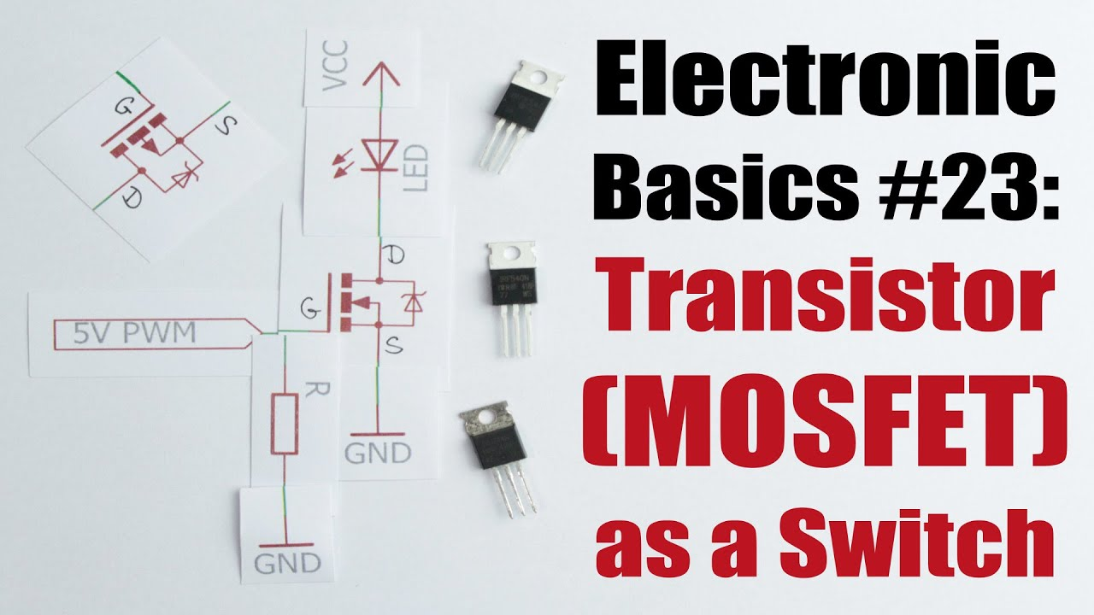**

**Transistor (MOSFET) as a Switch**

**Episode 24:** **Electronic Basics #24: Stepper Motors and how to use them**

 Stepper Motor Anatomy (Hybrid Synchronous Type)

* **Component: Hybrid Synchronous Stepper Motor (specifically a bipolar type, model YH42BYGH47-401A shown)**
* **Rotor (Rotating Part):**
  + **Consists of permanent magnets arranged in sections.**
  + **Each pole shoe has a toothed structure.**
  + **The teeth on different pole shoes are offset from each other. This offset, combined with alternating magnet polarities (N-S-N-S), creates many effective magnetic poles around the rotor.**
* **Stator (Stationary Part):**
  + **Contains multiple electromagnetic coils.**
  + **These coils are wound around a toothed iron core.**
  + **The stator teeth are designed to interact with the rotor teeth.**
* **Wires: Typically, 4 wires for a bipolar stepper motor (two wires for each of the two coil pairs/phases).**

**Key Applications:**

**3D Printers (for precise print head and bed movement).**

**CNC Machines.**

**Robotics.**

**Any device requiring accurate, repeatable positioning.**

**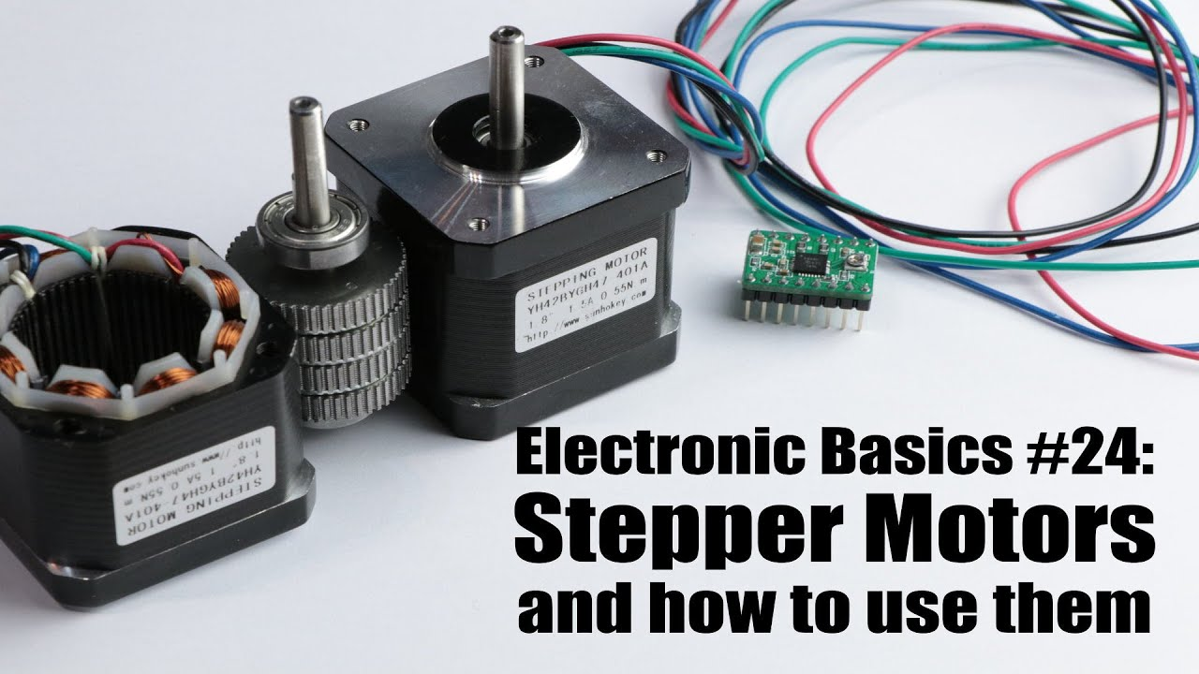**

**Episode 25:** **Electronic Basics #25: Servos and how to use them**

What is a Servo Motor?

* **A self-contained electrical device that rotates parts of a machine with high efficiency and great precision.**
* **Combines a DC motor, a gearbox, a potentiometer for position feedback, and control electronics.**
* **Commonly used for precise angular positioning tasks (typically 0-180 degrees).**
* **Has three wires:**
  + **Red: VCC (Power, typically 4.8V - 7.2V)**
  + **Brown/Black: GND (Ground)**
  + **Orange/Yellow: Control Signal (PWM)**

Internal Components & Mechanism

Key Internal Parts and Their Roles:

1. **DC Motor: The primary actuator that provides rotational movement.**
2. **Gearbox (Gears):**
   * **Reduces the high speed of the DC motor to a slower, more controllable output speed.**
   * **Increases the torque (rotational force) of the motor.**
   * **Can be made of plastic (common in smaller servos like SG90) or metal (in higher-torque servos like MG996R).**
3. **Potentiometer:**
   * **A variable resistor mechanically linked to the output shaft (via the gears).**
   * **Acts as a voltage divider, providing an analog voltage signal that corresponds to the *current angular position* of the servo shaft. This is the feedback mechanism.**
4. **Control Electronics (Control IC):**
   * **The "brain" of the servo (e.g., KC5188, KC2462 shown in the video).**
   * **It reads the incoming PWM control signal to determine the *desired/target position*.**
   * **It reads the voltage from the internal potentiometer to know the *current actual position*.**
   * **It compares the target position with the current position.**
5. **H-Bridge:**
   * **An electronic circuit (often integrated within the control IC or built with separate MOSFETs for higher power servos).**
   * **The control IC directs the H-bridge to drive the DC motor clockwise or counter-clockwise to move the shaft towards the target position.**
   * **When the current position matches the target position, the H-bridge stops the motor.**

**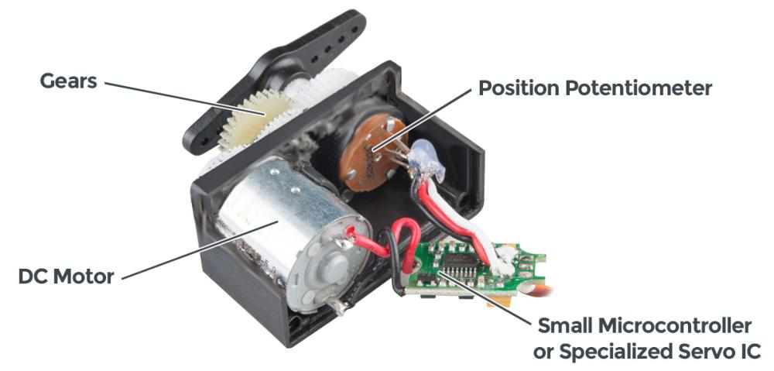**

**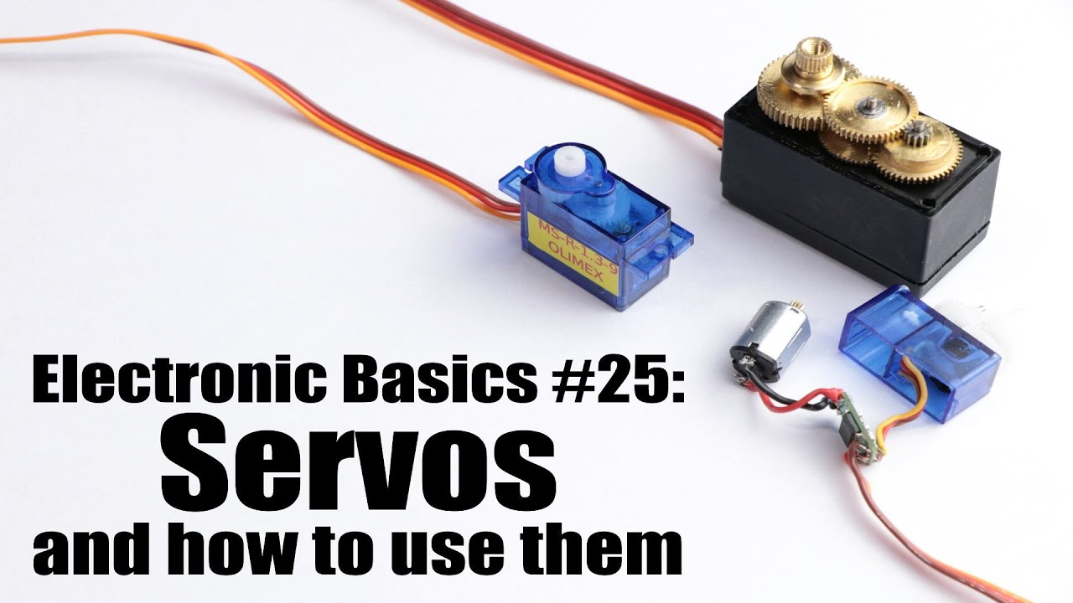**

**Episode 26:** **Electronic Basics #26: 555 Timer IC**

**Core Component Spotlight**

* **Instrument/Component Name: 555 Timer IC (Integrated Circuit)**

**Demystifying the 555 Timer IC**

* **What it is: A highly versatile and widely used integrated circuit for creating timing pulses, oscillations, or acting as a flip-flop.**
* **Internal Naming Origin: Named due to the presence of three internal 5kΩ resistors forming a voltage divider.**
* **Key Internal Blocks:**
  + **Voltage Divider: Creates reference voltages of 1/3 Vcc and 2/3 Vcc using the three 5kΩ resistors.**
  + **Two Comparators: One compares the Trigger input (Pin 2) to 1/3 Vcc, the other compares the Threshold input (Pin 6) to 2/3 Vcc (or Control Voltage Pin 5).**
  + **Flip-Flop (SR Latch): Stores the state (High/Low) and is controlled by the comparators and the Reset pin.**
  + **Output Driver: Buffers the flip-flop's output to drive external loads (Pin 3).**
  + **Discharge Transistor: Connected to Pin 7, used to discharge an external timing capacitor.**

**Basic Pin Functions Highlighted:**

**Pin 1 (GND): Ground.**

**Pin 2 (Trigger - TR): When voltage drops below 1/3 Vcc, it sets the flip-flop (output goes HIGH).**

**Pin 3 (Output - Q): The output of the timer.**

**Pin 4 (Reset - R): An active-low input that resets the flip-flop (output goes LOW). Usually tied to Vcc if not used.**

**Pin 5 (Control Voltage - CV): Allows access to the 2/3 Vcc reference. Can be used to modulate the timing. Often connected to ground via a 10nF capacitor for noise filtering and stability.**

**Pin 6 (Threshold - THR): When voltage exceeds 2/3 Vcc, it resets the flip-flop (output goes LOW).**

**Pin 7 (Discharge - DIS): Open collector output connected to the discharge transistor. Goes low when the main output (Pin 3) is low, allowing discharge of a capacitor.**

**Pin 8 (Vcc): Positive supply voltage.**

**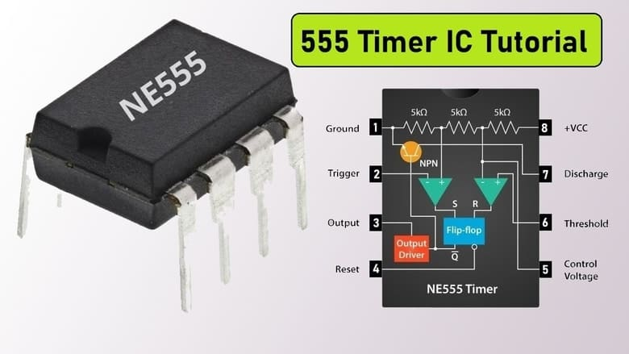**

**555 Timer IC**

Episode 27: Electronic Basics #27: ADC (Analog to Digital Converter)

This video explains the fundamental concept of Analog to Digital Converters (ADCs). An ADC is an electronic component or circuit that converts a continuous analog voltage signal into a discrete digital representation. This is crucial for microcontrollers like Arduino to read and process real-world analog sensor data. The video demonstrates this with an Arduino's analogRead() function, showing how an input voltage is translated into a 10-bit digital value (0-1023).

Instruments and Components Featured in ADC Demonstrations

The video utilizes several instruments and components to explain and demonstrate ADC functionality:

* **Main Instrument (focus of explanation):**Analog to Digital Converter (ADC)
  + **Internal ADC (in Arduino):**Utilized via analogRead().
  + **External ADC IC:**
    - **Component Name:**ADS7816 (a 12-bit, 200kHz SAR ADC)
  + **DIY Flash ADC:**
    - **Components Used:**LM324 Quad Op-Amp (as comparators), Resistors (for voltage divider), Breadboard.
* **Microcontroller:**
  + **Component Name:**Arduino Nano (or similar ATmega-based board)
  + **Used For:**Demonstrating its internal ADC, interfacing with external ADC (ADS7816), running code to read and display digital values.
* **Signal Generation & Measurement:**
  + **Component Name:**Ascel AE20125 10 MHz Function Generator
  + **Used For:**Creating defined analog input signals (e.g., a 10 kHz sine wave) for testing ADC sampling.
  + **Component Name: Rigol DS1052E Oscilloscope**
  + **Used For:**Visualizing analog waveforms from the function generator and the output of DACs (in the intro).
  + **Component Name: Metrahit Pro Multimeter**
  + **Used For:**Verifying DC voltage levels (e.g., Arduino's reference voltage, input voltage to DIY Flash ADC).
* **Power Supply:**
  + **Component Name:**ELV DPS 5315 Bench Power Supply
  + **Used For:**Providing stable power to the circuits.
* **Software:**
  + **Component Name:**Arduino IDE
  + **Used For:**Writing and uploading code to the Arduino, and viewing data via the Serial Monitor.

Key ADC Specifications: Sampling Rate & Resolution

The video highlights two critical specifications for ADCs:

1. **Sampling Rate:**
   * **Definition:**How frequently the ADC measures (samples) the incoming analog signal. Expressed in Samples per Second (S/s) or Hertz (Hz).
   * **Importance:** A sufficiently high sampling rate is needed to accurately capture the shape of a changing analog waveform.
   * **Rule of Thumb:** For good reconstruction, a sampling rate about 10 times the signal's frequency is often recommended.
2. **Resolution (Bits):**
   * **Definition:**The number of discrete digital values the ADC can output to represent the analog input range. Measured in bits.
   * **Importance:**Higher resolution means smaller voltage steps, leading to a more precise digital representation of the analog signal.
   * **Examples:**
     + **Arduino:** 10-bit ADC (1024 steps). With a 5V reference, each step is ~4.88mV.
     + **ADS7816 IC:** 12-bit ADC (4096 steps). With a 5V reference, each step is ~1.22mV.
     + **Video's 4-bit example:** 16 steps. With a 5V reference, each step is 312.5mV.

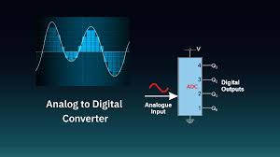

**ADC (Analog to Digital Converter)**

**Episode 28:** **Electronic Basics #28: IGBT and when to use them**

Understanding IGBTs: **The Basics**

* **Full Name:**Insulated Gate Bipolar Transistor.
* **Types:** Like MOSFETs, IGBTs come in N-channel and P-channel varieties. P-channel IGBTs are less common due to generally inferior characteristics (slower, higher saturation voltage).
* **Example Component:**The video uses an **IRGP50B60PD1** (an N-channel IGBT) for demonstrations.
* **Pinout:**
  + **G:** Gate (control input, similar to MOSFET gate)
  + **C:**Collector (main current path, similar to BJT collector)
  + **E:** Emitter (main current path, similar to BJT emitter)
* **Internal Structure (Simplified):**An IGBT can be thought of as having an N-channel MOSFET on its input (for gate control) which then drives a PNP Bipolar Junction Transistor (BJT) as its main output switching element.
* **Gate Drivers (for PWM/High-Frequency Switching):**
  + For Pulse Width Modulation (PWM) signals or switching at higher frequencies (e.g., >20kHz), a dedicated gate driver IC is essential.
  + **Example Driver ICs:**
    - **TC4420:**A common MOSFET/IGBT driver IC.
    - **IR2113:**A high and low-side driver IC, suitable for bootstrap operation in bridge circuits.
  + **Function:**Gate drivers provide high peak currents (e.g., the TC4420 can provide up to 6A peak) to rapidly charge and discharge the IGBT's gate capacitance. This is crucial because the gate charge (Q) required is constant, and for higher frequencies (f), the time (t) to deliver this charge is shorter, necessitating higher current (I) (since Q = I \* t).

MOSFET vs. IGBT: Key Differences & Performance Comparison

* **Switching Speed:**
  + **MOSFETs:** Generally faster. In the video's test, a generic MOSFET (likely IRZ44N) had turn-on times around 32ns and turn-off times around 160ns.
  + **IGBTs:** Generally slower. The IRGP50B60PD1 showed turn-on times around 145ns and turn-off times around 240ns.
  + **Implication:** MOSFETs are preferred for very high-frequency switching (>200 kHz).
* Conduction Losses (On-State Voltage Drop):
  + **MOSFET:** Behaves like a variable resistor (Rds(on)). The voltage drop (Vds) increases linearly with current (Vds = I \* Rds(on)). Power loss is I² \* Rds(on). Generally more efficient at *lower currents*.
  + **IGBT:** Has a more constant saturation voltage drop (Vce(sat)), typically similar to a diode drop plus a BJT saturation voltage (e.g., 0.7V to 2V+). Power loss is I \* Vce(sat). Can be more efficient at *very high currents* where the I²R losses in a MOSFET would become substantial.
  + **Video Example (Low Current):** MOSFET had a 0.024V drop @ 1.7A (0.04W loss). IGBT had a 0.79V drop @ 1.65A (1.3W loss) – significantly higher loss for the IGBT at this low current.
* **Voltage Handling (Breakdown Voltage):**
  + **IGBTs:** Generally designed for higher voltage applications. The IRGP50B60PD1 is rated for 600V.
  + **MOSFETs:** While high-voltage MOSFETs exist, many common ones have lower Vds\_max ratings (e.g., 55V for the implied IRZ44N).
* **Current Handling:**
  + **IGBTs:** Often capable of handling much higher continuous and peak currents (e.g., the IRGP50B60PD1 can handle pulsed currents up to 200A).

**MOSFETs:** Individual MOSFETs typically have lower current ratings compared to comparable IGBTs.

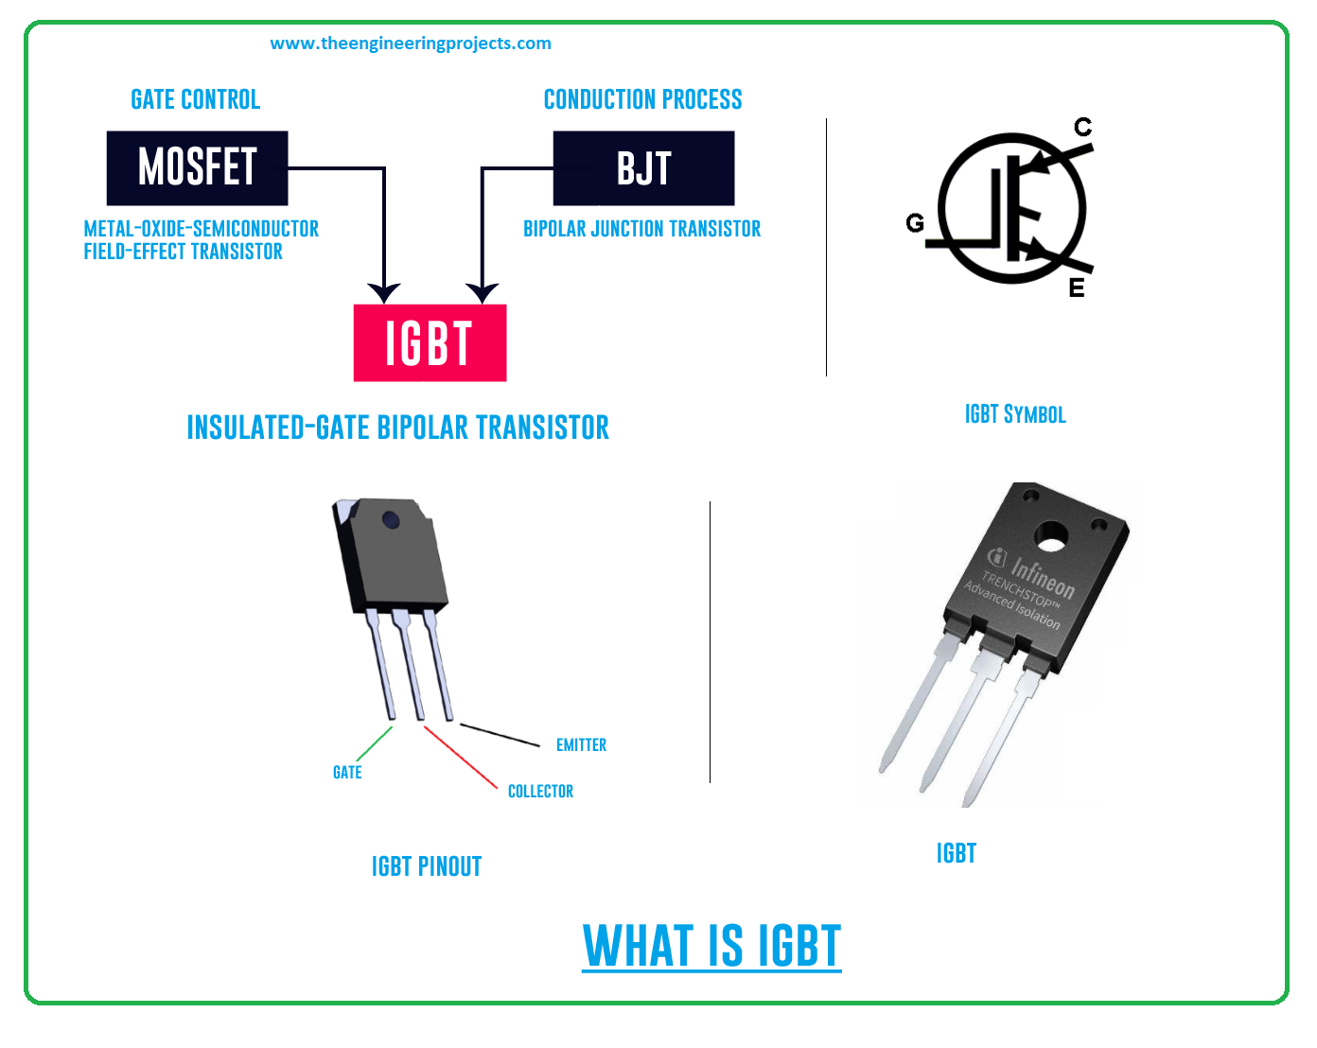

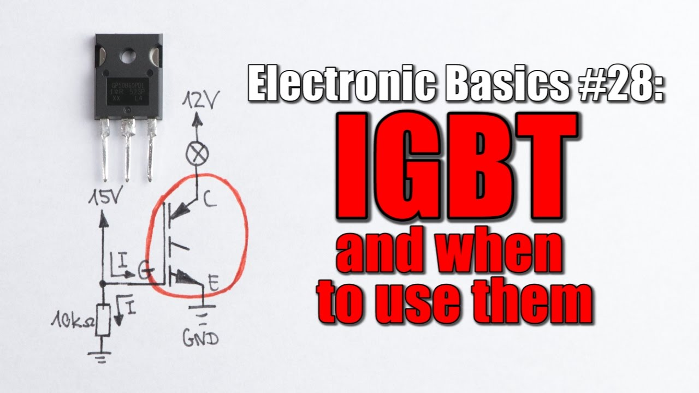

Episode 29: Electronic Basics #29: Solar Panel & Charge Controller

Overall Video Summary:  
This video provides a comprehensive introduction to solar panels, explaining their basic construction from individual cells, the importance of series connections for voltage, and the challenges of cell fragility and partial shading. It delves into how to maximize power output by understanding the Maximum Power Point (MPP) and introduces different types of charge controllers (PWM and MPPT) used to efficiently charge batteries. Practical demonstrations with various solar panels, LEDs, multimeters, and a DIY power logger illustrate these concepts.

**Key Points & Components:**

**Introduction to Solar Panels:**

* Solar panels are an easy-to-use regenerative energy source.
* Light shining on them creates an output voltage capable of powering loads.
* The video explores how to reach maximum power output and wire them for battery charging.

Instruments Used:

Metrahit Pro Multimeter: To measure voltage (e.g., 0.5162V from a small panel, 0.499V from a single cell, 14.32V from 100W panel).

UNI-T UT61D Multimeter: Also used for measurements.

Soldering Iron: For connecting tap wires to solar cells and components.

Components Used/Shown:

Small solar panel (various sizes shown initially, then a ~5V one for detailed tests).

Large 100W solar panel.

Individual blue polycrystalline solar cells.

Various LEDs (red, green, blue, white power LED, LED array).

Desk lamp (as a light source for small panels).

Alligator clips and wires.

Multipower MP4.5-12 Lead Acid Battery (12V 4.5Ah).

Solar Charge Controller (generic, and a "Sun 1081" branded one).

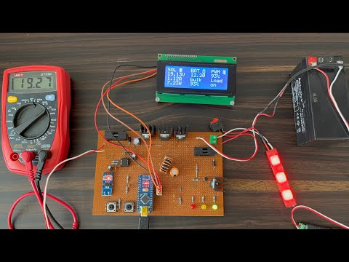

**Solar Panel & Charge Controller**

Episode 30: Electronic Basics #30: Microcontroller (Arduino) Timers

**Video Summary: Mastering Microcontroller Timers (ATmega328P / Arduino)**

This video explains the critical role of hardware timers in microcontroller projects for creating precisely timed events and Pulse Width Modulation (PWM) signals. It contrasts the robust timer-based approach with the limitations of software delays (like Arduino's delay() function), which are blocking and can be inaccurate. The tutorial focuses on configuring and using the 16-bit Timer1 of the ATmega328P microcontroller (found on the Arduino Uno) for various timing and PWM generation tasks.

Featured Instrument: ATmega328P Microcontroller (on Arduino Uno)

Microcontroller: Atmel ATmega328P (commonly used in Arduino Uno boards).

Key Peripherals Utilized:

Hardware Timers (specifically Timer1, a 16-bit timer, is detailed. The ATmega328P also has two 8-bit timers, Timer0 and Timer2).

GPIO Pins (Digital Pins for output, Analog Pins for input).

ADC (Analog-to-Digital Converter for reading potentiometer values).

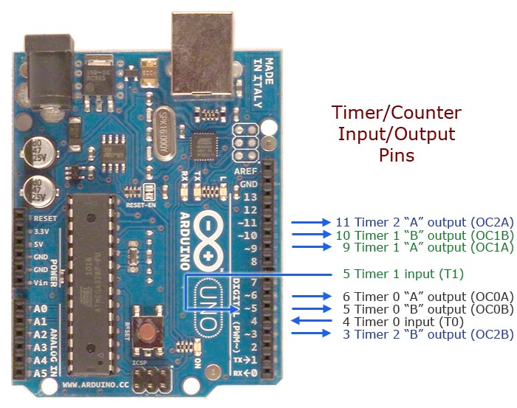

[This Photo](http://www.gammon.com.au/forum/?id=11504) by Unknown Author is licensed under [CC BY](https://creativecommons.org/licenses/by/3.0/)

Microcontroller (Arduino) Timers

Episode 31: Electronic Basics #31: Schottky Diode & Zener Diode

**Common Diodes**

* **Component:** Common Diode (e.g., 1N4007 is used as an example).
* **Function:**
  + Allows current to flow in one direction (anode to cathode) when **forward biased**, with a characteristic **forward voltage drop (Vf)** (e.g., 0.83V - 0.87V shown for 1N4007 at 0.5A-1A).
  + Blocks current flow when **reverse biased**.
* **Uses:** Reverse voltage protection, AC to DC rectification.
* **Instruments Used (for common diode demo):**
  + Power Supply (ELV DPS 5315)
  + Multimeter (Metrahit Pro)
  + Function Generator (ASCEL AE20125 - for AC rectification demo)
  + Oscilloscope (for AC rectification demo)

**Schottky Diodes**

* **Component:** Schottky Diode (e.g., 1N5819 is used as an example).
* **Symbol:** Standard diode symbol but the cathode bar has small "S"-like hooks/bends at its ends.

Uses: High-efficiency rectification (especially in SMPS), reverse polarity protection in power-sensitive circuits, high-frequency applications.

Drawbacks:

Generally have a lower reverse breakdown voltage compared to common diodes.

Higher reverse leakage current.

Instruments Used (for Schottky demo):

Power Supply (ELV DPS 5315)

Multimeter (Metrahit Pro)

Thermometer (TM-902C)

Function Generator (ASCEL AE20125)

Oscilloscope (Keysight/Agilent MSOX3054T)

Boost Converter Module (as an application example)

**Zener Diodes**

* **Component:** Zener Diode (also called Z-Diode).
* **Symbol:** Standard diode symbol but the cathode bar is "Z"-shaped or has small angled "wings".
* **Forward Bias Operation:**
  + Acts like a normal diode with a comparable forward voltage drop (e.g., ~0.86V shown).
  + *This is generally not how Zener diodes are used.*

Important Specifications:

Zener Voltage (Vz): The reverse breakdown voltage.

Power Dissipation: Maximum power the Zener can handle (e.g., 500mW).

Instruments Used (for Zener demo):

Power Supply (ELV DPS 5315)

Multimeter (Metrahit Pro & UNI-T UT61D)

Function Generator (ASCEL AE20125 - for AC clipping demo)

Oscilloscope (for AC clipping demo)

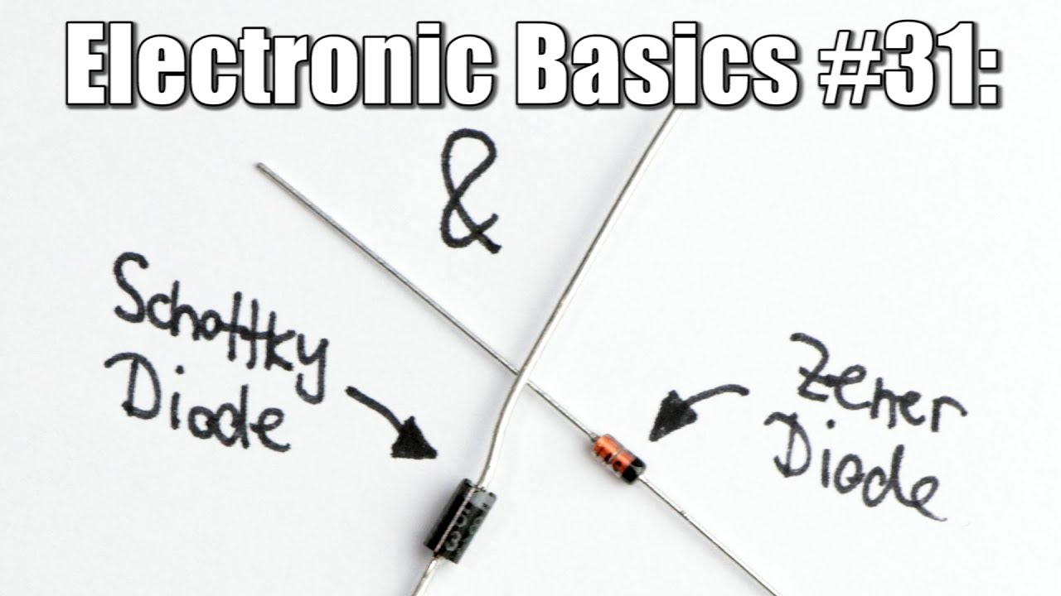

Schottky Diode & Zener Diode

Episode 32: Electronic Basics #32: Relays & Optocouplers

The video explains the workings, applications, advantages, and disadvantages of two crucial electronic components often found together: Relays and Optocouplers. It starts by examining a remote-controlled AC socket to reveal these components.

**I. Relays: The Electromechanical Switch**

* **Component Name:** Relay
* **What it is:** An electromechanical switch that uses an electromagnet to physically open or close one or more sets of electrical contacts.
* **Key Considerations & Usage:**
  + **Coil Voltage:** Must match the control signal (e.g., from a microcontroller).
  + **Contact Rating:** Specifies the maximum voltage (e.g., 250V AC) and current (e.g., 10A) the contacts can safely switch.
  + **Flyback Voltage:** When the relay coil is de-energized, the collapsing magnetic field induces a large reverse voltage spike.
  + **Flyback Diode (Snubber Diode):** A diode (e.g., 1N4007) is placed in parallel with the relay coil (cathode to positive, anode to negative of the coil supply) to provide a path for this induced current, protecting the control circuitry (like transistors or ICs) from damage.
  + **Galvanic Isolation:** The control circuit (coil) is electrically isolated from the switched circuit (contacts), which is a major safety and functional advantage.
  + **Power Loss (Switched Side):** Very low when contacts are closed.
  + **Switching Speed:** Relatively slow due to mechanical movement.
  + **Lifespan:** Mechanical contacts can wear out over time (arcing, physical wear).
  + **Audible Click:** Makes a clicking sound when switching.

**II. Optocouplers (Opto-isolators): Light-Based Isolation**

* **Component Name:** Optocoupler (or Opto-isolator, e.g., PC817, MOC30xx series)
* **What it is:** A component that transfers electrical signals between two isolated circuits using light.
* **Key Considerations & Usage:**
  + **Isolation:** Excellent for isolating a low-voltage control circuit (like a microcontroller) from a high-voltage or noisy circuit.
  + **Speed:** Generally faster than relays.
  + **Activation:** Requires a specific forward voltage and current for the internal LED.
  + **Output Capability:** The output phototransistor or photo-TRIAC has its own voltage and current limitations. They usually can't handle the large loads a relay can directly, but are perfect for triggering other devices.
  + **No Contact Wear:** Being solid-state, it doesn't have mechanical parts that wear out.

**III. Why Use Optocouplers with Relays?**

* **Enhanced Safety & Protection:** While a relay itself provides galvanic isolation, an optocoupler is often used to drive the relay coil from a microcontroller.
  + The microcontroller (e.g., 5V logic) can safely send a signal to the optocoupler's LED.
  + The optocoupler's output (phototransistor) then switches the higher voltage/current needed for the relay coil (e.g., 12V).
  + This creates *double galvanic isolation*:
    1. Between the microcontroller and the optocoupler's output.
    2. Between the relay coil circuit and the relay's high-power contacts.
  + This protects the sensitive microcontroller from the relay coil's flyback voltage (though the flyback diode on the relay coil is still essential) and from any faults in the relay coil circuit.
* **Simplified Interfacing:** Allows easy control of relays that might require different voltage levels than the microcontroller outputs.

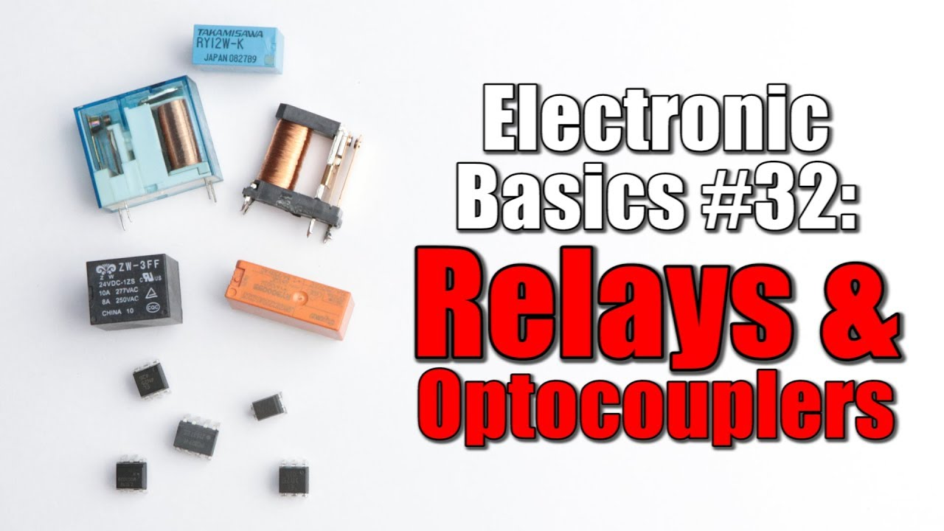

Episode 33: Electronic Basics #33: Strain Gauge/Load Cell and how to use them to measure weight

**Overall Project: Upgraded Electric Longboard**

* **Goal:** To improve a DIY electric longboard.
* **New Features Highlighted:**
  + New power switch and relay system.
  + New wireless remote and control circuit.
  + **Key Innovation:** A weight-measuring system for automatic braking.

**The Core Innovation: Weight-Sensing & Automatic Braking**

* **Purpose:** To detect if the rider jumps off or falls off the longboard.
* **Mechanism:** If no weight is detected, the longboard automatically brakes to prevent it from running away.
* **Sensor Used:** Strain Gauge.

**The Primary Sensor: Strain Gauge**

* **Component Name:** Strain Gauge
* **What it is:** A flexible piece of plastic with a metallic foil (resistance wire) in a zigzag pattern.

**Signal Conditioning & Microcontroller Interface**

* **Challenge:** The output voltage (VD) from the Wheatstone bridge is still very small (millivolts or microvolts).
* **Instruments/Components Used:**
  1. **Operational Amplifier (Op-Amp):** Configured as a differential amplifier to amplify the small voltage difference from the Wheatstone bridge (e.g., with a gain of ~196 in the example).
  2. **Analog-to-Digital Converter (ADC):** The amplified analog voltage is then fed into the ADC of a microcontroller (e.g., Arduino) to get a digital reading.
* **Consideration:** Temperature sensitivity of strain gauges can introduce errors.
  1. **Quarter-bridge (1 strain gauge):** Most susceptible to temperature.
  2. **Half-bridge (2 strain gauges):** Better temperature compensation as both gauges experience similar temperature changes, which can be cancelled out.
  3. **Full-bridge (4 strain gauges):** Offers the best temperature compensation and can also compensate for other undesired forces.
  4. **Trimmers (Potentiometers):** Used to precisely balance the Wheatstone bridge

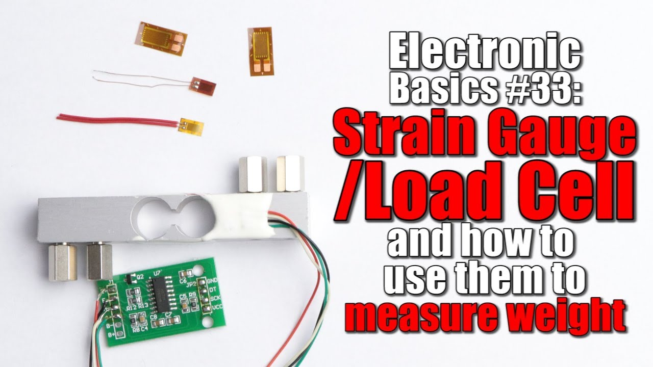

Episode 34: Electronic Basics #34: Two-Position Controller & PID Controller

**Hardware Upgrades & Modifications**

* **Electromagnet:**
  + Upgraded to a more powerful model: **XRN-XP30x22** (12VDC, rated for 10kg lifting force).
  + Replaced the older **LS-P20/15** (12VDC, 2.5kg).
* **Sensor:**
  + **SS495A** Linear Hall Effect Sensor.
  + Glued directly to the bottom center of the new electromagnet using two-component adhesive.
* **Control System:**
  + **Arduino Nano:** Used as the new brain for the control logic (initially for two-position, then for PID).
  + **MOSFET Switch Circuit:** The Arduino outputs signals to a MOSFET driver (**TC4420CPA**) which then drives a MOSFET (**IRLZ44N**) to switch the electromagnet (L1) ON/OFF. A flyback diode (**UF4007**) is used across the electromagnet.

**Introduction to PID Control**

* **Concept:** PID = Proportional, Integral, Derivative. A more sophisticated control loop feedback mechanism.
  + **Proportional (P) term:** Output is proportional to the current error (difference between setpoint and actual value). Gain: Kp. Reacts to current error but may leave a steady-state error.
  + **Integral (I) term:** Accumulates the error over time. Gain: Ki. Eliminates steady-state error by increasing output if the error persists.
  + **Derivative (D) term:** Reacts to the rate of change of the error. Gain: Kd. Helps to dampen oscillations and predict future error, improving stability for dynamic systems.
* **Implementation:**
  + **Arduino PID Library:** By Brett Beauregard.
  + The PID controller calculates an output value (0-255) which is then used to drive the electromagnet via Pulse Width Modulation (PWM) from the Arduino.
* **Instruments/Tools for Analysis & Tuning:**
  + **Oscilloscope:** To observe Hall sensor voltage, PWM signals, and system response.
  + **Serial Monitor (Arduino IDE):** To adjust setpoints and PID gains (Kp, Ki, Kd) in real-time.

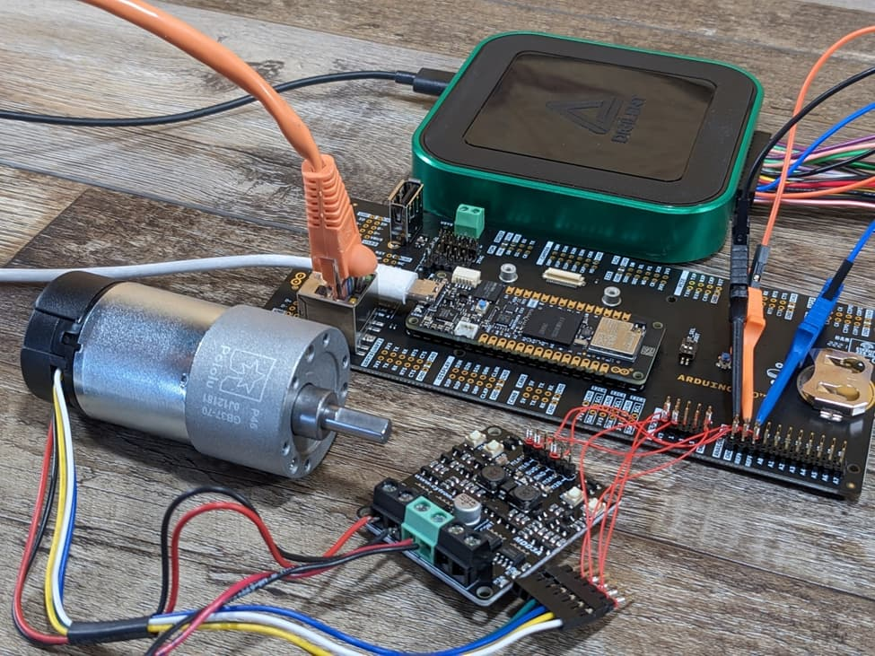

**Two-Position Controller & PID Controller**

Episode 35: Electronic Basics #35: Schmitt Trigger and when to use them

**Schmitt Trigger Explained**

* **Component Name:** Schmitt Trigger
* **Core Principle: Hysteresis:** A Schmitt Trigger introduces *hysteresis*, meaning it has two different threshold voltages:
  + **Upper Threshold Voltage (V<sub>TH+</sub> or V<sub>High</sub>):** The input voltage must rise above this level for the output to switch (e.g., from low to high for a non-inverting Schmitt trigger).
  + **Lower Threshold Voltage (V<sub>TH-</sub> or V<sub>Low</sub>):** The input voltage must fall below this level for the output to switch back (e.g., from high to low).
* **Benefit:** The gap between these two thresholds (the hysteresis voltage) prevents noise from causing multiple transitions. Once the output has switched, the input must cross the *other* threshold significantly for it to switch back, making it immune to small noise fluctuations around a single threshold.
* **Types:**
  + **Non-inverting Schmitt Trigger:** Output goes high when input exceeds V<sub>TH+</sub>, and low when input drops below V<sub>TH-</sub>.
  + **Inverting Schmitt Trigger:** Output goes low when input exceeds V<sub>TH+</sub>, and high when input drops below V<sub>TH-</sub>.

**Instruments & Components Used in Demonstration**

* **Oscilloscope:** To visualize input and output waveforms, noise, switch bounce, and hysteresis effects.
* **Function/Arbitrary Waveform Generator:** To provide input signals like triangle waves.
* **Breadboard:** For prototyping the circuits.
* **Power Supply:** (ELV DPS 5315 shown) To provide DC voltage to the circuits.
* **Components:**
  + **Op-Amp (MCP602):** For initial comparator and Schmitt Trigger explanation.
  + **74HC14 IC:** For dedicated Schmitt Trigger demonstrations.
  + **Resistors:** Various values (e.g., 10kΩ, 20kΩ for Op-Amp circuits; 10kΩ pull-up, 330Ω for oscillator).
  + **Capacitors:** (e.g., 100nF for RC filter, 4.7µF for oscillator).
  + **Potentiometer:** To vary input voltage and demonstrate threshold levels.
  + **Push Button Switch:** To demonstrate switch debouncing.
  + **LED:** As a visual indicator for output states.
  + **Arduino UNO:** As an example of a device with digital inputs that inherently have Schmitt Trigger characteristics (though an RC filter is still used for debouncing).

**Applications: What Schmitt Triggers Are Used With/For**

1. **Signal Conditioning/Noise Immunity:**  
   \* **What it uses:** Noisy digital or slowly rising/falling analog signals.  
   \* **How it's used:** Cleans up these signals by providing a sharp, clean digital output transition only when specific high and low thresholds are definitively crossed, ignoring minor noise.
2. **Switch Debouncing:**  
   \* **What it uses:** Mechanical switches (like push buttons) which physically "bounce," creating multiple electrical pulses.  
   \* **How it's used:** Typically combined with an RC (Resistor-Capacitor) filter. The RC filter slows down the sharp edges of the bounces, and the Schmitt Trigger then converts this smoothed, but still potentially messy, signal into a single, clean pulse.
3. **Relaxation Oscillators:**  
   \* **What it uses:** A resistor (R) and a capacitor (C) in a feedback loop with the Schmitt Trigger.  
   \* **How it's used:** The capacitor charges through the resistor. When its voltage reaches the Schmitt Trigger's upper threshold, the output flips, causing the capacitor to discharge through the resistor until it hits the lower threshold, flipping the output again. This creates a continuous square wave. The frequency can be adjusted by changing R or C.
4. **Interfacing with Microcontrollers (like Arduino):**  
   \* **What it uses:** External inputs (e.g., from debounced switches).  
   \* **How it's used:** Digital inputs on many microcontrollers (like the ATmega on an Arduino) already have Schmitt Trigger input characteristics, providing some inherent noise immunity. For very noisy environments or critical inputs, an external Schmitt Trigger can still be beneficial before the microcontroller's pin.

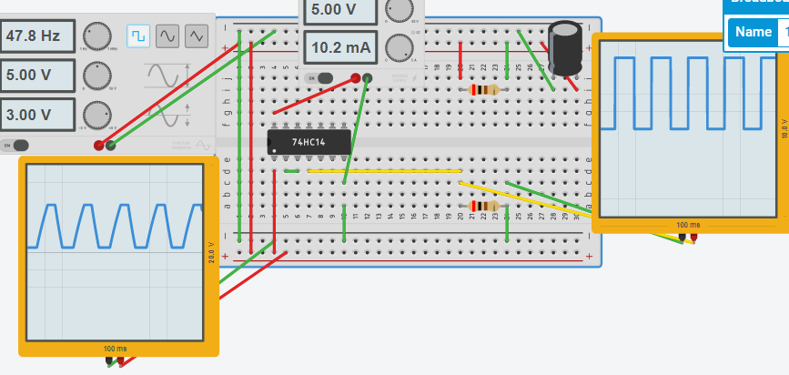

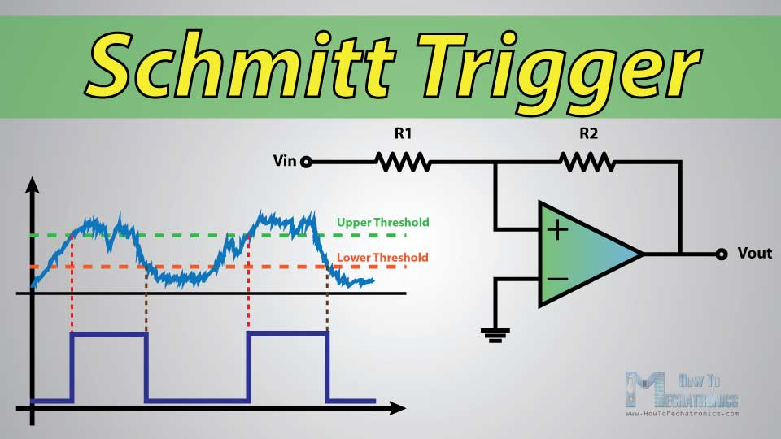

Episode 36: Electronic Basics #36: SPI and how to use it

**Overall Video Summary:**  
This video transitions from the previously discussed I2C protocol to the SPI (Serial Peripheral Interface) protocol. The presenter uses a DS3234 Real-Time Clock (RTC) IC, which, unlike many RTCs that use I2C, communicates via SPI. The tutorial demonstrates how to wire up the DS3234 to an Arduino Nano, understand the SPI pin functions, and write Arduino code to initialize the RTC, set its time/date, and read data back, verifying the communication with an oscilloscope and the Serial Monitor.

**Introduction to SPI & The DS3234 RTC Challenge**

* **Recap:** The video briefly revisits I2C as a common communication protocol.
* **New Component:** Introduces the **DS3234 Real-Time Clock (RTC) IC**.
  + This IC is designed for accurate timekeeping (seconds, minutes, hours, day, date, month, year) and includes features like programmable alarms and a square-wave output.
* **The Challenge:** The DS3234 IC does *not* use I2C pins (SCL, SDA). Instead, its datasheet reveals it uses pins like CLK, MISO, MOSI, and SS, indicating it communicates via the **SPI (Serial Peripheral Interface)** protocol.
* **Objective:** To learn how to use SPI with an Arduino to read from and write to the DS3234 RTC.

Instruments/Components Used for Setup:

Arduino Nano (as the SPI Master)

DS3234 Breakout Board (e.g., from SparkFun, acting as the SPI Slave)

Breadboard

Jumper Wires

**Verification & Advantages of SPI**

* **Instruments Used for Verification:**
  + **Digital Oscilloscope:**
    - To observe the square-wave output of the RTC (e.g., set to 8.192 kHz to confirm successful register write).
    - To visualize and decode the actual SPI communication on the CLK, MOSI, MISO, and CS lines.
  + **Arduino IDE Serial Monitor:** To display the time and date read from the RTC, confirming successful read operations.
* **SPI Advantages:**
  + **Speed:** SPI is generally much faster than I2C. The video demonstrates successful communication at 4 MHz, while I2C is often limited to 100 kHz or 400 kHz. This makes SPI suitable for high-speed data transfer (e.g., with SD cards).
* **SPI Disadvantages:**
  + **Pin Count:** Requires more pins than I2C, especially when using multiple slave devices, as each slave needs its own dedicated Chip Select (CS) line.

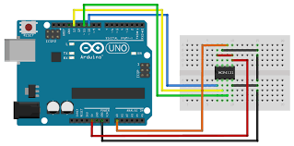

**SPI and how to use it**

Episode 37: Electronic Basics #37: What is Impedance? (AC Resistance?)

**Core Concept: Transition from DC Resistance to AC Impedance**

* **DC Circuits:**
  + **Resistors:** Oppose DC current flow, converting excess energy to heat (e.g., for LEDs). Their resistance (R) is constant.
  + **Inductors & Capacitors (in DC):** Primarily act as energy storage. They resist *sudden changes* in current (inductors) or voltage (capacitors) during transient states. In steady-state DC, ideal inductors act as short circuits, and ideal capacitors act as open circuits, not influencing steady current flow.
* **AC Circuits:**
  + The behavior of inductors and capacitors becomes much more dynamic and frequency-dependent.
  + **Impedance (Z):** The total opposition a circuit presents to alternating current. It's the AC equivalent of resistance and is also measured in Ohms (Ω). Impedance is a complex quantity that includes both resistance (R) and reactance (X).
  + **Reactance (X):** The opposition to AC current due to capacitance (capacitive reactance, XC) or inductance (inductive reactance, XL). It is frequency-dependent.

**Instruments & Components Used in Demonstrations:**

* **Signal Source:**
  + **Instrument:** Siglent SDG 2082X Function Generator (provides AC sine waves of varying frequencies and amplitudes).
* **Amplification:**
  + **Component:** An unspecified audio amplifier board (used to boost the function generator's signal to drive components like LEDs).
* **Measurement & Observation:**
  + **Instrument:** Oscilloscope (brand varies, Rigol shown in a thumbnail, another in use) – Used to visualize voltage and current waveforms, measure their RMS values, and determine phase differences.
  + **Instrument:** Current Clamp – Used with the oscilloscope to measure AC current.
  + **Instrument:** LCR Meter (Keysight U1732C) – Used to measure inductance (L), capacitance (C), resistance (R) of components, and also their impedance (Z) and phase angle at specific test frequencies.
  + **Instrument:** Multimeters (Metrahit Pro, Uni-T) – Used for basic DC measurements and resistance checks.
* **Components Under Test:**
  + Resistors
  + Inductors (e.g., a toroidal inductor measured ~214 µH)
  + Capacitors (e.g., a 1.0 µF WIMA MKP4 film capacitor)
  + LEDs (as loads)

**Behavior of Individual Components in AC Circuits:**

1. **Inductor in AC:**
   * **Inductive Reactance (XL):** Opposes changes in current. XL = 2πfL (where f is frequency, L is inductance).
   * **Phase Shift:** Voltage across the inductor *leads* the current through it by approximately 90° (for an ideal inductor).
   * **Frequency Dependence:** XL *increases* as frequency increases. (Higher frequency = more opposition from inductor).
   * The video demonstrates this by increasing frequency and showing the current (measured by current clamp) decrease.
2. **Capacitor in AC:**
   * **Capacitive Reactance (XC):** Opposes changes in voltage. XC = 1 / (2πfC) (where f is frequency, C is capacitance).
   * **Phase Shift:** Current through the capacitor *leads* the voltage across it by approximately 90° (for an ideal capacitor).
   * **Frequency Dependence:** XC *decreases* as frequency increases. (Higher frequency = less opposition from capacitor).
   * The video demonstrates this by increasing frequency and showing the current increase.
3. **Resistor in AC:**
   * **Resistance (R):** The opposition is purely resistive.
   * **Phase Shift:** Voltage and current are in phase (0° phase shift).
   * **Frequency Dependence:** Resistance (ideally) is not dependent on frequency.

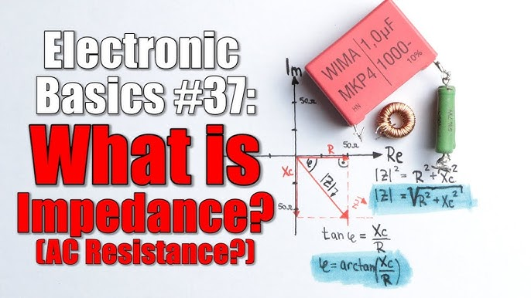

Episode 38: Electronic Basics #38: True, Reactive, Apparent & Deformed Power

The Star of the Show: The Energy Multimeter

* **Instrument Name:** The primary instrument showcased is a **Gossen Metrawatt METRAHIT ENERGY TRMS System Multimeter**.
* **Core Function:** It's an "Energy Multimeter" designed to measure not just standard electrical parameters but also energy consumption (mWh, Wh) and power quality metrics like power factor (PF), true power (W), reactive power (VAR), and apparent power (VA) for AC appliances.
* **Connection:** It uses three probes connected to a mains socket adapter to perform these measurements on devices plugged into the adapter.

Key Concepts Unveiled: Power Types & Power Factor

* **True Power (P):** The actual power consumed by a device to perform useful work (e.g., light, heat, motion). Measured in Watts (W).
* **Reactive Power (Q):** Power that oscillates between the source and reactive components (like inductors in motors/transformers or capacitors). It doesn't do useful work but still requires current to flow in the circuit. Measured in Volt-Amps Reactive (VAR).
  + **Inductive Reactive Power:** Caused by inductors; current *lags* voltage.
  + **Capacitive Reactive Power:** Caused by capacitors; current *leads* voltage.
* **Apparent Power (S):** The vector sum of True Power and Reactive Power (S = √(P² + Q²)). It's the total power that *appears* to be flowing, calculated as Voltage x Current. Measured in Volt-Amps (VA).
* **Deformed Power (D):** Arises when the current waveform is not sinusoidal (contains harmonics), often due to non-linear loads like switch-mode power supplies (e.g., laptop chargers). This also contributes to a lower effective power factor.
* **Power Factor (PF or λ):** The ratio of True Power to Apparent Power (PF = P/S). It indicates how effectively electrical power is being converted into useful work.
  + An ideal PF is 1 (True Power = Apparent Power, no reactive/deformed power).
  + A low PF means a significant portion of the current drawn is not doing useful work, leading to inefficiencies.
  + For sinusoidal waveforms, PF = cos(φ), where φ is the phase angle between voltage and current.

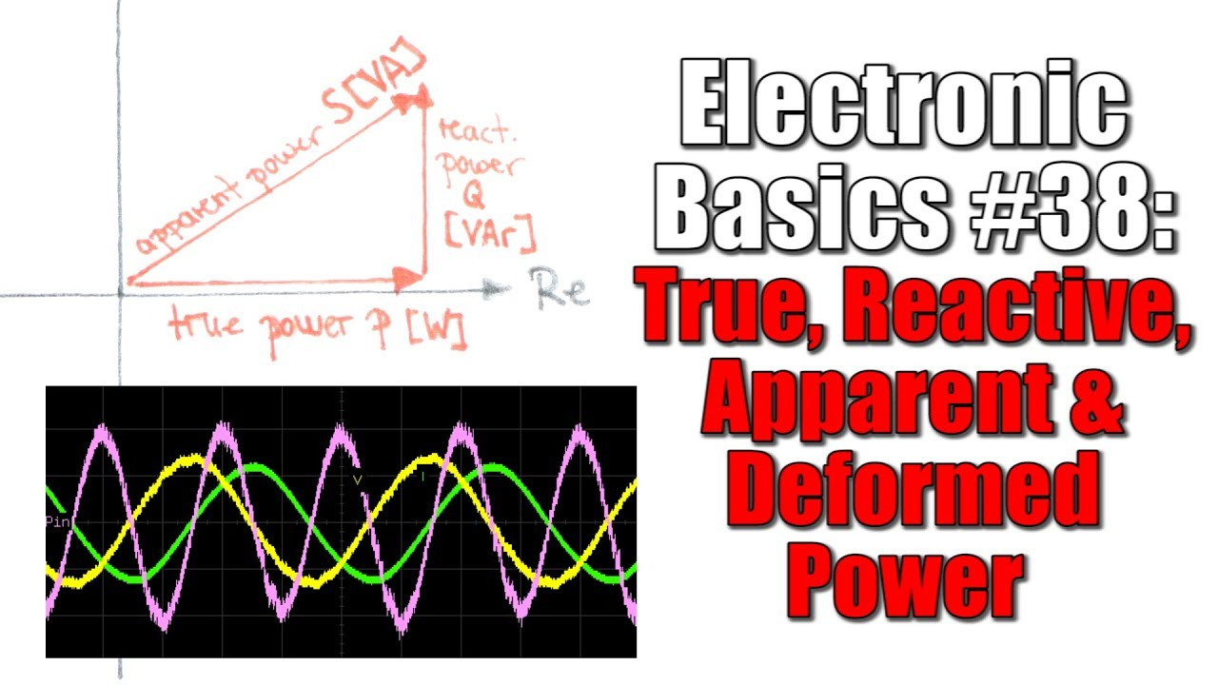

Episode 39: Controlling a BIG LED Matrix?! How Shift Registers work! || EB#39

The video documents the process of understanding and controlling a large, custom-made LED matrix received as a donation. The goal is to make it display text and animations.

**Hardware Deep Dive - Components & Initial Analysis:**

* **LED Matrix PCB:**
  + **LEDs:** 384 through-hole LEDs per board.
  + **Driver ICs:** Six **STP16C596** chips. These are 16-bit constant current LED sink drivers, which also function as Serial-In, Parallel-Out (SIPO) shift registers with a storage register.
  + **Logic ICs:** Two **SN74LS14** (Hex Schmitt Trigger Inverters) are used, likely for signal conditioning/buffering of control signals.
  + **Other Components:** Capacitors, resistors, and male/female headers for power and data input.
* **Initial Testing:** Directly applying voltage to individual LED pins confirms they are functional and emit an orange/red light.

**III. Reverse Engineering the Matrix Control:**

* **Anode Control (Rows/Lines):**
  + The 12 anode lines (rows) are grouped. Probing reveals the top male header pins control these anode lines in sets of three.
  + Multiplexing is necessary: only one group of three anode lines is active at any given time. The controller rapidly cycles through these four groups.
* **Cathode Control (Columns):**
  + The 32 cathode lines (columns) are controlled by the outputs of the six STP16C596 shift register/driver ICs.
  + Since 6 ICs x 16 outputs/IC = 96 outputs, and there are 384 LEDs, this confirms the multiplexing strategy. For each active group of 3 anode lines, 32 (columns) x 3 (active rows) = 96 LEDs are controllable at that instant.
* **Shift Register (STP16C596) Operation:**
  + **Serial Data In (SDI):** Data bits are clocked into the shift register serially. The matrix uses three separate SDI lines, one for each set of two STP16C596 ICs controlling a third of the columns.
  + **Clock (CLK):** A clock signal shifts the data bits through the register.
  + **Latch Enable (LE):** A pulse on this pin transfers the 16 bits from the internal shift register to the output storage register, making the data appear on the output pins (driving the cathodes).
  + **Output Enable (OE):** This pin (active low) enables or disables all outputs. In the video, it's tied to ground to keep outputs always enabled when latched.

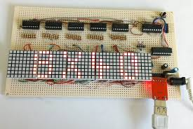

**Controlling a BIG LED Matrix**

Episode 40: How safe is contactless payment? || How does RFID & NFC work? || EB#40

Contactless Payments & Introduction

* **Concept:** The video starts by introducing the growing trend of contactless payments using services like Google Pay or contactless bank cards (e.g., Girocard, Maestro).
* **Core Idea:** To explore the technology (RFID/NFC) behind these payments, its security, and how it can be used in DIY Arduino projects.

Key Components & Instruments

* **RFID/NFC Readers (Interrogators):**
  + **RC522 Module (MFRC522 IC):** A popular and inexpensive module for Arduino, operating at 13.56 MHz. Used extensively in the video for DIY projects.
    - Features: SPI interface, PCB antenna.
  + **PN532 Module:** Another 13.56 MHz module, often considered more versatile for various NFC standards.
  + **RDM6300 Module:** Operates at a lower frequency (125 kHz).
  + **Smartphone NFC Reader:** Modern smartphones (like the Samsung Galaxy S7/S8+ shown) have built-in NFC readers/writers.
* **RFID/NFC Tags (Transponders):**
  + **Structure:** Consist of an IC (Integrated Circuit/chip) and an antenna (coil).
  + **Types shown:**
    - Mifare Classic 1K tags (cards and key fobs, 1KB memory, operate at 13.56 MHz).
    - Contactless Bank Card (Girocard/Maestro).
  + **Function:** Store data (UID, memory blocks) and communicate with the reader when in its RF field.
* **Instruments Used for Analysis:**
  + **Oscilloscope:** Used to visualize the RF signal generated by the RC522 reader, confirming its 13.56 MHz frequency and showing how the tag modulates this signal's amplitude to send data back.
  + **Arduino Uno:** Used as the microcontroller to interface with the RC522 reader module.

Security of Contactless Systems

* **Basic RFID Tags (like Mifare Classic 1K):**
  + Can be "dumb" and transmit their data relatively openly once powered by a reader.
  + Security relies on UID and potentially some simple key-based access to memory sectors.
* **Contactless Payment Cards (NFC):**
  + **Encryption:** Data exchanged during transactions is typically encrypted. The video implies that simply reading sensitive data with a basic Arduino reader isn't possible due to this.
  + **Close Proximity:** NFC requires the card to be very close to the reader (a few cm), reducing the risk of accidental reads from a distance.
  + **Payment Limits:** Most contactless payments have a limit (e.g., 25€ mentioned) for transactions without requiring a PIN, minimizing potential losses.
* **Anti-Skimming Card Holders/Sleeves:**
  + Made of metal or RF-blocking material.
  + When a card is inside, it damps or blocks the RF signals, preventing unauthorized readers from communicating with the card

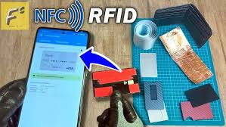

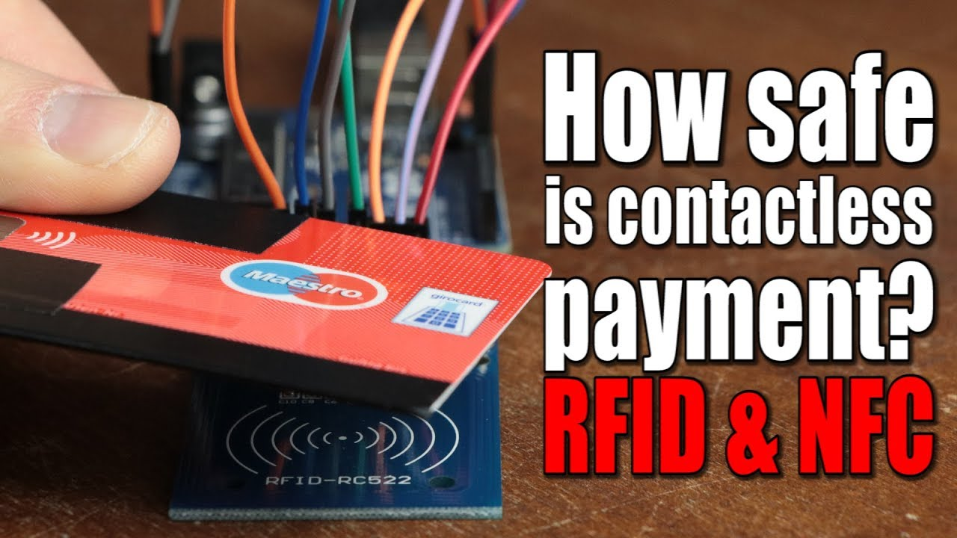

Episode 41: Does a DIY Audio Crossover make sense? How passive filters work! || EB#41

**1. Introduction & Premise**

* The video revisits a previous project where the host converted a bookshelf speaker into a portable boombox.
* A key modification was replacing the original audio crossover with a generic one from eBay.
* Many viewers questioned this, suggesting the original crossover was likely better designed for the specific speaker drivers.
* This video aims to:
  + Explain how audio crossovers (passive filters) function.
  + Demonstrate how to theoretically calculate them.
  + Determine if replacing or DIY-ing a crossover is advisable.

**2. Understanding Audio Signals & Speakers**

* **Audio Signal:** A complex AC (Alternating Current) signal typically spanning frequencies from 20Hz to 20,000Hz (the range of human hearing). This signal needs amplification before it can drive speakers.
* **Loudspeaker Components in a 2-Way System:**
  + **Woofer:** The larger speaker driver, designed to reproduce low-frequency sounds (e.g., 40Hz - 2000Hz). It's larger and has more inertia, allowing it to move more air for bass tones.
  + **Tweeter:** The smaller speaker driver, designed for high-frequency sounds (e.g., >2000Hz). It's small and agile for reproducing crisp high notes.
* **Role of the Audio Crossover:** To split the amplified audio signal into different frequency bands and direct them to the appropriate speaker driver (low frequencies to the woofer, high frequencies to the tweeter). This prevents distortion and potential damage to the drivers.

**Experimenting with Filter Components (Instruments & Setups Used)**

* **Instruments & Tools Used:**
  + **Function Generator (Siglent SDG 2082X):** To produce sine wave test signals at varying frequencies.
  + **Oscilloscope (Keysight InfiniiVision MSOX3054T "MegaZoom"):** To visualize and measure the input and output voltage waveforms and their frequencies.
  + **Audio Amplifier Module:** To boost the signal from the function generator before it reaches the filter and load.
  + **Dummy Load Resistor (4 Ohm):** Used in place of an actual speaker for consistent impedance during testing.
  + **LCR Meter (Keysight U1732C):** To measure the inductance and capacitance of components.
  + **Multimeter:** To measure resistance.
  + **Soldering Iron:** To assemble test circuits.
* **Experiments & Observations:**
  + **Resistor in Series:** Acts as a simple voltage divider. Attenuates the signal across *all* frequencies. Output voltage (Vout) = Vin \* (RLoad / (RSeries + RLoad)).
  + **Inductor (e.g., 150µH) in Series (RL Low-Pass Filter):**
    - The inductor's impedance (Inductive Reactance, XL = 2πfL) *increases* with frequency.
    - This configuration forms a **Low-Pass Filter**, attenuating high frequencies more than low frequencies.
    - Fc = R / (2πL) (where R is the load resistance).
  + **Capacitor (e.g., 10µF) in Series (RC High-Pass Filter):**
    - The capacitor's impedance (Capacitive Reactance, Xc = 1 / (2πfC)) *decreases* with frequency.
    - This configuration forms a **High-Pass Filter**, attenuating low frequencies more than high frequencies.
    - Fc = 1 / (2πRC) (where R is the load resistance).
  + **LC Filter (Second Order):** Combining an inductor and capacitor can create steeper -40dB/decade filters.
    - Fc = 1 / (2π√(LC)).

**5. Analyzing the Original vs. Replacement Crossover**

* **Software Used:** **VituixCAD** (free loudspeaker design and simulation software).
* **Original Bookshelf Speaker Crossover:**
  + A complex, likely third-order or mixed-order design.
  + Low-pass section for woofer had a cutoff around 700Hz.
  + High-pass section for tweeter was less clear-cut due to its complexity but generally started filtering above 2kHz, though with significant pre-attenuation.
* **eBay Replacement Crossover:**
  + A simpler, generic second-order design.
  + Its filter characteristics did *not* align well with the original design or the likely needs of the specific speaker drivers.
* **Key Insight:** Loudspeakers are not purely resistive loads; they have their own frequency-dependent impedance (largely inductive). A good crossover is designed to complement these specific driver characteristics to achieve a flat and smooth overall frequency response from the speaker system

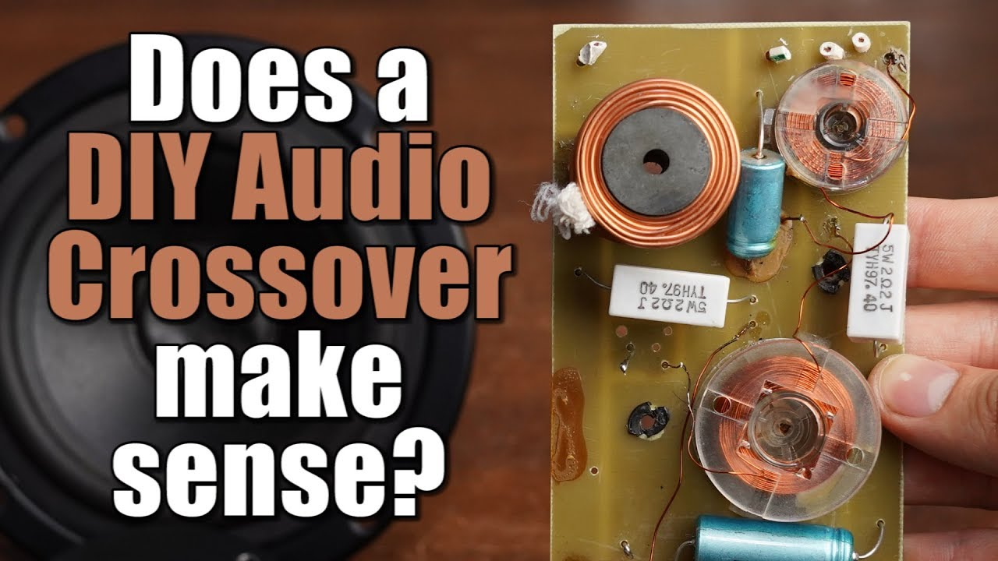

Episode 42: Is it easy to create your own Transformer? Everything you need to know about Transformers! || EB#42

* **Instrument Name:** Transformer
* **Primary Function:** To change (transform) AC (Alternating Current) voltage levels. Commonly used to step down high mains AC voltage (e.g., 230V) to lower, safer AC voltages (e.g., 12V, 15V) for electronic devices.
* **Core Components:**
  + **Iron Core (or Ferrite Core):** Made of a ferromagnetic material.
    - **Electrical Steel Sheets (Laminated):** Used in traditional low-frequency (50/60Hz) transformers to guide the magnetic flux and reduce eddy current losses.
    - **Ferrite:** Used in high-frequency transformers (like in Switch-Mode Power Supplies - SMPS) because it has lower losses at high frequencies.
  + **Primary Coil (Winding):** Copper wire wrapped around one part of the core. Receives the input AC voltage (e.g., mains voltage).
  + **Secondary Coil (Winding):** Copper wire wrapped around another part of the core (or sometimes over the primary). The output AC voltage is induced here.
* **Operating Principle (Electromagnetic Induction):**
  + An AC voltage applied to the **primary coil** creates an AC current.
  + This AC current generates a changing **magnetic flux** within the **core material**.
  + The core guides this changing magnetic flux through to the **secondary coil**.
  + The changing magnetic flux passing through the secondary coil induces an AC voltage across it (Faraday's Law of Induction).
* **Voltage Transformation Ratio:** The ratio of output voltage (V₂) to input voltage (V₁) is approximately equal to the ratio of the number of turns in the secondary coil (N₂) to the number of turns in the primary coil (N₁). (V₂/V₁ ≈ N₂/N₁)

Instruments Used for Analysis in the Video

* **Multimeter (e.g., Metrahit Pro/Energy):**
  + Measures AC Voltage (input and output).
  + Measures AC Current (input and output).
  + Measures Resistance of coils.
  + Measures Power (Apparent Power in VA, Real Power in Watts).
* **LCR Meter (e.g., Keysight U1732C):**
  + Measures Inductance (L) of the coils (e.g., primary inductance was ~5.1 Henry).
* **Oscilloscope (e.g., InfiniiVision MSOX3054T):**
  + Visualizes AC waveforms.
  + Measures Frequency of the AC signal (e.g., mains 50Hz, SMPS ~25-30kHz)

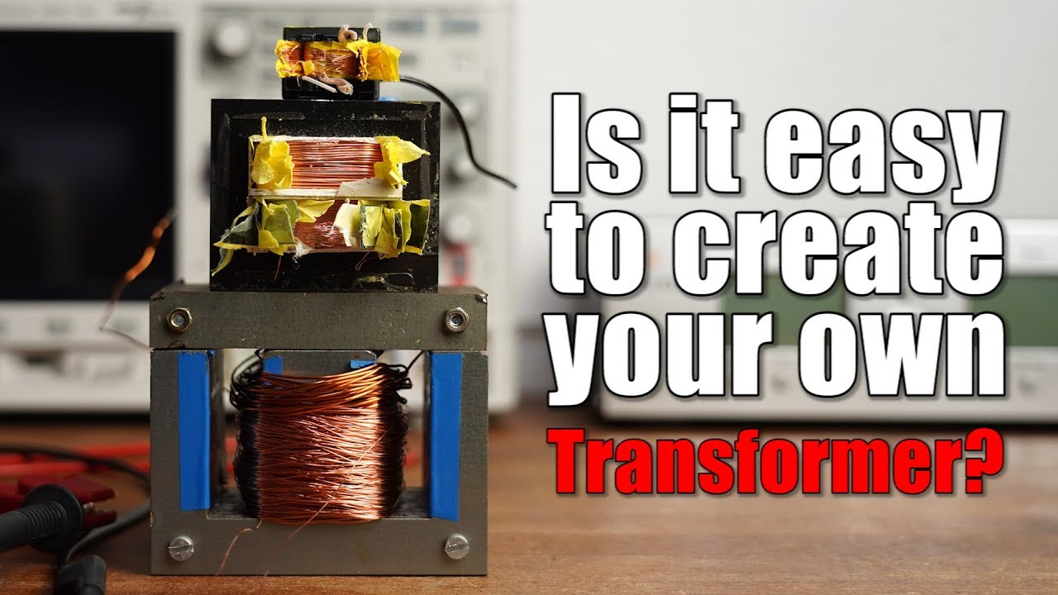

Episode 43: Controlling Mechanical 7-Segment Displays?! How RS-485 and UART works! || EB#43

**The Star of the Show: Mechanical 7-Segment Displays**

* **Instrument Name:** Mechanical 7-Segment Display (also known as flip-segment or electromagnetic displays).

Key Feature (Latching): Once a segment is flipped, it stays in that position without continuous power, making them very low power for static displays. Power is only needed to change the state.

Source: The displays and the control module in the video were provided by the company Alfazeta.

**Understanding the Control Board (Alfazeta Module)**

* **Purpose:** To simplify the complex task of controlling multiple (10 in this case) mechanical 7-segment displays.
* **Reverse Engineering Process:** The video details disassembling the control board, identifying components, checking datasheets, and tracing connections using a multimeter's continuity function.
* **Core Component:** The control board is primarily driven by an **ATmega32A microcontroller**.
* **Driving Mechanism (Multiplexing):**
  + The board uses a multiplexing or matrix control scheme.
  + **High-voltage source driver ICs (TD62783AFG)** are used to select which display unit is currently active (by providing power to one side of all its electromagnets).
  + **Darlington transistor array ICs (ULN2003-type, e.g., SN75468)** are used to select which specific segments within the active display are energized (by sinking current from the other side of the electromagnets).
  + This allows a smaller number of microcontroller pins to control a large number of segments.
* **Configuration:**
  + **DIP Switches:** Used to set the baud rate for communication and the module's address (when multiple modules are daisy-chained).

**Key Instrument Uses & Features Summarized**

* **Mechanical 7-Segment Displays Use:**
  + Physical moving segments (plastic).
  + Permanent magnets on segments.
  + Electromagnets (coils) for actuation.
  + Latching mechanism (no power to hold state).
* **Control Board Uses:**
  + ATmega32A microcontroller.
  + Multiplexing logic (source drivers, Darlington arrays).
  + UART and RS-485 communication interfaces.
  + DIP switches for configuration.
* **RS-485 Standard Uses:**
  + Differential signaling (A and B lines).
  + Twisted pair wiring.
  + Asynchronous serial data transmission.
* **Overall Project Uses:**
  + ESP8266 for WiFi connectivity and data fetching (YouTube API).
  + MAX485 for UART to RS-485 conversion.
  + A specific communication protocol (defined by Alfazeta) over RS-485 to send data to the displays.

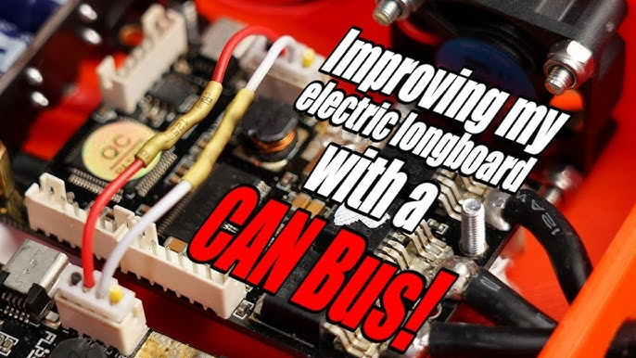

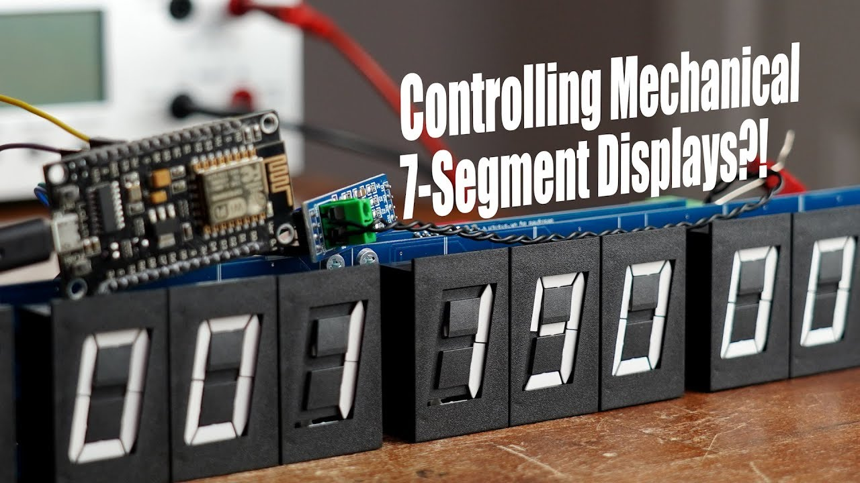

Episode 44: Improving my electric longboard with a CAN Bus! What can the CAN Bus do? EB#44

**CAN Bus Implementation**

* **Core Idea:** To use the CAN (Controller Area Network) bus feature of the FSESCs (Flipsky Electronic Speed Controllers, specifically VESC-based) to ensure perfect synchronization between them.
* **Goal:** One ESC (master) receives the remote control signal, and then communicates this information digitally to the other ESC (slave) via CAN bus, ensuring identical commands.

**What is CAN Bus?**

* **Definition:** CAN stands for **Controller Area Network**.
* **Function:** It's a robust serial bus system designed to allow microcontrollers and devices (nodes) to communicate with each other via messages (frames) without needing a central host computer.
* **Physical Layer:** Typically uses two wires: CANH (CAN High) and CANL (CAN Low) for differential signaling.

**Key Features & How CAN Bus Works (General Explanation)**

* **Signal Lines & Logic:**
  + **CANH & CANL:** Two wires providing differential signaling, making it robust against noise.
  + **Dominant State (Logic 0):** When a device actively drives the bus, creating a voltage difference between CANH and CANL (e.g., CANH goes higher, CANL goes lower).
  + **Recessive State (Logic 1):** When no device is actively driving the bus, the lines return to a common voltage level.
* **Communication:**
  + **Message-Based:** Nodes send data in "frames."
  + **Asynchronous:** No separate clock line; nodes synchronize based on the baud rate and transitions on the bus.
  + **Half-Duplex:** A node can either send or receive at a given time, not both simultaneously on the same pair.
* **Arbitration (Collision Avoidance):**
  + **ID-Based Priority:** Each CAN frame starts with an identifier (CAN-ID). Lower numerical IDs have higher priority.
  + **Non-Destructive Bitwise Arbitration:** If multiple nodes start transmitting simultaneously, they monitor the bus. If a node transmitting a recessive bit (1) detects a dominant bit (0) from another node (with a lower ID), it stops transmitting. The node with the lowest ID (highest priority) continues. This prevents data corruption.
* **Frame Protocol:** Includes:
  + Start of Frame (SOF)
  + CAN-ID (Identifier)
  + Control bits
  + Data (0-64 bits)
  + CRC (Cyclic Redundancy Check) for error detection.
  + ACK (Acknowledge) slot for receivers to indicate successful reception.
  + End of Frame (EOF)
* **Robustness & Reliability:**
  + Differential signaling and twisted-pair wiring reduce noise susceptibility.
  + CRC and ACK mechanisms ensure data integrity.
* **Termination:**
  + Requires termination resistors (e.g., 120Ω) at both ends of the bus to prevent signal reflections. For low-speed CAN, individual nodes might have higher resistance termination.
* **Types:**
  + High-Speed CAN (up to 1 Mbit/s)
  + Low-Speed CAN (e.g., 125 kbit/s, fault-tolerant)
  + CAN-FD (Flexible Data-Rate, up to 5 Mbit/s or more)

**Practical Implementation on Electric Longboard**

* **Hardware Components Used:**
  + **FSESCs (Flipsky Electronic Speed Controllers):** VESC-based controllers with CAN bus capability.
  + **4-pin JST Connectors:** To connect to the CAN port on the FSESCs.
  + **Wires:** To create the CAN bus link between the two FSESCs (CANH to CANH, CANL to CANL).
* **Software Tool:**
  + **VESC Tool:** Software used to configure the FSESCs.

**Instrument Used for Analysis**

* **Component Name:** **Oscilloscope** (specifically a Keysight InfiniiVision model is visible)
* **Usage in Video:**
  1. **Initial Problem Diagnosis:** To confirm that both ESCs were indeed receiving the same PPM signal from the remote control receiver.
  2. **CAN Bus Signal Analysis:**
     + To visualize the CANH and CANL differential signals.
     + To observe the voltage levels for dominant (0) and recessive (1) states.
     + To decode the CAN frames and view the data being transmitted (IDs, data payload, CRC etc.), demonstrating the communication between the ESCs.

**Outcome & Benefits for the Longboard**

* **Synchronized Motor Operation:** The primary goal of having both wheels start and run at the same RPM was achieved.
* **Enabled Traction Control:** By using CAN bus, the VESC's built-in traction control feature became functional. This feature attempts to match the power consumption and RPM of both wheels, which can improve handling, especially in curves or on slippery/uneven terrain (like mud).

**Broader Applications of CAN Bus**

* **Automotive Industry (Primary Use):** Extensively used in cars for communication between various ECUs (Electronic Control Units) like:
  + Engine control
  + Transmission
  + ABS (Anti-lock Braking System)
  + Airbags
  + Dashboard instruments (instrument cluster)
  + Body control modules (windows, locks, lights, mirrors)
  + Infotainment systems
  + Parking assist systems
  + OBD-II (On-Board Diagnostics) port often provides access to CAN bus data.
* **Industrial Automation:** Control systems, robotics.
* **Aerospace, Medical Equipment, and more.**
* **DIY Electronics:** CAN controller/transceiver modules (e.g., MCP2515 controller + TJA1050 transceiver) are available for hobbyists to interface with microcontrollers like Arduino to read from or send data to a CAN bus.

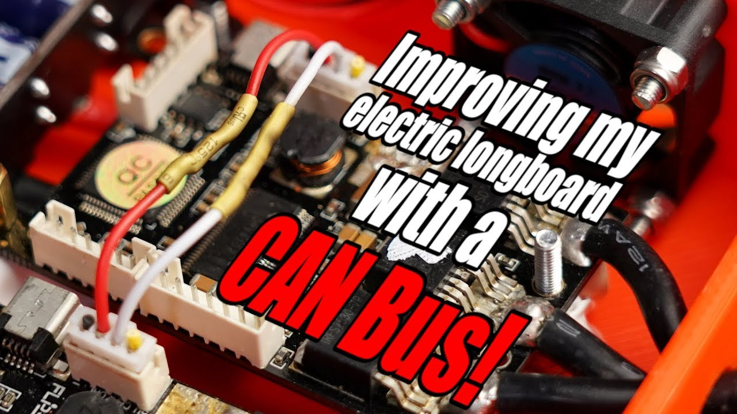

Episode 45: Building a Digital Music Player with I2S?! What is I2S! EB#45

The main objective is to play back a pre-recorded, high-quality (16-bit, 44.1 kHz) audio clip ("Stay creative") using an ESP32 microcontroller, and also to explore recording audio with an I²S microphone. The video emphasizes maintaining audio quality by bypassing the ESP32's limited internal DAC.

**Understanding Digital Audio Basics**

* **Audio Source:** A .wav file, which is a PCM (Pulse Code Modulation) audio format.
* **Bit Depth:** The original audio is 16-bit, meaning each sample has 2<sup>16</sup> (65,536) possible amplitude levels. Higher bit depth means better dynamic range and closer representation to the original analog sound.
* **Sampling Rate:** The original audio is sampled at 44.1 kHz (44,100 times per second). This determines the highest frequency that can be accurately reproduced.
* **Data Transfer:** The ESP32 needs to read this digital audio data from a source and then convert it back to an analog signal for a speaker.

**Input Side: Storing and Reading Audio Data**

* **Component:** MicroSD Card Breakout Board.
  + **Purpose:** To store the .wav audio file.
  + **Interface with ESP32:** SPI (Serial Peripheral Interface) - A fast serial communication protocol allowing the ESP32 to read the audio data bits from the MicroSD card efficiently without losing the original 16-bit, 44.1 kHz quality.

**Output Side Challenge: ESP32's Internal DAC**

* **ESP32 Internal DAC (Digital-to-Analog Converter):**
  + The ESP32 has a built-in DAC, but it only offers an **8-bit resolution**.
  + **Problem:** Using the internal DAC would create a bottleneck, reducing the 16-bit audio data to 8-bit, significantly degrading sound quality.

**Practical Implementation & Components Used with I²S**

**1. I²S Microphone (Input Test):**  
\* **Component Name:** **INMP441** I²S MEMS Microphone Breakout Board.  
\* **Purpose:** To capture audio and send digital data to the ESP32 via I²S.  
\* **ESP32 Connection:** Connected to user-configurable GPIO pins on the ESP32, defined in the code for WS, SCK, and SD.  
\* **Testing:** Code was written to read data from the mic and display it on the Arduino IDE's Serial Plotter. Whistling/tapping showed the mic was capturing sound.  
**2. I²S DAC & Amplifier (Output for Playback):**  
\* **Component Name:** **MAX98357A** I²S Audio Breakout Board (DAC and Class-D Amplifier).  
\* **Purpose:** To receive digital audio data from the ESP32 via I²S, convert it to an analog signal (DAC), and amplify it to drive a speaker.  
\* **ESP32 Connection:** Connected to GPIO pins for WS, SCK, and SD (DIN on the amp board).  
\* **Combined Setup for Playback:**  
\* ESP32 (Master)  
\* MicroSD Card Breakout Board (Audio source via SPI)  
\* MAX98357A I²S Amplifier Board (Audio output via I²S)  
\* Speaker  
\* **Software:** Used the "ESP8266Audio" library and code snippets from SparkFun.  
\* **Result:** Successfully played back the "Stay creative" and "Awesome" audio clips with good quality.

**Instruments & Tools Used for Analysis & Development**

* **Computer with Arduino IDE:** For writing and uploading code to the ESP32.
  + **Uses:** Serial Monitor and Serial Plotter for debugging and visualizing data from the I²S microphone.
* **Oscilloscope:** (Specifically, a Keysight InfiniiVision MSOX3054T is shown).
  + **Uses:** To visualize the I²S signals (Word Select, Serial Clock, Serial Data) in real-time, confirming their behavior and frequencies during both microphone input and amplifier output. This helps understand the timing and data flow of the I²S protocol.
* **Soldering Iron:** For connecting wires to the breakout boards.
* **Multimeter (implied):** For general electronics work, though not explicitly shown for a specific measurement in this context.
* **Audio Editing Software (e.g., Audacity):** Shown at the beginning for recording and viewing the initial sound wave.

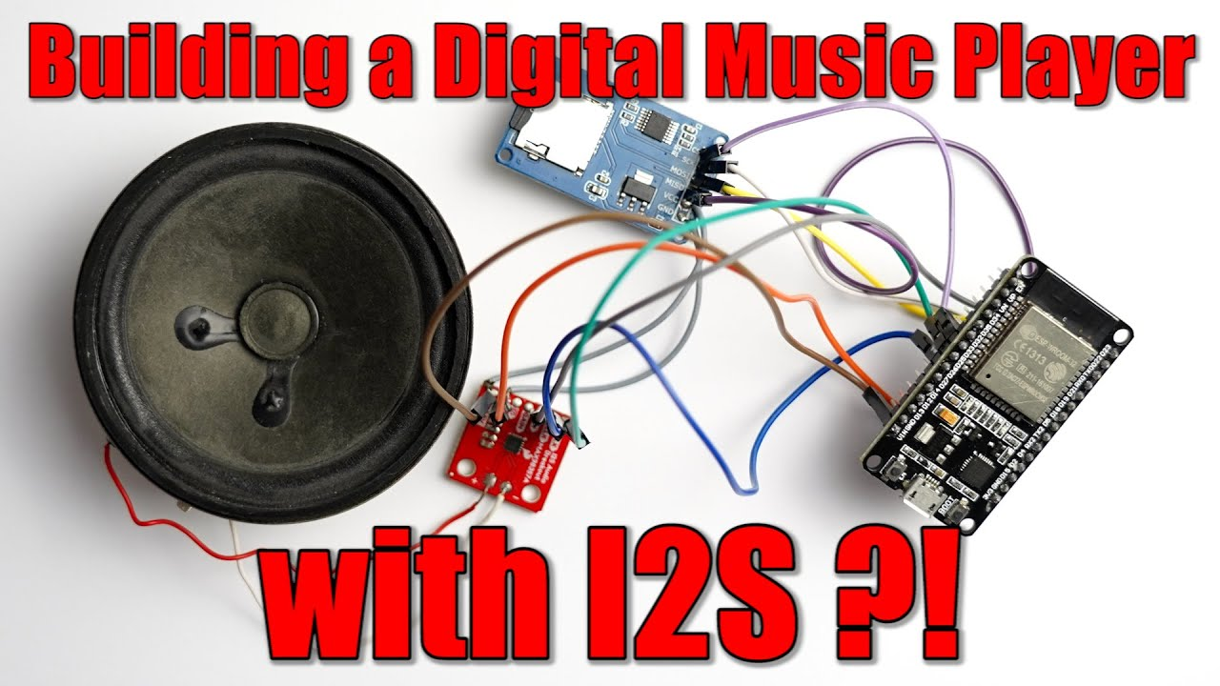

Episode 46: Does this old Induction Motor still work? || How do Asynchronous Motors work? EB#46

**Video Overview:**  
The video demystifies the asynchronous motor (also known as an induction motor), a common industrial workhorse often overlooked by hobbyists. It contrasts these with typical hobbyist motors (stepper, DC, BLDC) and explains their construction, operating principles, wiring, and practical considerations, including a crucial safety warning.

**Key Points & Components/Instruments:**

1. **Introduction & Comparison:**
   * Compares asynchronous motors to smaller hobbyist motors like **stepper motors**, **DC motors**, and **Brushless DC (BLDC) motors**.
   * Highlights that asynchronous motors are the "most widely used motor type in the world."
2. **Initial Motor Exploration (Old Motor):**
   * **Component:** Old asynchronous motor with a gearbox.
   * **Component:** Terminal box with 6 connection points (U1, U2, V1, V2, W1, W2).
   * **Instrument:** **Multimeter** used to check continuity and identify the three separate stator coils.
   * **Component:** Metal bridge connector pieces for configuring coils.
   * Disassembly attempt revealed a cooling **fan** and **gearbox**.
3. **New Motor Teardown & Core Components:**
   * **Component:** New blue 3-phase asynchronous motor (used as the primary example).
   * **Instruments:** Screwdrivers, Allen keys.
   * **Stator:** The stationary part containing insulated copper **coil windings**. These create the magnetic field.
   * **Rotor:** The rotating part. In this type of motor, it's a **squirrel cage rotor**, made of conductive metal bars shorted at both ends by rings. *Crucially, it has no permanent magnets or brushes.*
   * **Cooling Fan:** Attached to the rotor shaft.
   * **Bearings:** Allow the rotor to spin freely.
   * **Terminal Box:** Provides access to connect the stator windings.

**Wiring & Powering Asynchronous Motors: Star vs. Delta and Safety**

**Key Points & Components/Instruments:**

1. **Wiring Configurations:**
   * **Bridge Connectors:** Used in the terminal box to set up:
     + **Delta (Δ) Configuration:** Coils are connected end-to-start in a triangle. Each coil sees the full phase-to-phase voltage.
     + **Star (Y or Wye) Configuration:** One end of all three coils is connected to a common neutral point. Each coil sees the phase-to-neutral voltage (phase-to-phase voltage / √3).
   * **Type Plate:** Provides crucial information:
     + **Voltage Rating (e.g., 230V/400V):**
       - The lower voltage (230V) is the maximum voltage per coil.
       - If mains is 400V phase-to-phase, use **Star** configuration (each coil gets ~230V).
       - If mains were 230V phase-to-phase, use **Delta** configuration.
     + Power (kW), RPM, IP rating, frequency (Hz).
   * **Instrument:** **Multimeter** used to measure the 3-phase AC voltage from the grid (showing ~400V phase-to-phase) and current draw of the motor (~450mA in star, much higher if incorrectly wired in delta for 400V).
   * **Instrument:** **Oscilloscope** used to visualize the 3-phase AC waveforms and their 120° phase shift.
2. **Safety Warning:**
   * **EXTREMELY IMPORTANT:** Working with 230V/400V AC mains is **LETHAL**. This should only be done by qualified professionals. This high voltage is a primary reason these motors are less common in typical hobbyist projects.

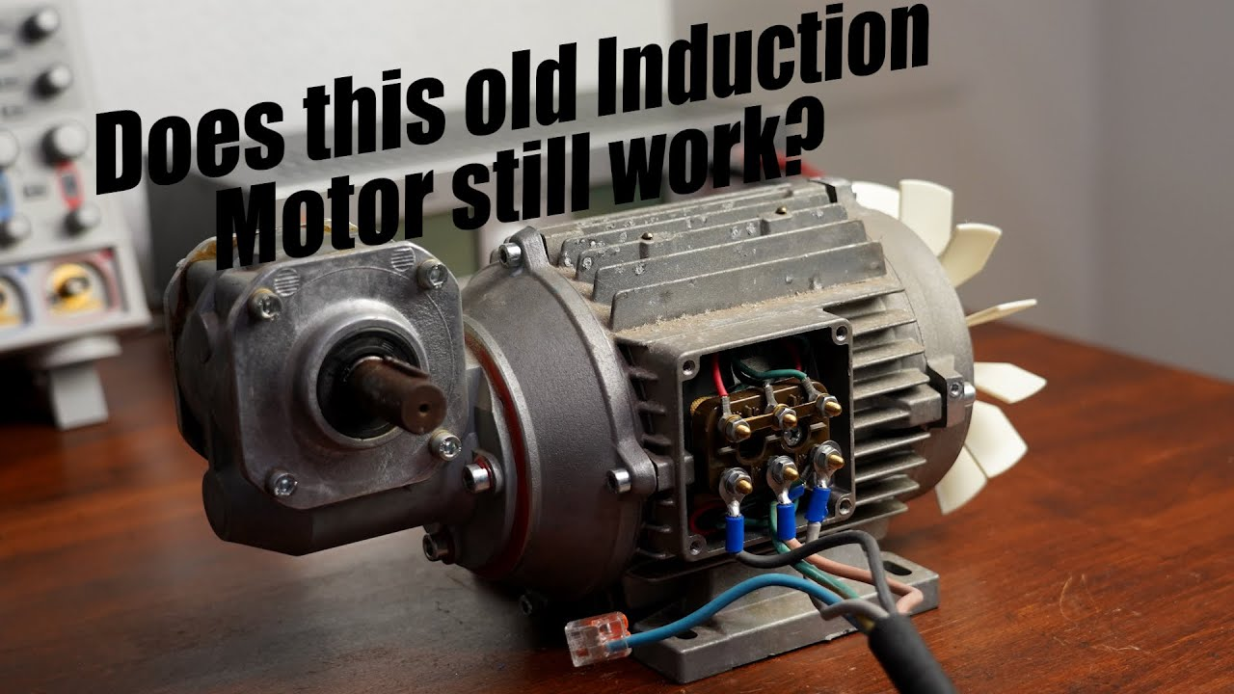

Episode 47: Building a Tube Amp! Does it produce better audio quality though? EB#47

**Key Components & Their Roles:**

* **Vacuum Tubes (Model: 6J4 Triodes):** In this specific amplifier, these are used for **pre-amplification**. Their primary role is to color the sound, adding the characteristic "warm," "natural," and "pleasant" distortion often associated with "tube sound." They are *not* the main power drivers for the speakers.
* **Solid-State ICs (Integrated Circuits):** The actual heavy lifting of power amplification is done by modern semiconductor components:
  + **Operational Amplifiers (Op-Amps):** Used in various signal processing stages.
  + **Headphone Amplifier IC:** Dedicated chip for driving headphones.
  + **Class-D Audio Amplifier IC:** An efficient modern amplifier chip responsible for driving the main speakers.
* **Boost Converter:** A circuit to step up the input voltage (e.g., 12V-24V DC) to the high DC voltage (96V in the tested product) required to operate the vacuum tubes

Practical Challenges of Tubes:

High Voltage Requirement: Tubes need high DC voltages (e.g., 100V-150V) to operate, requiring a boost converter in low-voltage systems.

Power Loss: The heater filaments consume significant power (e.g., 1.8W per tube shown), which is dissipated as heat.

Less Linearity: Compared to transistors, tubes are generally less linear, meaning they inherently introduce more distortion.

Overdrive Characteristics: Tubes are known for a "softer" or less harsh clipping characteristic when overdriven compared to transistors, which is favored in applications like guitar amplifiers.

Sponsor: Altium Designer (PCB design and schematic software).

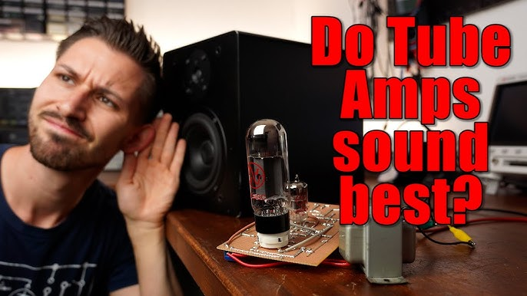

Episode 48: The Best Protection for your Circuits? eFuse! Here is why they are awesome! EB#48

**Essential Protection Features for Robust Projects**

The video highlights the need for a protection circuit that can handle:

1. **Undervoltage:** Prevents the circuit from operating when the supply voltage is too low, which can cause erratic behavior or damage.
2. **Overvoltage:** Protects components from voltages exceeding their safe operating limits.
3. **Reverse Voltage:** Prevents catastrophic damage if the power supply is connected with incorrect polarity.
4. **Overcurrent (Short Circuit):** Limits the current to a safe level if a short circuit occurs or the load draws too much power.
5. **(Implicit) Overtemperature:** While not explicitly listed at the start, the chosen eFuse also offers this.

**Introducing the "eFuse" IC - A Smart & Programmable Solution**

* **Component Name:** **eFuse IC** (Electronic Fuse).
* **Function:** A programmable integrated circuit designed to provide multiple protection features in a compact package.
* **Specific IC Used (Main Example):** **Texas Instruments TPS259621DDAR**
  + Cost-effective (around $0.86 in small quantities).
  + Package: SO-PowerPad-8 (manageable for hand-soldering onto a breakout board).
  + Requires only a few external passive components (resistors, capacitors) to configure its protection thresholds.

**Testing the Protection Features**

* **Instruments Used for Testing:**
  + **Lab Bench Power Supply:** ELV DPS 5315 (to simulate various input voltage and current conditions).
  + **Digital Multimeter:** Metrahit Pro (to measure input/output voltages and currents).
  + **Oscilloscope:** Keysight InfiniiVision MSOX3000 series (to observe current waveforms, especially during current limiting).
  + **Type K Thermometer:** (To measure IC temperature during overvoltage clamping).
* **Verification:** The video demonstrates that the configured undervoltage, overvoltage, and overcurrent protections work as expected.

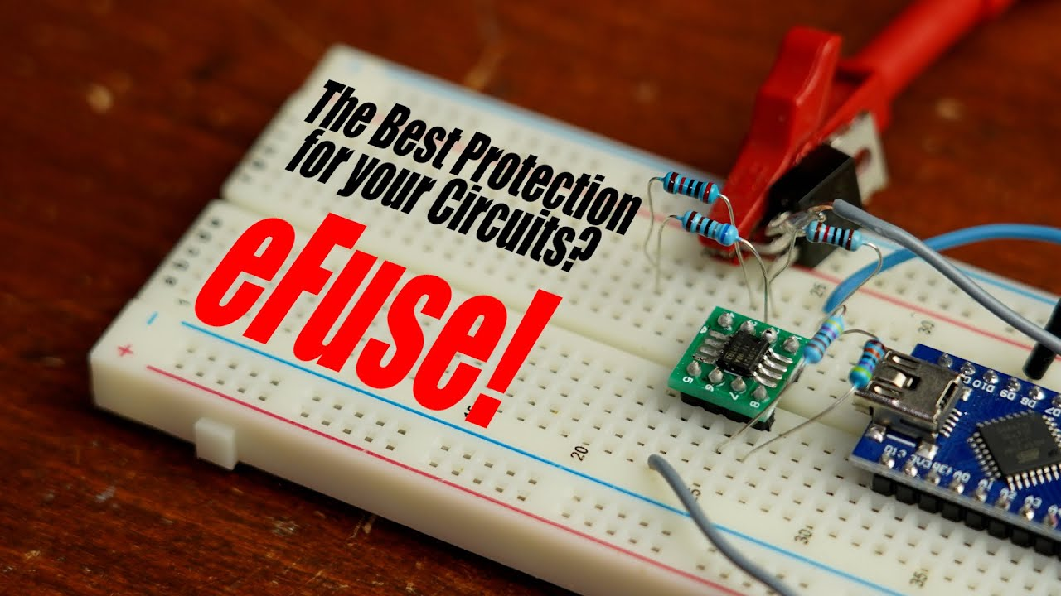

Episode 49: Everything you need to know when buying/using an Oscilloscope! EB#49

**Introduction & The Critical Mistake**

* **Initial Project:** A DIY Switch-Mode Power Supply (SMPS) converting 230V AC to 5V DC, tested with a multimeter (showing ~5.1V).
* **The "Hold It!" Moment (The Big Mistake):**
  + The presenter was about to connect a standard oscilloscope probe (alligator clip to ground, tip to a point in the SMPS) to his mains-powered, non-isolated SMPS prototype.
  + **Why it's a mistake:** Standard oscilloscope grounds are tied to Protective Earth (PE) via the scope's power cord. Connecting this ground to a live or neutral part of a mains-referenced, non-isolated circuit creates a **short circuit through the scope**. This can:
    - Damage the oscilloscope.
    - Damage the Device Under Test (DUT).
    - Trip circuit breakers (RCD or main breaker).
  + This sets the stage for the tutorial on safe and correct oscilloscope usage.

**II. Oscilloscope Fundamentals & Key Controls**

* **What is an Oscilloscope?**
  + An instrument that visualizes electrical signals (voltage and, indirectly, current) as waveforms over time. Essential for analyzing dynamic signals.
* **Oscilloscopes Mentioned/Used:**
  + **Keysight DSOX1204G:** The primary oscilloscope used for demonstrations in the video (a budget-friendly but professional model, approx. €1,429).
  + **Keysight MSOX3054T:** A very high-end oscilloscope mentioned for comparison (approx. €15,842).
  + (Visually, other brands like Rigol and Siglent are shown as cheaper alternatives).
* **Choosing an Oscilloscope - Key Specifications:**
  + **Amount of Channels:** Determines how many signals can be viewed simultaneously (e.g., 2-channel, 4-channel). 4-channel is recommended for more complex analysis.
  + **Bandwidth:** The maximum frequency the scope can accurately measure. The signal amplitude is attenuated by -3dB (drops to 70.7%) at the rated bandwidth.
    - **Rule of Thumb:** Scope bandwidth should be at least 5 times the highest frequency component of the signal you want to measure accurately (e.g., a 200MHz scope is good for signals up to ~40MHz).
  + **Sampling Rate:** The number of samples (measurements) the scope takes per second to digitize the analog signal (e.g., 2 GSa/s - Giga Samples per second). Higher is better for accurately capturing fast-changing signals. Note: Sampling rate can be shared across active channels.
* **Passive Probes (Standard Oscilloscope Probes):**
  + **Connection:** BNC connector to the scope input, alligator clip to the circuit's ground reference, and the probe tip to the signal point.
  + **Attenuation/Scaling Factor:** Usually switchable between x1 and x10.
    - **x1 setting:** Direct connection. Lower input resistance, higher input capacitance, leads to lower bandwidth (e.g., 6MHz on a 200MHz probe). Loads the circuit more.
    - **x10 setting:** Attenuates the signal by a factor of 10. Higher input resistance, lower input capacitance, allows for higher bandwidth (e.g., 200MHz). Loads the circuit less. *Generally, x10 is preferred for better signal integrity.*
    - **Crucial:** The oscilloscope's input channel setting for probe attenuation *must match* the physical switch setting on the probe itself for correct voltage readings.
* **Key Oscilloscope Controls & Functions:**
  + **Triggering:**
    - **Purpose:** To stabilize repetitive waveforms on the screen by starting the sweep at the same point on the waveform each time.
    - **Trigger Types:** Edge (most common, triggers on rising or falling edge), Pulse Width, Pattern, Rise/Fall Time, etc.
    - **Trigger Level:** The voltage threshold that the signal must cross to initiate a trigger.
  + **Vertical Controls (Voltage Axis - Y):**
    - **Volts/Division (Volts/div):** Sets the voltage scale for each vertical grid division on the display.
    - **Position Knob:** Moves the waveform up or down on the display.
  + **Horizontal Controls (Time Axis - X):**
    - **Time/Division (Time/div):** Sets the time scale for each horizontal grid division on the display (controls zoom level on the time axis).
    - **Position Knob:** Moves the waveform left or right on the display.
  + **Measure Function:** Provides automatic measurements of waveform parameters like frequency, period, peak-to-peak voltage (Vpp), RMS voltage, rise time, fall time, etc.
  + **Cursor Function:** Allows manual placement of two cursors (voltage or time) on the waveform to measure specific differences (Delta V, Delta T). Useful for precise custom measurements.
  + **AC/DC Coupling:**
    - **DC Coupling:** Displays both the AC and DC components of the signal. This is the default.
    - **AC Coupling:** Inserts a capacitor in series with the input, blocking the DC component of the signal. This allows you to zoom in on small AC variations (like ripple voltage) superimposed on a large DC offset.
  + **Single Mode (Single Shot Capture):**
    - Used to capture non-repetitive or single events (e.g., a capacitor charging). The scope waits for a trigger event, captures one screen of data, and then stops.

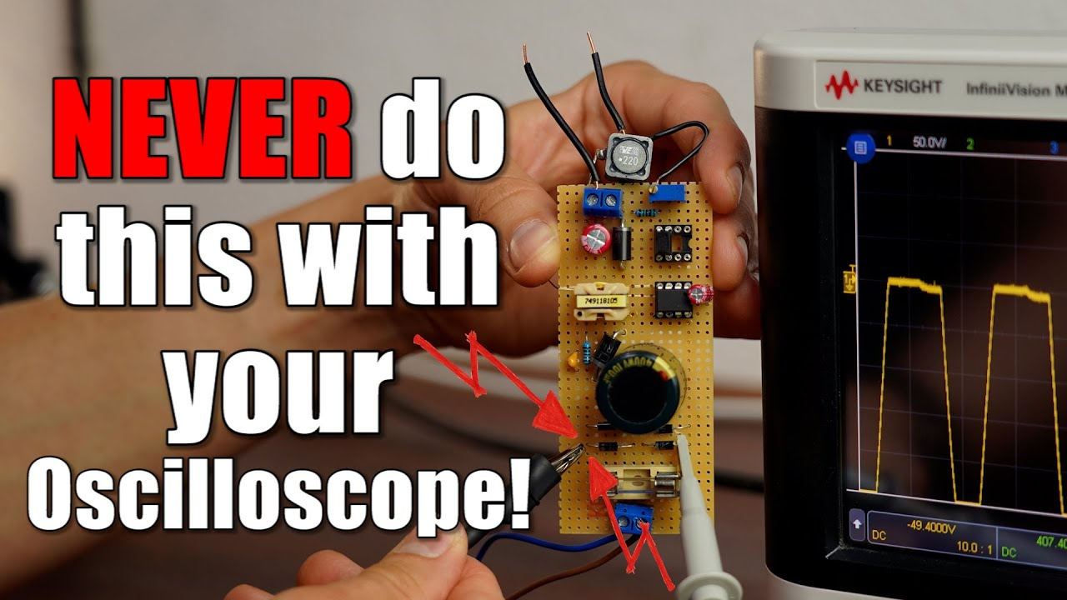

Episode 50: Probably the most used component nobody knows of! TL431 Guide! EB#50

**Video Title (Implied): Understanding the TL431 - The Unsung Hero of Power Supplies**

**Overall Theme:** The video explores the TL431, a surprisingly versatile and precise programmable reference IC, explaining its internal workings and showcasing its numerous applications, especially its critical role in Switch-Mode Power Supplies (SMPS).

**Introduction: The Marvel of Switch-Mode Power Supplies (SMPS)**

* **Key Point:** SMPS are amazing for efficiently converting mains voltage to lower DC voltages for everyday electronics (phones, laptops, etc.).
* **Context:** The video revisits a previous project where the host built a DIY SMPS, which used a then-unfamiliar component: the TL431.
* **Goal:** To demystify the TL431 and its capabilities.

**II. The Star Component: Unveiling the TL431**

* **Component Name:** **TL431** (and its variants like TL432).
* **Datasheet Description:** "Precision Programmable Reference."
* **Key Features Highlighted:**
  + Three pins: **Cathode**, **Anode**, and **Reference (Ref)**.
  + Internal precise voltage reference (typically **2.495V**, often rounded to 2.5V).
* **Internal Structure (Simplified Block Diagram):**
  + A comparator.
  + An NPN transistor (acting as the main current path).
  + A diode.
  + The internal 2.5V voltage reference.

**Key Applications and Demonstrations of the TL431**

**A. As a Simple Comparator (Open-Loop Configuration)**

* **Instrument Use:** With a power supply, resistors, and an oscilloscope/multimeter for observation.

**B. As an Adjustable Precision Zener Diode (Closed-Loop Configuration)**

* **Instrument Use:** With a power supply, resistors, and a multimeter.
* **1. Basic 2.5V Zener:**
  + **How it's used:** The Ref pin is connected directly to the Cathode.
  + **Function:** The TL431 will conduct current to maintain 2.5V between its Cathode and Anode, behaving like a very stable 2.5V Zener diode.
  + **Advantage:** More stable than standard Zener diodes with varying input voltage, current, or temperature.
* **2. Adjustable "Zener" Voltage:**
  + **How it's used:** A voltage divider (two resistors, R1 and R2) is connected from the Cathode to Ground, with the Ref pin tapped from the midpoint of this divider.
  + **Function:** The TL431 regulates the Cathode voltage (Vout) such that the voltage at the Ref pin is 2.5V. The output voltage is determined by: Vout = 2.5V \* (1 + R1/R2).

**C. Voltage Monitoring / Protection Circuits**

* **Instrument Use:** Power supply, resistors, potentiometer, MOSFET, load (LEDs).
* **Example:** A 12V battery over-discharge protection circuit.

**D. Precision Constant Current Sink**

* **Instrument Use:** Power supply, resistors, NPN transistor (BC337), potentiometer, LED as load, multimeter.

Function: The current through the load (connected to the collector) is I = 2.5V / R\_sense. This current remains constant regardless of variations in supply voltage or load characteristics (within limits).

**E. Switch-Mode Power Supply (SMPS) Feedback Loop (The Primary Application)**

* **Instrument Use:** Components of a flyback converter (transformer, MOSFET, diodes, capacitors, optocoupler), PWM signal source (Teensy in the DIY example), oscilloscope, electronic load.
* **Why it's used:** To regulate the output voltage of an isolated SMPS by providing feedback from the secondary (output) side to the primary (input/control) side.

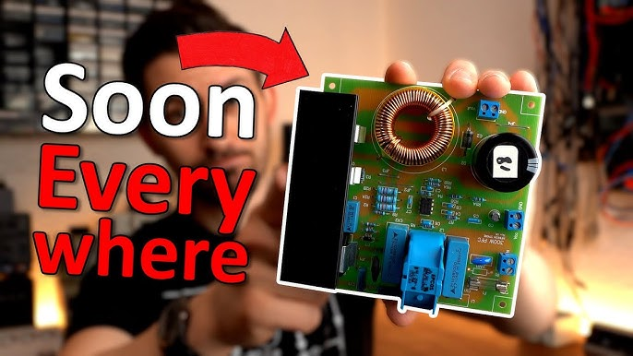

**Probably the most used component nobody knows of! TL431 Guide!**

**Episode 51:** **This component can control tons of circuits! Digital Potentiometer Guide! EB#51**

**Overall Summary:**

**GreatScott! explores the limitations of traditional mechanical potentiometers in projects requiring dynamic or programmatic adjustments. He introduces digital potentiometers (DigiPots) as an IC-based solution that allows resistance to be controlled digitally. The video covers the basics of how they work, demonstrates controlling a simple 3-wire DigiPot (X9C series) with push buttons, discusses its limitations (voltage/current), and then moves to a more robust high-voltage DigiPot (MCP41HVX1) controlled via SPI with an Arduino. The ultimate demonstration involves replacing a mechanical trimpot on a high-power LED boost converter with a DigiPot to programmatically dim the LED.**

**Introducing Digital Potentiometers (DigiPots)**

* **Component Name: Digital Potentiometer (also called DigiPot or XDCP - eXternally Digitally Controlled Potentiometer).**
* **Function: An integrated circuit that mimics the behavior of a mechanical potentiometer but allows its resistance (wiper position) to be controlled by digital signals from a microcontroller or other digital logic.**
* **Internal Structure: Typically consists of a series array of many small resistors and a set of digitally controlled analog switches (like MOSFETs) that tap into different points along the resistor string to set the wiper position.**
* **Advantages: Enables programmatic control, can be more precise, smaller footprint, and can have non-volatile memory to retain settings.**

**Basic Digital Potentiometer (X9C Series) & Control**

* **Instrument/Component Examples:**
  + **X9C103: 10 kΩ digital potentiometer.**
  + **X9C104: 100 kΩ digital potentiometer.**
* **Control Method (What it uses): These specific models use a simple 3-wire digital interface:**
  + **CS (Chip Select): Enables the IC for programming.**
  + **U/D (Up/Down): Determines if the wiper moves up or down the resistor array.**
  + **INC (Increment): A pulse on this pin moves the wiper one step in the direction set by U/D.**

**Controlling a High-Voltage DigiPot (MCP41HVX1) with Arduino**

* **Instrument for Control: Arduino Nano (or any microcontroller with SPI).**
* **Communication Protocol (What it uses): SPI (Serial Peripheral Interface) - requires MOSI, MISO, SCK, and CS lines.**
* **Software: The presenter used an existing Arduino library and example code found on Instructables to simplify SPI communication and control of the MCP41HVX1.**

**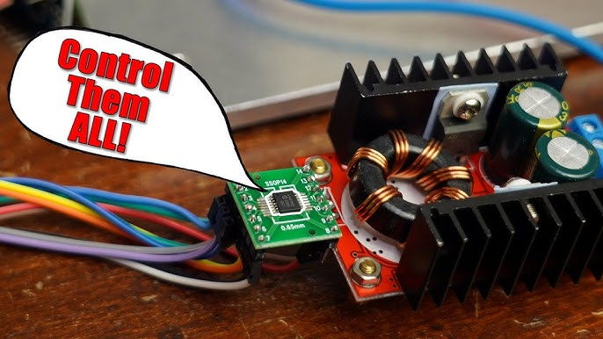**

**This component can control tons of circuits! Digital Potentiometer Guide!**

**Episode 52:** **Negative Voltages are more important than you think! So here is how to make them! EB#52**

**Creating Dual Rail (Positive & Negative) Voltages**

**Introduction: Why Dual Rail?  
Most electronic devices use a single positive DC voltage. However, certain applications, especially involving operational amplifiers (op-amps), audio circuits, waveform generators, ADCs, and DACs, require both a positive and a negative voltage rail relative to a common ground. This is known as a "dual rail" or "bipolar" power supply. The video demonstrates how a DIY waveform generator can output signals that swing above and below ground because it's powered by such a supply (+12V, GND, -12V).**

**Modifying a Standard Boost Converter Module**

* **Concept: Take a common DC-DC boost converter module and add an inverting charge pump circuit to its output.**
* **Boost Converter IC: The specific IC on the example module had its markings removed, but it was identified as a boost converter controller by probing its switching (SW) and feedback (FB) pins.**
* **Inverting Charge Pump Addition:**
  + **Connects to the switching node of the boost converter.**
  + **Components:**
    - **1x "Flying" Capacitor (e.g., 1µF ceramic, C2 in schematic).**
    - **2x Diodes (e.g., UF4007 or Schottky, D2 & D3 in schematic).**
    - **1x Output Smoothing Capacitor (e.g., 1µF ceramic for V-).**

**Pros: Utilizes readily available boost converter modules. Output voltage is adjustable via the boost converter's potentiometer.**

**Cons: Same as Method 1 – relatively low output current and significant switching noise. The DIY version showed even more noise than the commercial module, likely due to the specific boost converter used.**

**Instruments Used:**

**Soldering Iron, Hot Air Rework Station (for initial module deconstruction).**

**Oscilloscope (Keysight MSOX3054T) for reverse engineering and testing.**

**Multimeter.**

**Summary of Trade-offs & Key Instruments:**

* **Charge Pump based (Methods 1 & 2):**
  + **Pros: Simple, efficient, small.**
  + **Cons: Noisy, low output current.**
* **Transformer-based Linear (Method 3):**
  + **Pros: Very low noise, high output current.**
  + **Cons: Bulky, requires AC mains, less efficient (heat).**
* **Rail Splitter (Method 4):**
  + **Pros (Op-Amp buffered): Simple, relatively low noise (if op-amp is good).**
  + **Cons: Current limited by op-amp/buffer, not as efficient as charge pumps. Basic resistive version is highly load-sensitive.**

**Key Instruments Featured:**

* **Oscilloscope: Keysight InfiniVision MSOX3054T**
* **Multimeters: METRAHIT Pro, Gossen Metrawatt**
* **Bench Power Supply: ELV DPS 5315**
* **Soldering Iron & Hot Air Rework Station**
* **Digital Thermometer: TM-902C**

**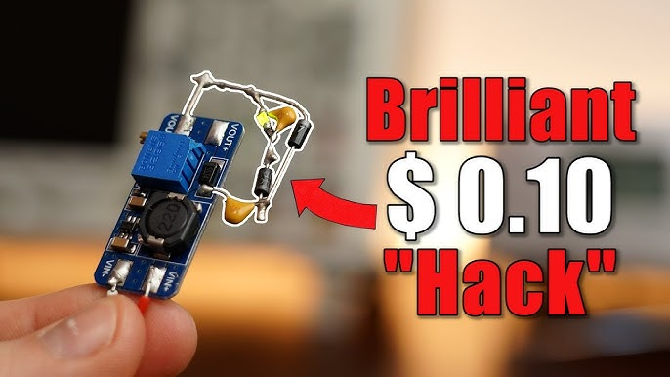**

**Episode 53:** **Mechanical Switches are Obsolete?! Switch to a Latch Circuit! EB#53**

**What is a Latch Circuit & Why Use It?**

* **Core Concept: A latch circuit is an electronic circuit that can "remember" a state (ON or OFF). It changes its output state based on a brief input signal (SET or RESET pulse) and then holds that state until another specific input signal is received.**
* **Quiz Introduction: The video begins by asking what the lighting in his corridor, a power supply button, and a DIY overcurrent protection circuit have in common – the answer is a latch circuit.**
* **Comparison with Toggle Switches:**
  + **Mechanical toggle switches physically stay in the ON or OFF position.**
  + **Latch circuits allow momentary push buttons to achieve a toggle (ON/OFF) or set/reset functionality.**
* **Advantages/Applications:**
  + **Cost/Complexity (for lighting): Using a latching relay ("Stromstoßrelais") can be simpler and cheaper for controlling a light from multiple locations compared to complex wiring of multiple 3-way/4-way mechanical switches.**
  + **Essential Functionality:**
    - **Overcurrent Protection: Prevents rapid on/off cycling by latching in the "tripped" state until manually reset.**
    - **Self-Deactivating Microcontrollers: Allows a microcontroller to turn itself completely off to save power, waiting for an external event (via the latch) to turn back on.**
    - **Power Buttons: Many electronic devices use momentary push buttons with latch circuits to toggle power.**

**A. Using Dedicated ICs (Integrated Circuits):**

* **Component: 74LS279 (or HD74LS279) Quadruple S-R Latch IC.**
* **Functionality:**
  + **SET (S) input: A high pulse on SET makes the Q output HIGH.**
  + **RESET (R) input: A high pulse on RESET makes the Q output LOW.**
  + **The output (Q) remains in its state even after the input pulse is removed.**

**B. Building an SR Latch from Logic Gates:**

* **Components: Two NOR gates (can also be done with NAND gates).**
* **Configuration: The output of each NOR gate is fed into one input of the other NOR gate, creating a cross-coupled feedback loop. The remaining inputs act as SET and RESET.**
* **Truth Table: Explained how different combinations of S and R inputs affect the Q and Q\_bar outputs.**

**C. Latching Relays ("Stromstoßrelais" - Impulse Relay):**

* **Component: Theben OKTO S12-230 (example).**
* **Application: Commonly used in home wiring to control lights from multiple push-button locations.**
* **Mechanism (Mechanical Latch):**

**D. Transistor-Based Toggle Latch Circuit (DIY Power Button):**

* **Goal: To create a circuit that toggles an output ON or OFF with each press of a single momentary push button.**
* **Key Components:**
  + **P-Channel MOSFET (e.g., IRF5210) as the main switch.**
  + **NPN BJTs (e.g., BC547 x2) for control logic.**
  + **Resistors (various values, e.g., 100kΩ).**
  + **Capacitor (e.g., 22µF) for timing/debouncing the push button.**
* **Simplified Operation:**
  + **Initial State (OFF): MOSFET gate is high, MOSFET is OFF.**
  + **First Push (Turn ON): Button press activates the first BJT, which pulls the MOSFET gate low. MOSFET turns ON. The output of the MOSFET then provides feedback to keep the first BJT latched ON. The capacitor helps manage the initial state change.**
  + **Second Push (Turn OFF): Button press, with the capacitor's previous state, activates the second BJT, which pulls the base of the first BJT low, turning it OFF. This makes the MOSFET gate high, turning the MOSFET OFF. The capacitor then recharges for the next cycle.**

**Key Instruments/Components Used in Demonstrations:**

* **Instruments:**
  + **Keysight E36312A DC Power Supply**
  + **ELV DPS 5315 DC Power Supply**
  + **Metrahit Pro Multimeter (for microcontroller current measurement)**
* **Components for Latch Circuits & Demos:**
  + **Breadboard, Perfboard**
  + **74LS279 SR Latch IC**
  + **NOR Gate IC (implicitly, for the logic gate demo)**
  + **IRF5210 P-Channel MOSFET**
  + **BC547 NPN BJT**
  + **Resistors (100kΩ, 4.7kΩ, etc.)**
  + **Capacitors (22µF, 4.7µF, 1000µF)**
  + **LEDs**
  + **Momentary Push Buttons**
  + **Theben OKTO S12-230 Latching Relay**
  + **Light bulb (as a load)**
  + **Arduino Nano & Distance Sensor (for microcontroller example)**
  + **NE555P Timer IC (mentioned as containing an SR Latch)**

**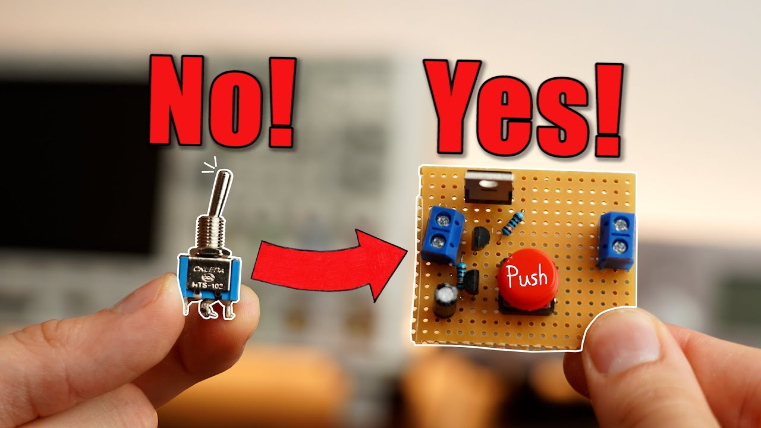**

**Mechanical Switches are Obsolete?! Switch to a Latch Circuit!**

Episode 54: **The Best Protection for your Circuit is NOT a Fuse!.....but a Resettable Fuse? EB#54**

**The Better Alternative: Resettable Fuses (PPTCs)**

* **Component Name: Resettable Fuse, also known as Polymeric Positive Temperature Coefficient (PPTC) device, MultiFuse, PolyFuse, or PolySwitch.**
* **Advantage: They are reusable and automatically reset after the fault is cleared and they cool down, addressing many limitations of traditional fuses.**

**Key Parameters for Selection:**

**V\_max (Maximum Voltage): The maximum voltage the fuse can withstand without damage.**

**I\_max (Maximum Current): The maximum fault current the fuse can interrupt without damage.**

**I\_hold (Hold Current): The maximum current the fuse will pass continuously without tripping at a specified temperature.**

**I\_trip (Trip Current): The minimum current at which the fuse will trip (switch to high resistance) at a specified temperature.**

**Behavioral Notes:**

**Trip Time: PPTCs are relatively slow to trip compared to some other protection devices (e.g., eFuses), often taking seconds, depending on the overcurrent level and ambient temperature. Traditional glass fuses can also be slow for currents just above their rating.**

**Leakage Current: When tripped, a small leakage current still flows, keeping the PPTC hot and in its high-resistance state.**

**Resistance Change: After tripping and resetting, the PPTC's initial (cold) resistance may be slightly higher than before its first trip. It can take a considerable time (e.g., an hour as per datasheets) to fully return to its original cold resistance.**

**Power Loss: PPTCs inherently have some resistance, leading to power loss (V x I) and self-heating even during normal operation, which must be considered.**

**nstruments & Demonstrations**

**The video uses several instruments to demonstrate and test the fuses:**

1. **Bench Power Supply (ELV DPS 5315):**
   * **Use: To provide a controlled voltage (e.g., 12V) and current to the circuits under test.**
   * **Demonstration: Shows the current draw of circuits, the power supply's current limiting feature kicking in, and how it powers the load through the fuse.**
2. **Digital Multimeter (Keysight 34470A):**
   * **Use: To measure the voltage drop across the fuse and its resistance.**
   * **Demonstration: Shows the low initial resistance, the increasing voltage drop (and thus resistance) as the PPTC heats up, and the high resistance state when tripped. Also used to compare the initial resistance before and after a trip.**
3. **Thermocouple / Temperature Meter (TM-902C Type K Power):**
   * **Use: To measure the surface temperature of the PPTC.**
   * **Demonstration: Shows the PPTC heating up as current increases, reaching a high temperature when tripped, and cooling down to reset.**
4. **Constant Current Electronic Load (DIY or Commercial):**
   * **Use: To draw a precise and adjustable amount of current through the fuse, allowing controlled testing of its I\_hold and I\_trip characteristics.**
   * **Demonstration: Used to incrementally increase current through the PPTC to observe its behavior at different current levels, including hold current, trip current, and the time-to-trip.**
5. **Breadboard:**
   * **Use: For quickly setting up test circuits with jumper wires.**
   * **Demonstration: Used for initial tests of the PPTC with the constant current load and multimeter.**
6. **Soldering Iron:**
   * **Use: To permanently attach PPTCs into circuits (e.g., with a power resistor load or onto an LED strip).**
7. **Loads Used for Testing:**
   * **Transistor (MPSA42): Shown smoking and exploding at the beginning to illustrate the need for protection.**
   * **Power Resistor (e.g., 50W 10RJ): Used as a high-power load to test the PPTC's ability to handle and interrupt significant current.**
   * **RGB LED Strip: Used as a practical example of a circuit that might benefit from PPTC protection.**
   * **Capacitor: Shown exploding when connected with reverse polarity.**
8. **Trip Indicator Circuit:**
   * **Components: An LED, a current-limiting resistor, and a diode (like 1N4148).**
   * **Use: Connected in parallel with the main load. When the PPTC trips, the voltage across the main load drops significantly, but enough voltage appears across the tripped PPTC to light up the indicator LED, visually signaling the tripped state.**

**Comparison & Application**

* **PPTC vs. Traditional Glass Fuse:**
  + **PPTC: Resettable, slightly slower trip, higher power loss during normal operation, medium V/I handling. Good for development, inaccessible locations, or frequent minor overloads.**
  + **Glass Fuse: One-time use, can be even slower for slight overloads, very low power loss, can handle very high V/I. Good for catastrophic failure protection.**
* **PPTC vs. eFuse:**
  + **eFuse: Very fast trip, precise, programmable, low power loss, but more expensive and complex, lower V/I handling.**
* **Common Use Cases for PPTCs:**
  + **USB port protection.**
  + **Battery pack protection (for overcurrent and often over-temperature due to their PTC nature).**
  + **Motor protection.**
  + **General low to medium power DC circuit protection where resettability is valued.**

**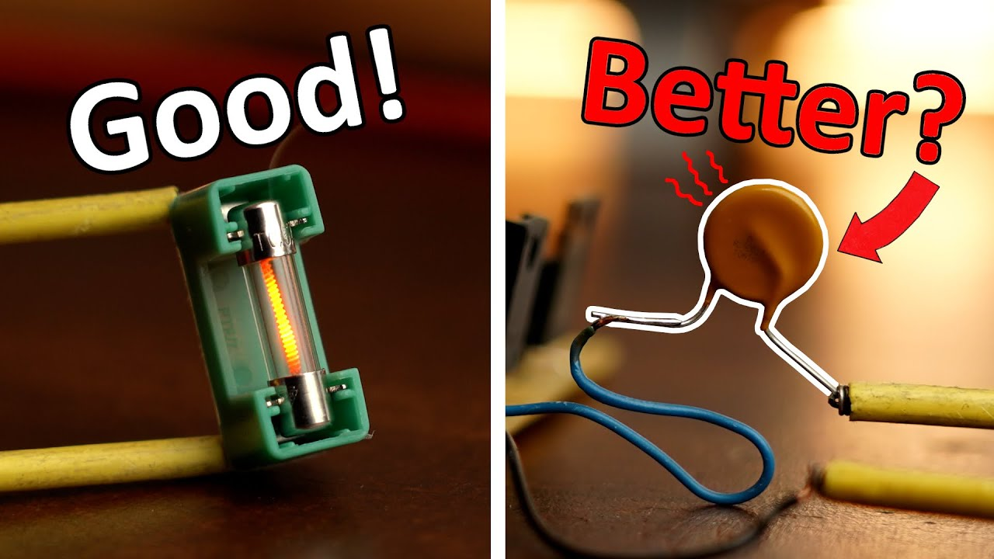**

**Resettable Fuse**

**Episode 55:** **The Most Important Circuit for our Electrical Future?! (PFC) EB#55**

**Video Overview: Understanding Power Factor and Its Correction  
The video explains why some AC-powered devices (like a heat gun) are efficient in how they draw power from the mains, while others (like cheap LED strip power supplies) are inefficient, leading to poor power factor and current harmonics. It then delves into the concept of Power Factor Correction (PFC), demonstrating both passive and, more extensively, active PFC methods to improve power quality and reduce stress on the electrical grid.**

**Instruments & Components Used/Demonstrated**

* **Oscilloscope:**
  + **Model: Keysight InfiniiVision MSOX3054T**
  + **Usage: Visualizing AC mains voltage (green waveform) and AC input current (yellow waveform) for different loads. Used to show phase relationships, current waveform shape (sinusoidal vs. pulsed), and PWM signals in Active PFC. Also used for FFT (Fast Fourier Transform) to analyze current harmonics.**
* **Multimeter (Power Quality Analyzer):**
  + **Model: Metrahit Energy (by Gossen Metrawatt)**
  + **Usage: Measuring Real Power (W), Apparent Power (VA), Reactive Power (VAr), Power Factor (PF), voltage, and current.**
* **Clamp Meter (Current Probe):**
  + **Model: Hantek CC-65 (connected to oscilloscope)**
  + **Usage: Non-invasively measuring the AC input current flowing to the devices under test.**
* **Heat Gun:**
  + **Model: MOWIS 1800W**
  + **Usage: Example of a "good" resistive load. Shows nearly perfect sinusoidal current in-phase with voltage (PF ≈ 1.0).**
* **LED Strip with AC-DC Adapter:**
  + **Usage: Example of a "bad" load with a low power factor (PF ≈ 0.56) and pulsed current draw.**
* **Generic AC-DC Power Supply (12V):**
  + **Usage: Another example of a device with poor input current waveform and low PF, which is then improved by adding an external Active PFC circuit.**
* **PFC Development Boards/ICs:**
  + **Active PFC Development Board (Main Demo): EVALPFC2ICE2PCS03TOBO1 (from Infineon, featuring ICE2PCS03 IC). Used to demonstrate how Active PFC shapes input current.**
  + **Active PFC Controller IC (Mentioned): ICE2PCS01GXUMA1 (from Infineon, found on Mouser).**
  + **Other Components for PFC: Inductors, capacitors, MOSFETs, diodes (as part of the PFC circuits).**

**Key Concepts Explained**

* **Real Power (W): The actual power used by a device to perform useful work (light, heat, motion). *Analogy: The liquid (drink) in a glass.***
* **Apparent Power (VA): The total power (Voltage x Current) that the power grid must supply. *Analogy: The total volume in the glass (liquid + foam).***
* **Reactive Power (VAr): Power that oscillates between the source and the load, not performing useful work but contributing to the current flow and stressing the grid. It can be caused by phase differences between voltage and current (capacitive/inductive loads) or by current harmonics. *Analogy: The foam in the glass.***
* **Power Factor (PF): The ratio of Real Power to Apparent Power (PF = W/VA). An ideal PF is 1.0. A low PF indicates inefficient power usage from the grid's perspective.**
* **Phase Shift: In AC circuits with capacitors or inductors, current can lead (capacitive) or lag (inductive) the voltage, causing reactive power.**
* **Current Harmonics: Non-sinusoidal current waveforms (like pulses) can be mathematically decomposed into a fundamental frequency component (e.g., 50Hz) and multiple higher-frequency components (harmonics, e.g., 150Hz, 250Hz). These harmonics also contribute to reactive power and distortion.**

**Solutions: Power Factor Correction (PFC)**

* **Passive PFC:**
  + **Method: Uses passive components (capacitors for inductive loads like motors, or inductors for capacitive loads) to compensate for phase shifts.**
  + **Effectiveness: Simpler, less expensive, but generally less effective at correcting complex harmonic distortion or achieving very high PF.**
* **Active PFC:**
  + **Method: Uses active electronic circuits (typically a controller IC, MOSFET switch, inductor, diode, and capacitor – often a boost converter topology) to actively shape the input current.**
  + **Goal: To make the input current drawn from the mains sinusoidal and in-phase with the mains voltage.**
  + **Effectiveness: More complex and costly, but can achieve very high PF (close to 1.0) and significantly reduce current harmonics.**

****

**The Most Important Circuit for our Electrical Future?! (PFC)**

**Episode 56:** **These 3 Cent Components are actually USEFUL?! (Color Ring Inductor) EB#56**

**Video Headline: Demystifying Cheap Color Ring Inductors: Are They Useful?**

**Overall Goal: The video investigates the practicality and limitations of inexpensive "color ring inductors," which resemble resistors but are indeed inductors. The presenter aims to determine if they are a viable alternative to more conventional power inductors by testing their performance under stress.**

**1. Introduction to Inductors**

* **Component Focus: Inductors (general)**
* **Types Shown & Usage:**
  + **Power Inductor (Toroidal): Copper wire wrapped around a ferromagnetic core. Easy to identify. Used in beefy power supplies (e.g., 0:05-0:17).**
  + **SMD (Surface Mount Device) Power Inductor: Packaged for surface mounting, internally similar to toroidal (copper wire around a core). Harder to identify visually. Used in smaller power supplies (e.g., 0:18-0:30).**
  + **Color Ring Inductor: The main subject. Looks like a resistor with color bands. Very cheap. Internally, it's also a copper wire wrapped around a ferromagnetic core (revealed at 2:46-2:52). The color bands indicate inductance value via a specific chart (shown at 3:05).**

**The Puzzle of Color Ring Inductors**

* **Instrument (Component): Color Ring Inductor**

**3. Testing the Color Ring Inductor**

* **Test 1: Boost Converter Performance**
  + **Instrument Used: A small DC-DC boost converter module.**
  + **Original Component: An SMD inductor (22µH) allowing ~1A output current.**
  + **Replacement Component: A 22µH color ring inductor.**

**4. Conclusion & Recommendations**

* **Color Ring Inductors - The Verdict:**
  + **They *are* real inductors.**
  + **Their primary limitation is a low saturation current compared to dedicated power inductors of similar inductance values.**
  + **The "1W power" rating is largely irrelevant for their use in switching power supplies.**
  + **Lack of detailed datasheets (especially saturation current) is a major issue.**
* **Suitable Uses:**
  + **Low-power, low-current applications.**
  + **Signal filtering (e.g., RF, audio).**
  + **Simple LC oscillators.**
  + **Good for beginners experimenting with basic inductor properties due to low cost.**

**Sponsor Segment (Particle Photon 2)**

* **Instrument: Particle Photon 2 (IoT Development Board)**
* **Usage Shown (1:37 - 2:45): The presenter used it to build a remote battery voltage monitoring system for their solar setup.**
  + **Features Highlighted: Wi-Fi (2.4GHz & 5GHz), BLE, 3MB RAM, ARM Cortex M33 CPU.**
  + **Application: Connected to multiple 12V batteries in a solar system via a perfboard circuit with voltage dividers. The Photon 2 reads the voltages and publishes them to Particle's IoT platform, allowing remote monitoring via the internet.**
  + **Programming: Done wirelessly via Particle Workbench.**

**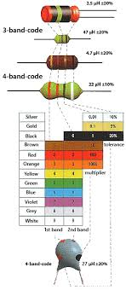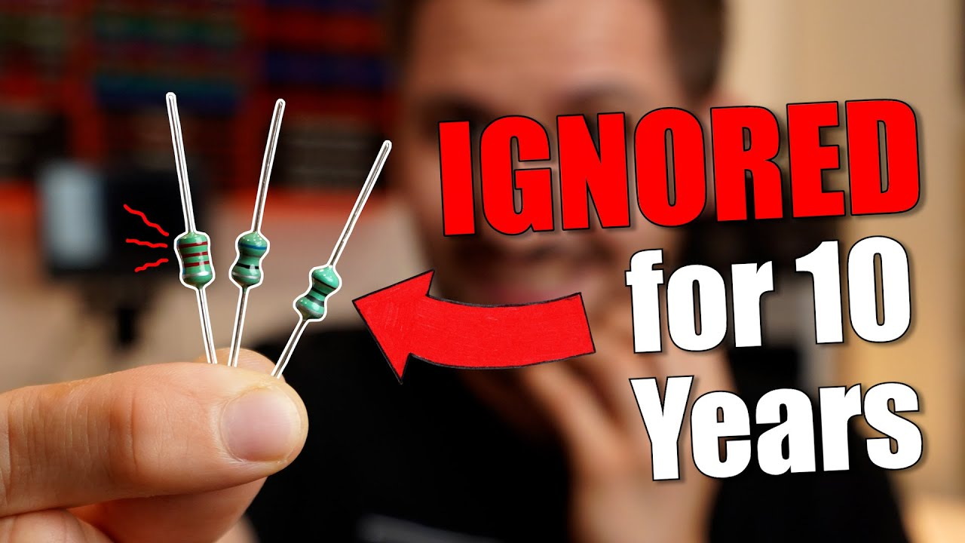**

**Episode 57:** **Ground is MORE IMPORTANT than you think! EB#57**

**The Earth as a Conductor – Powering a Lightbulb with Soil!**

* **Key Point: Soil (Earth/ground) can conduct electricity, though its resistance varies with moisture and composition.**
* **Experiment: The video starts by showing soil from a garden being used to complete a circuit and light up a lightbulb.**
  + **Instruments/Components Used:**
    - **Glass Container: To hold the soil.**
    - **Soil: The conductive medium.**
    - **Metal Plates: Used as electrodes to make contact with the soil. Larger plates improve contact and reduce resistance.**
    - **Lightbulb & Socket: The load in the circuit.**
    - **Power Supply (AC): To provide the voltage.**
    - **Multimeter: Used to measure resistance and voltage drop across the soil, demonstrating higher resistance with dry soil or smaller contact points, and lower resistance with wet soil or larger plates. Adding sand between soil layers increased resistance.**
* **Observation: The lightbulb illuminates, proving soil's conductivity. The brightness depends on the soil's resistance (affected by moisture, contact area).**

**Protective Earth (PE) in AC Systems – The Lifesaver**

* **Key Point: The "ground" wire in AC power cables (Protective Earth or PE) is a crucial safety feature, not primarily for powering devices.**
* **Components & System:**
  + **AC Power Cable: Contains Live (L1, brown), Neutral (N, blue), and Protective Earth (PE, green/yellow) wires.**
  + **Appliance (Toaster): The metal chassis of the toaster is connected to the PE wire.**
  + **Wall Outlet/Power Strip: The PE contacts in the outlet connect to the building's PE system.**
  + **Main Distribution Panel: Contains:**
    - **Circuit Breakers (MCBs): Protect against overcurrent (short circuits).**
    - **RCD (Residual Current Device) / GFCI: Detects imbalances in current between Live and Neutral (indicating current leakage to Earth) and trips.**
    - **Earth Busbar & Earth Rod: The building's PE system is connected to a metal rod (e.g., 9m long) driven deep into the physical Earth.**

**Ground (GND) in DC Electronics – The Common Reference Point**

* **Key Point: In most electronic circuit schematics, the "GND" symbol represents the circuit's common 0-volt reference potential, not necessarily a connection to the physical Earth.**
* **Components & System:**
  + **Circuit Schematics: Show multiple GND symbols.**
  + **PCB (Printed Circuit Board): Often utilizes a "ground plane" – a large area of copper connected to all GND points. This is like the circuit's "local earth."**
  + **Bench Power Supply / Battery: The negative terminal is typically designated as the 0V reference (GND) for the circuit.**

**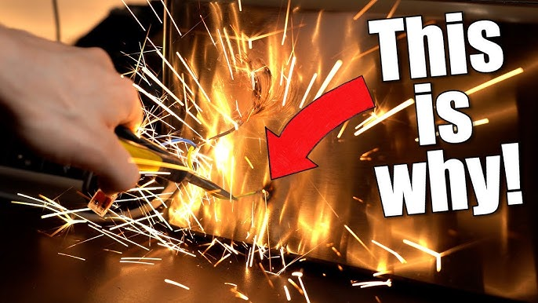**

**Episode 58:** **This Component solves "All" Motor Problems?! (Motor Encoder) EB#58**

**The video explores "Motor Encoders," sophisticated sensors that provide precise feedback on a motor's position and speed. This is inspired by projects like the "SmartKnob," which uses a magnetic encoder for a haptic input device. The creator aims to demystify these components and show their power beyond simple input.**

**What is a Motor Encoder & How Does It Work?**

**Instrument Name: Motor Encoder (various types)**

**Motor encoders are devices that track the rotational position and/or speed of a motor shaft. The video contrasts them with traditional mechanical rotary encoders:**

1. **Traditional (Mechanical) Rotary Encoder:**
   * **Mechanism: Uses a disc with conductive and non-conductive patterns. Two offset mechanical contacts (pins A and B) sweep across these patterns.**
   * **Signal: Generates two square wave signals (A and B). The sequence in which these signals change (A before B, or B before A) determines the direction of rotation. Each pulse represents a step.**
   * **Limitations: Lower resolution (e.g., 20 steps/revolution = 18° per step), mechanical wear.**
2. **Magnetic Motor Encoder (e.g., AS5600):**
   * **Mechanism: Uses a small diametrically magnetized magnet (North and South poles on the flat faces) attached to the motor shaft. An IC (like the AS5600) contains Hall effect sensors that detect the orientation of the magnet's field.**
   * **Signal/Output: Can provide high-resolution (e.g., 12-bit, meaning 4096 steps per revolution, or ~0.088° per step) analog, PWM, or digital (I²C) output representing the absolute angle.**
   * **Used with: Motors (for the SmartKnob mockup, a small BLDC motor is used), microcontrollers (Arduino for testing).**
3. **Capacitive Motor Encoder (e.g., AMT102):**
   * **Mechanism: Uses patented capacitive ASIC technology. A rotor with a specific pattern moves, and changes in capacitance are measured by sensors on a stator.**
   * **Signal/Output: Generates A, B (quadrature) signals similar to mechanical encoders, but with much higher precision, and often an Index (X) pulse (once per revolution).**
   * **Resolution: High, e.g., 2048 Pulses Per Revolution (PPR), which is ~0.176° per step.**
   * **Used with: BLDC motors, DC motors, and motor controllers (like the Solo Motor Controller).**

**Key Components & Technologies Demonstrated**

* **Motor Types Shown:**
  + **Small DC Motors (for robot example)**
  + **BLDC (Brushless DC) Motors (for SmartKnob mockup, and with Solo Motor Controller)**
  + **Stepper Motors (mentioned for comparison)**
* **Encoder ICs/Modules:**
  + **AS5600: A 12-bit magnetic rotary position sensor IC.**
  + **AMT102: A modular incremental capacitive encoder.**
* **Control Systems:**
  + **Arduino: Used for basic reading of the AS5600 encoder.**
  + **Solo Uno Motor Controller (Sponsor): A sophisticated motor driver board capable of precise BLDC motor control using encoder feedback. It features:**
    - **High power handling (up to 58V, 100A peak).**
    - **Encoder input (for A, B, X signals).**
    - **"Motion Terminal" software for:**
      * **Motor identification (detecting motor parameters).**
      * **Encoder testing and calibration.**
      * **PID (Proportional-Integral-Derivative) controller tuning.**
      * **Control modes: Position, Speed, Torque.**
* **Other:**
  + **3D Printed Enclosures/Mounts: Used to attach encoders to motors.**

**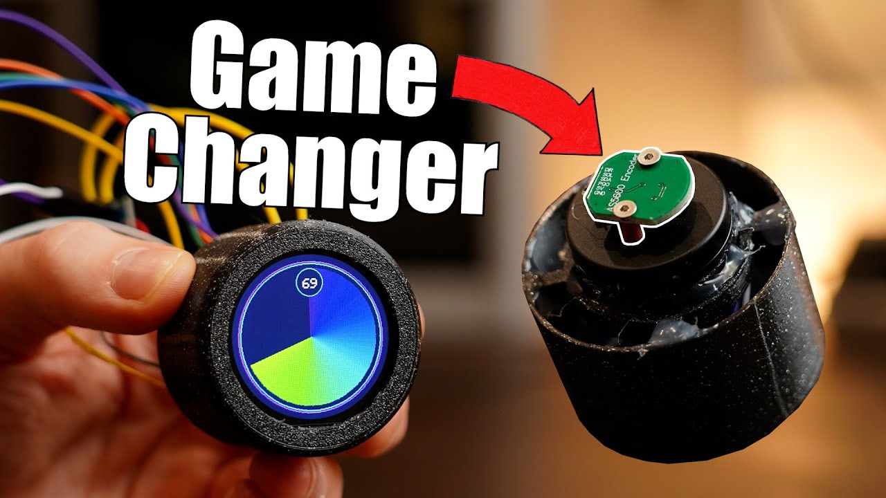**

**This Component solves "All" Motor Problems?! (Motor Encoder)**

**Episode 59:** **This $0.70 Component SAVES your Circuit?! (Surge Protection) EB#59**

**Video Summary: Understanding & Testing Overvoltage Protection**

**Introduction: The Peril of Overvoltage  
The video begins by dramatically illustrating how a simple LED can be instantly destroyed by an overvoltage pulse. The presenter explains that while such events might seem rare, they can be caused by various sources and can lead to the immediate destruction of sensitive electronics. The goal is to explore and test different protective components designed to prevent this damage.**

**1. Sources of Overvoltage:  
The presenter identifies three main culprits for overvoltage events:**

* **Lightning Strikes: Indirect strikes near power lines.**
* **Inductive Load Switching: Motors or heavy machinery on the grid turning on/off, causing voltage spikes.**
  + ***Instrument Used:* AC Power Source (PeakTech 2240) to simulate grid, Oscilloscope (Keysight InfiniiVision MSOX3054T) to observe spikes.**
* **Electrostatic Discharge (ESD): Static electricity buildup (e.g., rubbing feet on carpet) discharging into electronics.**

**2. Testing Methodology & High Voltage Generation:  
To test protective components, a controlled overvoltage source is needed.**

* **ESD Generator (Wimshurst Machine):**
  + ***Instrument Used:* A hand-cranked Wimshurst-style electrostatic generator.**
  + ***Capability:* Generates high voltage sparks (e.g., ~8-9kV measured, estimated 15,000V for a 5mm air gap, or 30,000V for 1cm).**
  + ***Limitation:* Voltage and current are not precisely controllable or easily measurable for consistent testing, but good for demonstrating destructive power.**
* **Insulation Tester:**
  + ***Instrument Used:* PeakTech 2695 Insulation Tester.**
  + ***Capability:* Can create precise DC voltages (e.g., 125V to 1000V).**
  + ***Limitation for this test:* Output current is heavily limited (e.g., ~3.6mA). This makes it "too safe" as the voltage breaks down too quickly to damage the test circuits, rendering it unsuitable for destructive testing of protection components.**
* **Test Circuit: A simple microcontroller (HT66F004) based LED blinking circuit powered by a 5V lab power supply (ELV DPS 5315).**

**Inside Commercial Surge Protectors:**

* **Cheaper PV System Surge Protector (€25):**
  + **Contains multiple MOVs (blue discs).**
  + **A small heatsink.**
  + **A green LED in series (likely as an indicator).**
* **More Expensive Industrial Surge Protector (OBO Bettermann, similar to €75 model):**
  + **Uses a large MOV.**
  + **Features a sophisticated spring-loaded lever system. If the MOV overheats due to excessive current, a solder joint melts, releasing the spring. This physically disconnects the MOV from the circuit and changes a visual indicator (green to red), preventing potential fire hazards from a failed (shorted) MOV.**
* **Expensive Home Surge Protector (€150): Implied to have even more robust or sophisticated mechanisms similar to the industrial one, justifying its higher cost for enhanced safety and reliability.**

**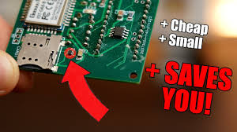**

**Surge Protection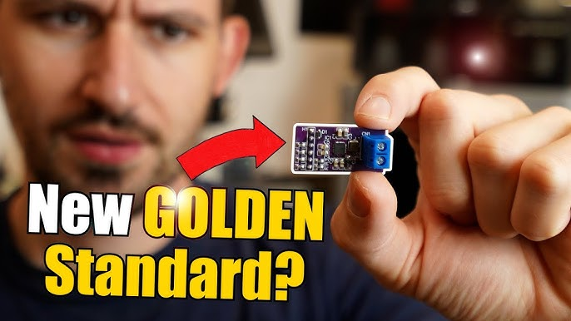**

**Episode 60:** **Is This the NEW GOLDEN Standard for Communication? (I3C) EB#60**

**Project Goal: Affordable Haptic Feedback**

**The presenter is impressed with a haptic feedback system powered by a Piezo Haptic Driver. However, the official development kit (BOS1921-KIT) costs around €240, which is too expensive for most projects. The goal is to create a much cheaper custom breakout board for the core IC.**

**The Core Component: BOS1921 Piezo Haptic Driver**

* **Component Name: BOS1921 Piezo Haptic Driver IC from Boreas Technologies.**
* **Function: A single-chip piezo actuator driver capable of creating diverse vibration patterns for haptic feedback. It can drive actuators with waveforms up to 190 Vpk-pk.**
* **Cost: The IC itself is much more affordable, around €4.**
* **Communication: Supports both I²C (Inter-Integrated Circuit) and its successor, I3C (Improved Inter-Integrated Circuit).**

**I²C vs. I3C: The Communication Protocols**

**The BOS1921 supports both I²C and I3C. The presenter explores the differences:**

* **I²C (Inter-Integrated Circuit):**
  + **A widely used, 2-wire (SDA - data, SCL - clock) serial communication protocol.**
  + **Uses an open-collector design, requiring external pull-up resistors.**
  + **Maximum frequency for this IC: 1 MHz (1 Mb/s data rate).**
  + **Addresses are often static, sometimes configurable with hardware jumpers/resistors, which can lead to address conflicts.**
  + **Interrupts from slave devices require separate physical pins on the master.**
* **I3C (Improved Inter-Integrated Circuit):**
  + **Successor to I²C, backward compatible.**
  + **Key Advantages/Features:**
    1. **Higher Speed: Supports up to 12.5 MHz for this IC (12.5 Mb/s data rate).**
    2. **Power Efficiency: Uses push-pull drivers, eliminating the need for constant power draw through pull-up resistors (like I²C's open-collector design).**
    3. **Dynamic Addressing: The master controller assigns dynamic addresses to targets during initialization, preventing address conflicts.**
    4. **Common Command Codes (CCC): Standardized commands for operations like resetting or setting dynamic addresses.**
    5. **Hot Join (HJM): Allows devices to be added to the bus while it's active (*Note: The BOS1921 IC does NOT support this feature*).**
    6. **In-Band Interrupts (IBI): Allows slave devices to signal interrupts to the master over the existing SDA/SCL lines, saving dedicated interrupt pins (*Note: The BOS1921 IC does NOT support this feature*).**
* **I3C Challenges:**
  + **Complexity: More complex to implement in software (bit-banging is difficult).**
  + **Hardware Requirement: Generally requires dedicated I3C peripheral hardware on the microcontroller.**
  + **Availability: Fewer microcontrollers currently offer native I3C support (e.g., presenter is using a PIC18-Q20 for I3C development).**

**Instruments & Tools Used:**

* **Laptop: Running Boreas Technologies software (for waveform editing/playback) and Microchip MPLAB X IDE (for PIC microcontroller programming).**
* **Keysight HD304MSO Oscilloscope: (Video Sponsor) Used for visualizing I²C and I3C signals, checking signal integrity, and measuring frequencies. Features its 14-bit ADC.**
* **Bench Power Supply: To power the boards, with current limiting for safety during testing.**
* **FLIR TG267 Thermal Camera: To diagnose the short circuit by identifying the overheating component.**
* **Metrahit Pro Multimeter: For general voltage and continuity checks, and to observe the interrupt pin behavior.**
* **MHP30 Mini Hot Plate: For reflow soldering the SMT components on the custom PCB.**
* **Soldering Iron & Tweezers: For manual soldering (headers, terminals) and component placement.**
* **Solder Paste & Stencil: For applying solder paste to the PCB pads.**
* **Breadboard & Jumper Wires: For prototyping and connecting modules.**
* **Arduino Nano: Used for initial I²C demonstrations and as a master to test the breakout board via the original dev kit's MCU.**
* **PIC18-Q20 Microcontroller Development Board: Used for dedicated I3C development and testing.**
* **Piezoelectric Actuator: The component that produces the haptic feedback.**

**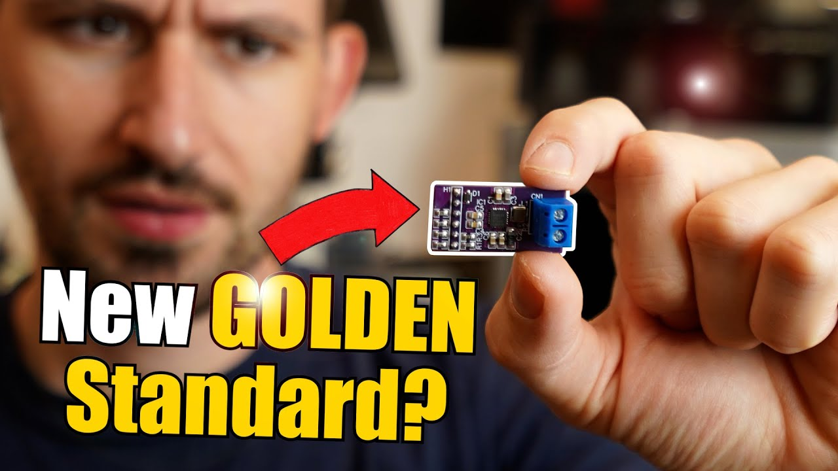**

**Is This the NEW GOLDEN Standard for Communication? (I3C)**

**Episode 61:** **The World's Simplest Audio Amp just got BETTER?! (MOSFET Amp) EB#61**

* **The video starts by referencing a previous project: "The World's Simplest Audio Amplifier."**
  + **Original Components (approximate): BC337 BJT, R1=3.3kΩ, R2=1kΩ, R3=100Ω, R4=22Ω, C1=10µF, C2=10µF.**
  + **Original Use: Designed for headphones with a 5V supply.**
* **Modern Challenge:**
  + **Wired headphones are less common; smartphones often lack 3.5mm jacks, using USB-C instead.**
  + **The original amp is too low-power for a loudspeaker.**
* **Goal: Revive the simple design to make it powerful enough for a loudspeaker, and compare BJT (Darlington) vs. MOSFET.**

**Upgrading with a Darlington Transistor (TIP142)**

* **Objective: Increase collector current (Ic) to around 500mA to drive a loudspeaker.**
* **Initial Component Change:**
  + **Replaced the BC337 BJT with a TIP142 Darlington Transistor (capable of handling much higher currents, e.g., 10A).**
* **Circuit Modifications & Challenges:**
  + **Higher Vce Drop: Darlington transistors have a higher saturation voltage (Vce) drop (around 1-2V) compared to a single BJT. This reduces the available voltage swing for the audio signal if the supply voltage is too low.**
  + **Increased Supply Voltage: Supply voltage was increased from 5V to 12V.**
  + **New Resistor Values (for 12V, ~500mA Ic):**
    - **Collector Resistor (Rc): Calculated to be around 10Ω.**
    - **Emitter Resistor (Re): Calculated to be around 2Ω.**
  + **Power Resistors Needed: The original small resistors would burn up. Larger power resistors (e.g., 50W 10RJ for Rc, 10W2RJ for Re) were used.**
  + **Heat Dissipation: The TIP142 got very hot. A heatsink was added.**
  + **Output Capacitor: Increased to 4700µF for better low-frequency response with the loudspeaker.**
  + **Biasing Resistors (Voltage Divider): Values changed to 680Ω (R1) and 220Ω (R2) to provide appropriate base current and bias for the Darlington.**
* **Result: The Darlington amplifier worked, producing decent volume for the loudspeaker. Audio quality seemed okay, with low Total Harmonic Distortion (THD) observed on the oscilloscope.**

**Key Components & Instruments Used:**

* **Transistors:**
  + **BC337 (Original BJT)**
  + **TIP142 (Darlington Pair Transistor)**
  + **IRFZ44N (N-Channel MOSFET)**
* **Passive Components:**
  + **Resistors (various, including high-power 10Ω and 2Ω)**
  + **Capacitors (10µF, 4700µF electrolytic, 10µF input coupling)**
  + **Potentiometer (50kΩ for MOSFET biasing)**
* **Other:**
  + **Loudspeaker**
  + **Heatsink**
  + **Smartphone (with USB-C to 3.5mm audio adapter)**
  + **Alligator clips, breadboard wires**
* **Test & Measurement Equipment:**
  + **Bench Power Supply: ELV DPS 5315 (to provide adjustable DC voltage and monitor current/power)**
  + **Oscilloscope: Keysight HD304MSO (to view waveforms and perform FFT for THD analysis)**
  + **Function Generator: Siglent SDG 2082X (to provide a clean sine wave test signal at various frequencies)**
  + **Digital Multimeter: Metrahit Pro (for voltage measurements)**
  + **Thermometer: TM-902C (with K-type thermocouple to measure component temperatures)**
  + **Component Tester: (Briefly shown testing a MOSFET)**

**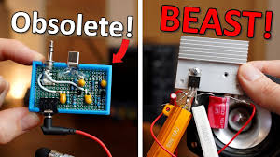**

**MOSFET Amp**

**Episode 62:** **Not a Microcontroller!...This is Better?! (PLC) EB#62**

**Overall Summary: Diving into Industrial Control with PLCs**

**GreatScott! takes a departure from his usual microcontroller-centric projects to explore the world of Programmable Logic Controllers (PLCs), specifically using the Arduino Opta PLC. He contrasts PLCs with microcontrollers like Arduino and ESP boards, demonstrating their strengths in industrial automation through a conveyor belt sorting project. The video highlights the ease of programming (especially with graphical languages), robust I/O handling, and reliability of PLCs, while also touching upon their cost and limitations for certain high-speed custom tasks where microcontrollers might be preferred.**

**Key Instrument: The Arduino Opta PLC**

* **Component Name: Arduino Opta PLC**
* **What it is: A Programmable Logic Controller designed for industrial automation and control tasks. It's a more robust and industrially-oriented "brain" compared to typical hobbyist microcontrollers.**
* **Key Features Highlighted:**
  + **Industrial Design: Larger, rigid form factor, often with DIN rail mounting for easy integration into electrical cabinets.**
  + **Standardized I/O:**
    - **Inputs: Typically 0-24V DC for digital signals and 0-10V DC for analog signals (the Opta supports both, configurable per input). This allows direct connection of industrial sensors.**
    - **Outputs: The Arduino Opta features 4 built-in relays capable of switching higher voltages and currents (e.g., 250V AC at up to 10A), suitable for directly controlling motors, lights, solenoids, etc.**
  + **Robust Wiring: Uses screw terminals for secure and reliable connections.**
  + **Operating Environment: Designed for wider temperature ranges and industrial certifications (CE, UL, etc.).**
  + **Programming: Can be programmed using the Arduino PLC IDE.**
    - **Supports IEC 61131-3 standard languages:**
      * **Function Block Diagram (FBD): A graphical language, which GreatScott! primarily uses.**
      * **Ladder Diagram (LD)**
      * **Sequential Function Chart (SFC)**
      * **Structured Text (ST)**
      * **Instruction List (IL)**
    - **Also supports traditional Arduino Sketch (C++).**
  + **Live Debug Mode: A powerful feature allowing real-time monitoring of variable states and logic flow, greatly simplifying troubleshooting.**

**Automated Conveyor Belt Sorter**

**This project demonstrates the practical application of the Arduino Opta PLC.**

* **Objective:**
  + **To create a conveyor belt system that can detect different types of objects.**
  + **Specifically, if a metal object is detected, the conveyor should stop, reverse for a set duration to "eject" the metal object, and then resume normal operation.**
* **Instruments & Components Used with the PLC:**
  + **Conveyor Belt: A small mechanical conveyor with a DC Motor (GreatScott! powers this at 5V for slower, controllable speed).**
  + **Industrial Switchboard: A control panel with:**
    - **Pushbuttons: For Start and Stop operations.**
    - **Indicator LEDs: Green for "running" state, Red for "metal detected/reversing" state.**
  + **Industrial Stack Light: A multi-segment light tower (Red and Green segments utilized for status indication).**
  + **Proximity Sensors (Inputs to PLC):**
    - **Inductive Proximity Sensor: Detects metal objects.**
    - **Capacitive Proximity Sensor: Detects non-metal objects (like plastic or glass bottles).**
  + **Power Supply:**
    - **The PLC itself is powered (e.g., via USB for programming, or its specified DC input for operation).**
    - **A Bench Power Supply is used to provide 12V DC for the sensors and the stack light, and 5V DC for the conveyor motor.**
  + **Wiring Components: Various wires, screw terminals on the PLC, and Wago Connectors are briefly shown for power distribution.**
* **PLC Logic Elements Used:**
  + **Inputs: Start button, Stop button, Inductive Sensor, Capacitive Sensor.**
  + **Outputs: Conveyor Motor (Forward/Reverse via PLC relays), Green LED, Red LED, Stack Light segments.**
  + **Function Blocks:**
    - **TOF (Timer Off-Delay): Used to control the duration of the conveyor reversal (e.g., 3000ms).**
    - **RS Flip-Flop (Set-Reset Latch): Used to maintain states (e.g., conveyor running state).**
    - **EQ (Equal), OR, AND: Basic logic operators to build the decision-making process.**

**